Garden Cottage

Design and Access Statement

Proposals to install restraint straps and helibars to stabilise the south gable end

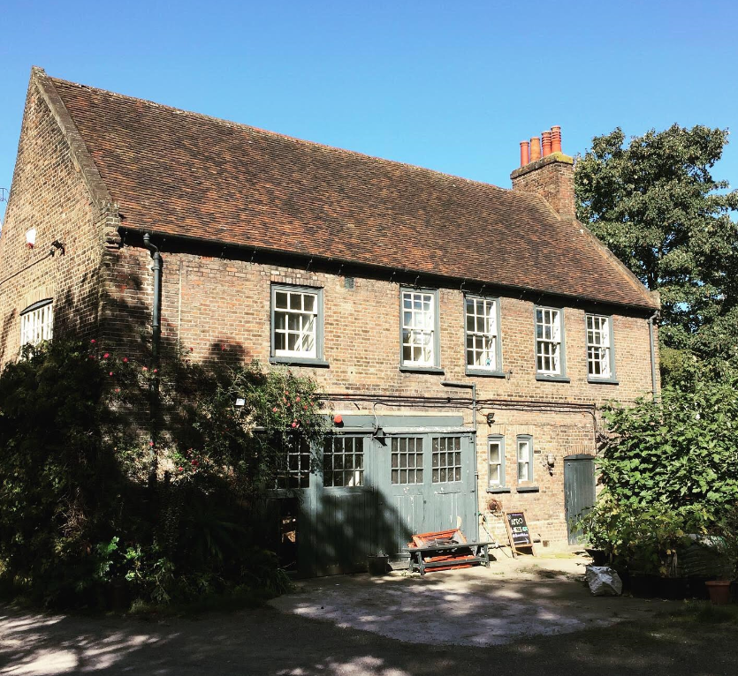

February 2020

Version 2



1. **Introduction**
   1. **Purpose of the Design and Access Statement**

This Design and Access Statement accompanies an application by the National Trust for listed building consent to:

1. Fix internal restraint straps to the south gable end and rafters
2. Install Helifix helibars to the south gable end

The Statement explains how the proposed development is a suitable response to the site and its setting.

* 1. **Structure and content of the document**

This Design and Access Statement is presented in three main sections. In section 2 the application site and its location are described. In section 3 the design development process is described. In section 4 reference is made to access.

1. **Application site and surroundings**

**2.1 Application site location**

Garden Cottage is situated within the grounds of Fenton House off Windmill Hill within the Church Row / Hampstead Grove conservation area. To the south and west, properties are in residential use. To the north and east lie the garden and rear yard of Fenton House. Figure 1 shows the location of the application site.

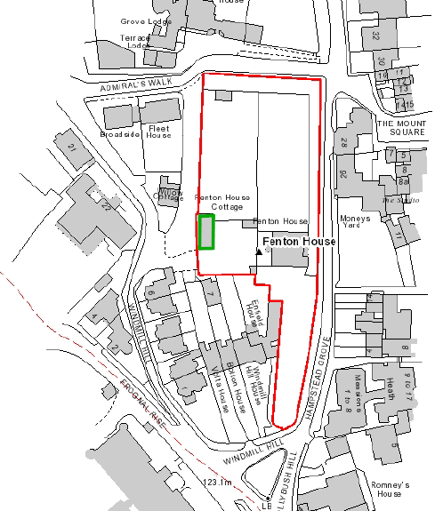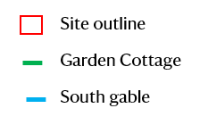

*Figure 1: Application site with Garden Cottage outlined in green, boundary of the   
Fenton House grounds in red and location of south gable in blue*

* 1. **Description of heritage assets**

The National Trust is the owner and custodian of Garden Cottage which is a Grade II listed building. In the Historic England listing description Garden Cottage is described as follows:

*Fenton House Garage*

*TQ2686SW HAMPSTEAD GROVE798-1/16/734 (West side)14/05/74 Fenton House Garage GV II*

*Stable building, including the old coachman's living quarters, to Fenton House (qv), now a garage. c1693, altered and modernised. Brown brick with plain 1st floor band. Tiled roof with C20 gables. 2 storeys 3 windows. Altered doorways. Flush framed sashes with exposed boxing. INTERIOR: not inspected.*

To the east of Garden Cottage is Fenton House which is a Grade I listed building. The walls surrounding Fenton House and Garden Cottage are Grade II listed.

Photographs 1 and 2 show views of Garden Cottage from the front and rear respectively.

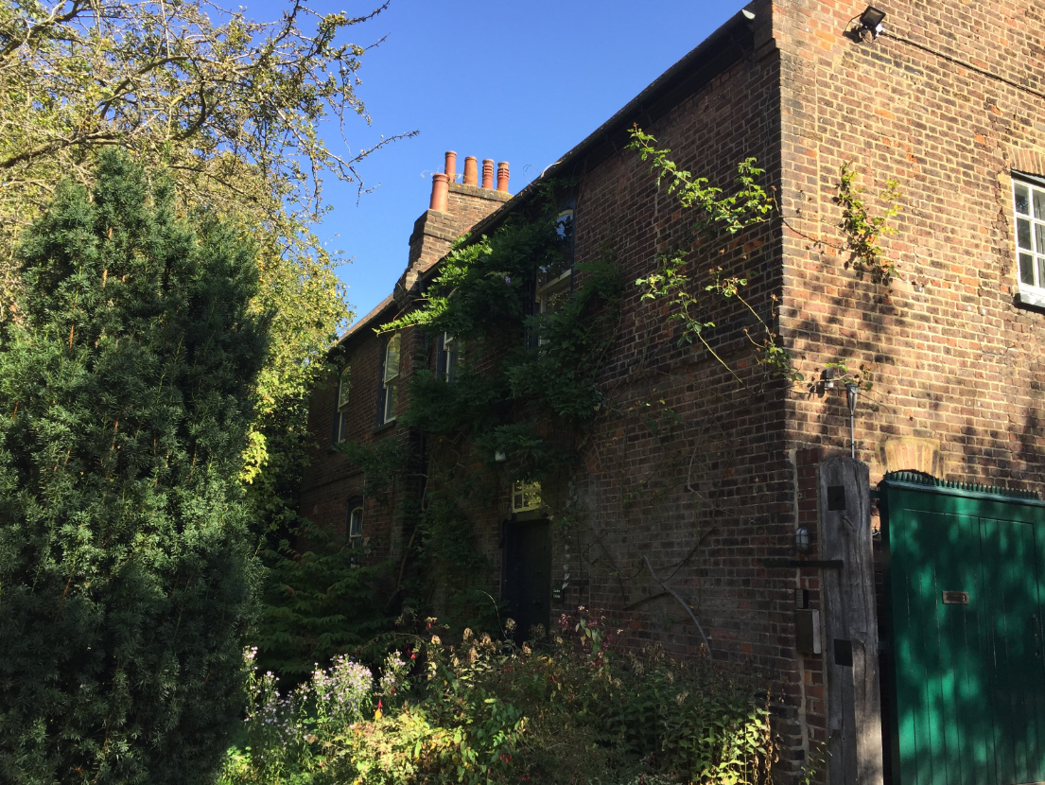

*Photo 1: West elevation of Garden Cottage taken from Windmill Hill*

 *Photo 2: East elevation of Garden Cottage taken from the yard of Fenton House*

1. **Design development**
   1. **Proposed design**

Listed building consent is sought for the following work which will be discussed in turn:

1. Fit internal restraint straps to the south gable end and rafters
2. Install Helifix helibars to the south gable end

**3.1.1 Fit internal restraint straps to the south gable end and rafters**

The south gable end is showing signs of movement as the apex is leaning (photo 3). The National Trust instructed a structural engineer to inspect the gable who confirmed that there is evidence of rotation of the uppermost part.

To provide support to this, the structural engineer has recommended fixing restraint straps plugged and screwed to the brickwork of the gable and secured to the underside of the first four common rafters on each slope with timber noggins between the rafters (see figure 3). To access the gable end, boarding will be laid on top of the attic joists to spread the workers weight and protect the lath and plaster ceiling below.

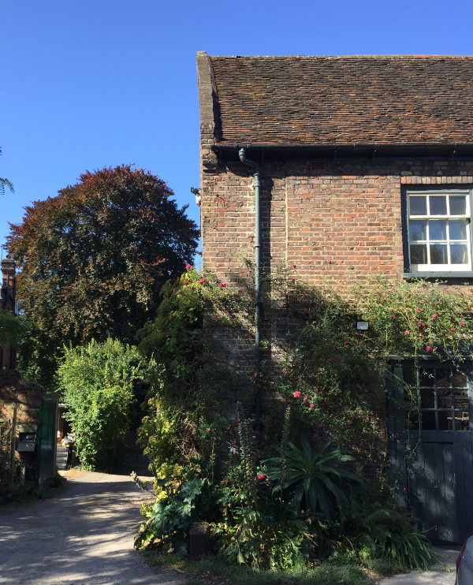  
*Photo 3: Leaning apex on the south gable end*

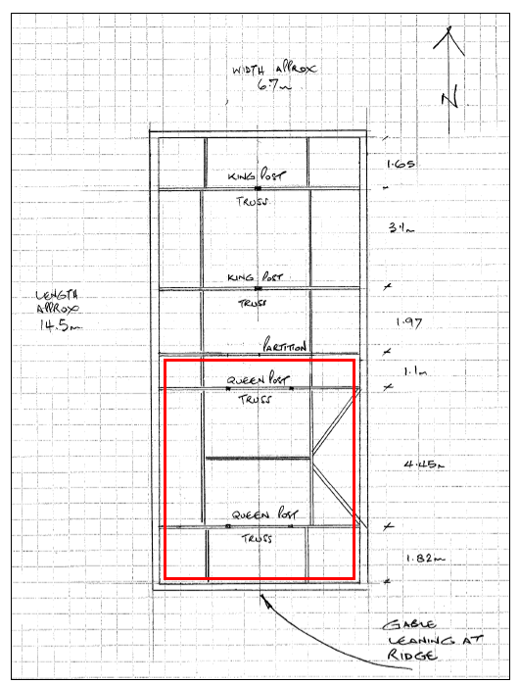  
*Figure 2: Roof construction with red outline showing location of attic joists*

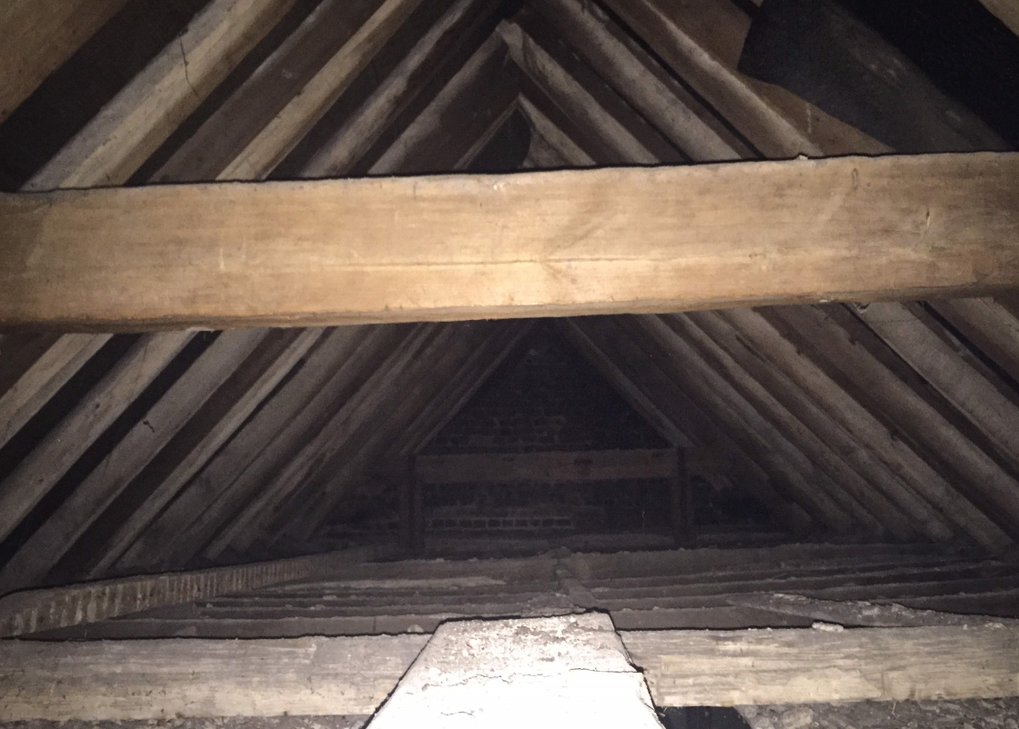  
*Photo 4: Looking south along the attic ceiling with the lath and plaster ceiling below.*

The straps will be stainless-steel 27.5mm x 2.5mm x 1500mm fixed to new treated softwood noggins between common rafters at approximately 360mm centres and 150mm leg plugged to brickwork of gable.

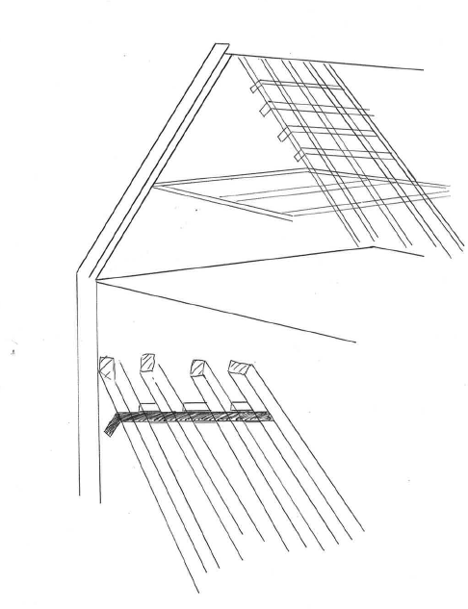

First floor flat

Leaning gable

Loft space

Attic space

Allow 4no. straps on both slopes above attic purlin fixed to wall, rafters and timber noggins between rafters.

*Figure 3: 4no. straps fixed in the attic space to provide restraint to the wall*

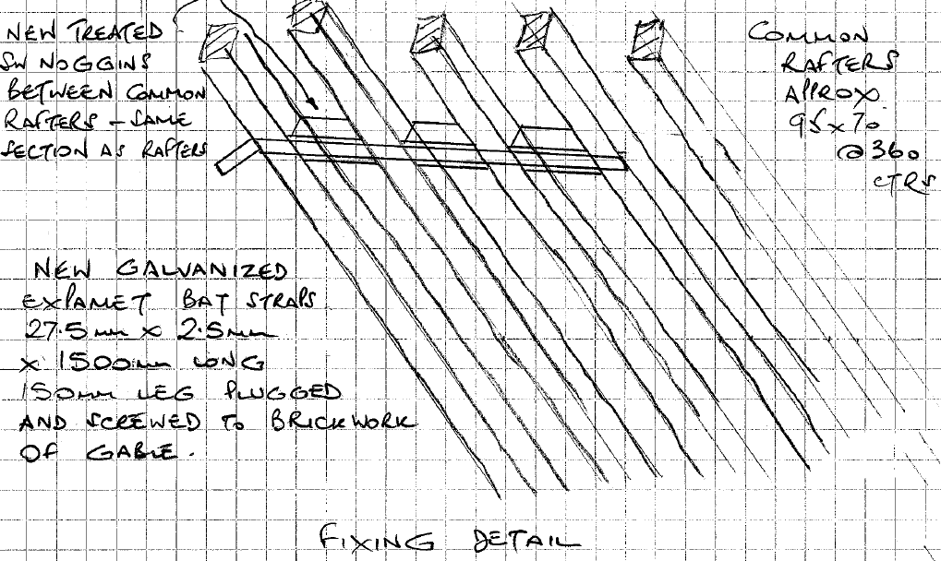  
*Figure 4: Fixing details*

* + 1. **Install Helifix helibars to the south gable end**

The gable end has several cracks which require repointing. To provide strength to the wall and prevent further cracking, the proposal is to install 4.5mm Helifix helibars every 5 courses across the cracks. These will be grouted in with a resin and lime mortar pointed over the top.

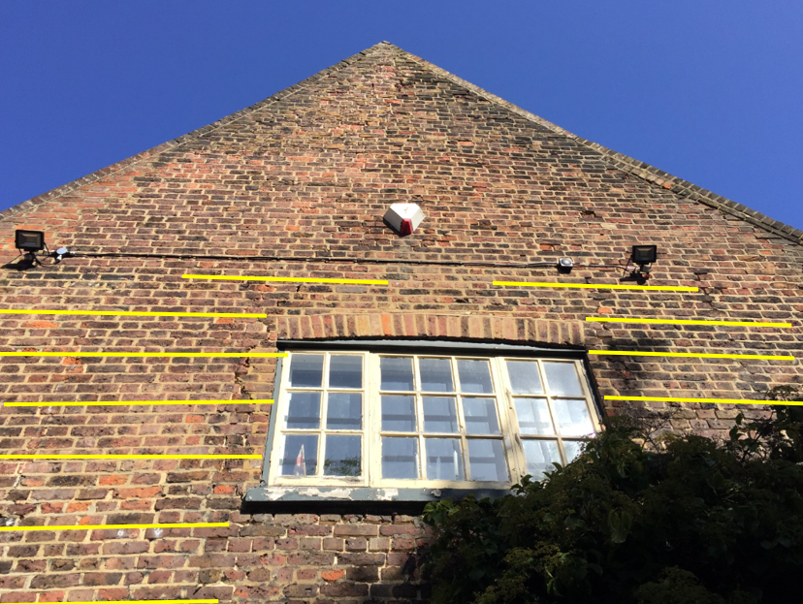  
*Photo 5: 4.5mm Helifix Helibar for masonry crack repair to be installed as per manufacturers specification every 5 courses across the south gable.*

**3.2 Design considerations**

Acting on the advice of a structural engineer with considerable experience of working in the heritage and conservation section, the National Trust considers that it has arrived at a good design solution for the repairs to the south gable wall.

The repairs are in keeping with the character of this heritage asset and are reversible. Further information about heritage considerations can be found in the Heritage Statement which accompanies the listed building consent application.

1. **Access**

The proposed works have no implications on existing pedestrian and vehicular access to the site.