Planning Department

2nd Floor, 5 Pancras Square  
c/o Town Hall, Judd Street

London  
WC1H 9JE

FAO: Ben Farrant

17th March 2020

Dear Sir / Madam,

**22 FROGNAL WAY, LONDON, NW3 6XE**

**APPLICATION FOR PLANNING PERMISSION FOR EXTERNAL LANDSCAPE PLATFORM LIFT**

We enclose an application for planning permission for the inclusion of an external platform lift to the landscape scheme at the above-named site.

The lift is a landscape/garden feature that is incorporated to the garden design. It has been illustrated on landscape masterplan details submitted (and approved) pursuant to Condition 3 and Condition 6 attached to the grant of planning permission (2015/3530/P, dated 9th March 2017) for redevelopment of the site.

As the illustrative information identifies it is very small scale and will not be distinguishable from the external landscape features that are incorporated.

This is very much a landscape feature that seeks to address the site constraints which limit access to the lower garden. The lift has always been part of the landscape proposal. It is likely infrequently used and solely for the purposes of the enjoyment of the garden.

The lift is frameless glass and stands at circa 1m in height. It will not be visible to those from outside of the garden.

The following details are enclosed:

* Planning application drawings including:
* Site Location Plan
* Proposed Site Plan
* Platform lift plans
* Platform lift elevations
* Landscape masterplan
* Illustrative plan, section and elevation drawings
* Design and Access Statement

We trust that this is sufficient for the Council to register this application and to consider these proposals. Please contact Matthew Gibbs with any queries.

Yours faithfully,

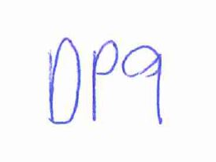

**DP9 Ltd**