**Design and Access and Heritage Statement.** March 2020

### Introduction

This design and access statement has been prepared in support of the proposed works at 3 Hampstead Hill Gardens, London. The proposals are for alterations to the ground floor to add a spiral wine store under the existing floor level with an access hatch.

### The Site and Location Assessment

### 3 Hampstead Hill Gardens (also known as Charlecote) is a grand, detached, mid-late 19th Century, Grade II listed residence located within the Hampstead Conservation Area (see CH’s OS Extract). Nos 1-11 Hampstead Hill Gardens form a group of detached buildings similar in nature, scale and character. The massing of the five bedroom dwelling comprises 2 No two storey with attic blocks arranged corner to corner with one and two storey appendages to the rear. The whole is constructed in red brick under a substantial tiled roof with coved cornicing at eaves and tall brick slab chimneys.

### Proposed Development

The proposals are to install a spiral wine store within the dining room located to the rear of the ground floor of the dwelling. The dining room was an extension to the main building in the 1950’s although we cannot find details of the extension on the planning portal. The store is a watertight, pre-cast cylindrical system that is sunk into the ground below the internal floor level. The cellar is naturally ventilated via a passive system, this is provided by two pipes which will run to the external wall of the property. Submitted with the application is a full structural report to ensure the cellar can be installed without disturbing the existing fabric of the building. The report confirms that the cellar should be install a minimum of 150mm away from any structural wall or foundation to ensure no damage is done. The location of the cellar has been chosen to ensure it has been kept away from the existing structure and there will be no adverse impact on the building.

The Spiral Cellar company have installed their product into a number to similar listed properties and are very conscious of the importance of the surrounding structure and would not proceed if they were not 100% happy with suitability of the existing structure.

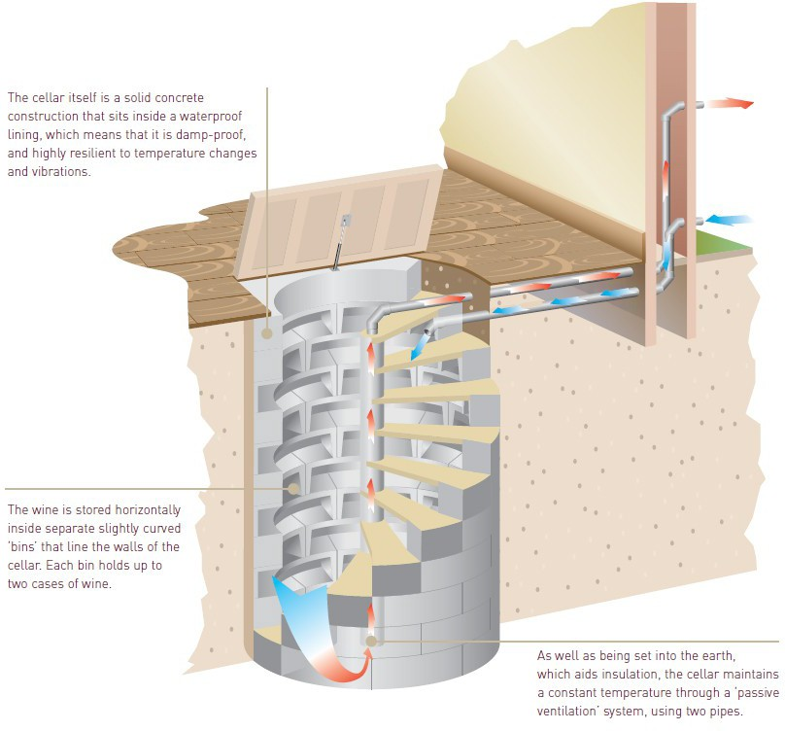

Spiral Cellars Diagram

### Listing Description:

Name: 3 Hampstead Hill Gardens

List Entry Number: 1378699

Location: 3 Hampstead Hill Gardens Date First Listed: 14-May-1974

Description: TQ2685NE HAMPSTEAD HILL GARDENS 798-1/27/763 Nos.3 AND 3A 14/05/74 (Formerly Listed as: HAMPSTEAD HILL GARDENS Nos.1 & 2, Nos.3-5 (consec), Nos.7-11 (odd)) GV II

Detached studio house, now sub-divided. 1877-8 right hand portion, extended 1881 to left. Red brick with plain 1st floor band. Tiled hipped roofs with segmental pedimented dormers, very tall slab chimney-stacks and coved eaves cornice. EXTERIOR: 2 storeys and attics. Irregular front 2 windows to each portion. Right hand portion built as a studio with chambers beneath. Round-arched rubbed brick entrance with Ionic pilasters supporting a pediment; panelled door with fanlight. To right, slightly projecting bay with Venetian type transom and mullion windows in rubbed brick cases to ground and 1st floor; 1st floor window having a festooned frieze and pediment; to right a narrow window. Pedimented dormer with oculus supported by scrolled consoles. Above entrance, a rubbed brick plaque dated 1877. Left hand bay projects, base of right-hand bay converted to a garage. Gauged brick flat arches to transom and mullion casements, those to 1st floor with undulating brick aprons. All windows with small leaded panes. INTERIOR: not inspected at time of survey but noted to have a fine contemporary staircase.

### Heritage

The site has previously gained planning permission for Installation of external lighting (two wall lights to ground floor rear, one to side elevation at first floor level, two to front elevation at ground level) plus replacement of garage door and internal alterations, including alterations to lighting and layout.(Planning reference 2013/7268/L). The ground floor is of modern construct and will have little impact of the existing architecture or structure of the dwelling. Like many of the houses of this type it has modified and modernised during its life it ensure the building caters for the need of the inhabitants. The proposed wine store will be installed in the entrance hall on the ground floor. The proposed wine store will be a non-habitable space contained completely below the level of the existing ground floor. The adjacent flooring will be protected at all times to ensure no damage is done to this area. When the store has been installed the flooring will be relayed with a new trap door located as per the drawings.

### Development Amount

The proposed works will not increase the floor area of the dwelling. store depth – 3.00m

store diameter – 2.3m

### Design Solution

The **Layout** of the dwelling will be as existing, the only minor alteration being the addition of the wine store within the dining room. The access door to the store will have a minimal impact on the dwelling. See Spiral Cellars data sheets for construction details, Appendix A.

The **Scale** of existing dwelling will remain as existing.

There are no **Landscaping** proposals as part of these works.

**Appearance** of the elevations will not be changed by the proposed works. To the front elevation two small vents are to be located adjacent to the front door, these will provide the passive ventilation as described above.

Access to the dwelling will be unaffected by the proposals as set out above. The new staircase within the store will be well lit and for occasional use only to the non-habitable space.

### Summary

The proposed alterations as set out above will have no impact on the building and a minimal effect on the wider dwelling. The store is a modest space thereby preserving the character and appearance of the listed building. The owners of the property wish to ensure all works are completed to the highest standards with the correct material and finishes.

## Appendix A

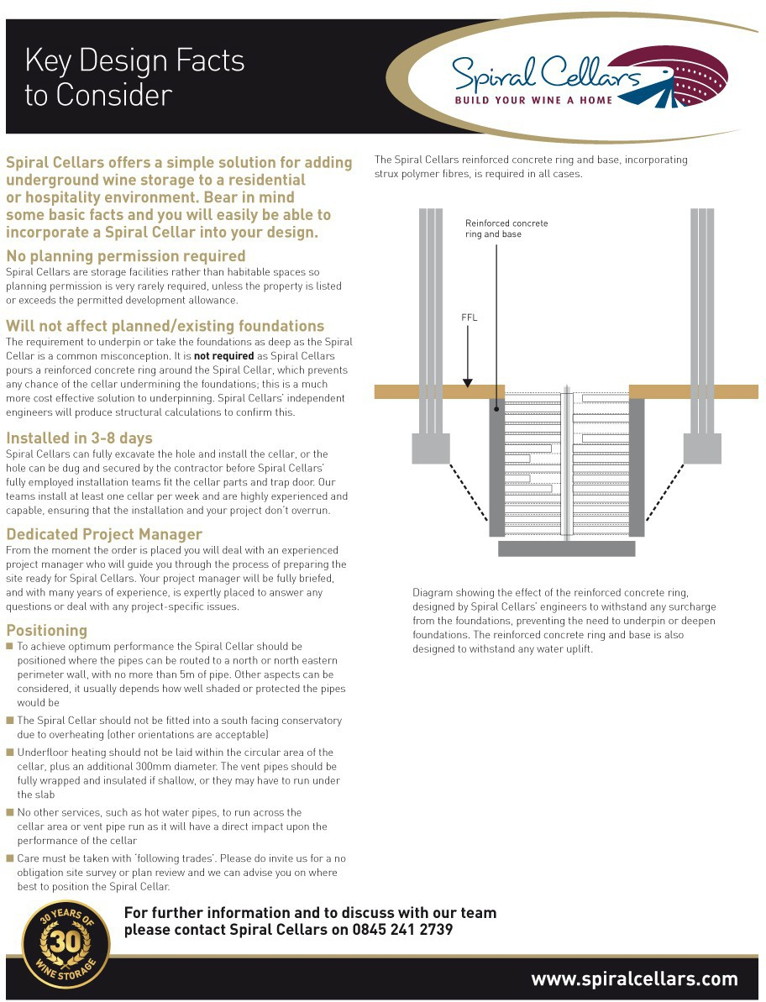



Spiral Cellars Ventilation Pipe Exit Options

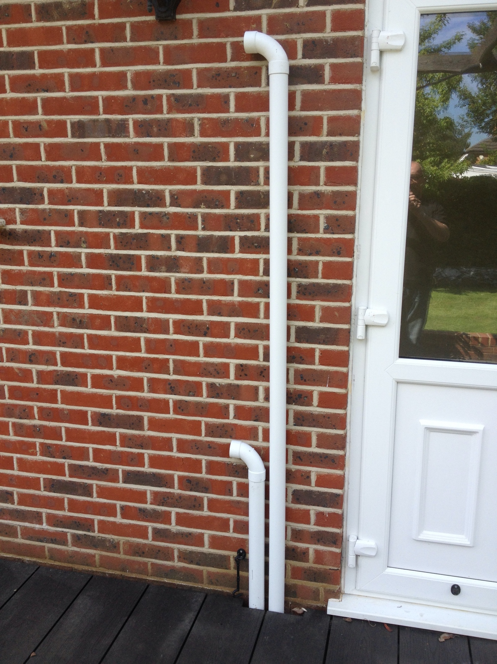page1image25719184

Standard External Detail – Plastic Pipes

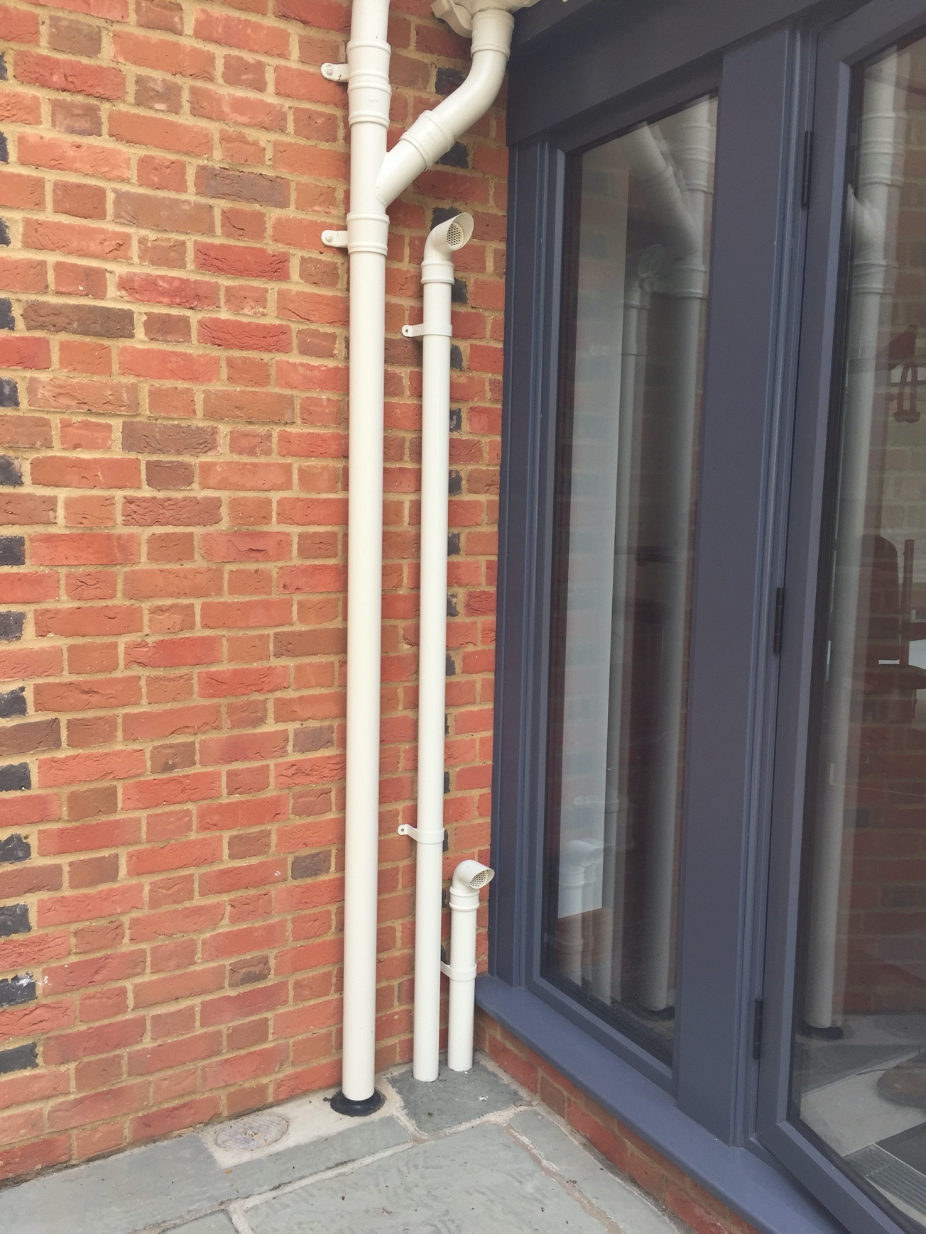

Special External Option – Cast Aluminium Pipes painted to match existing furniture

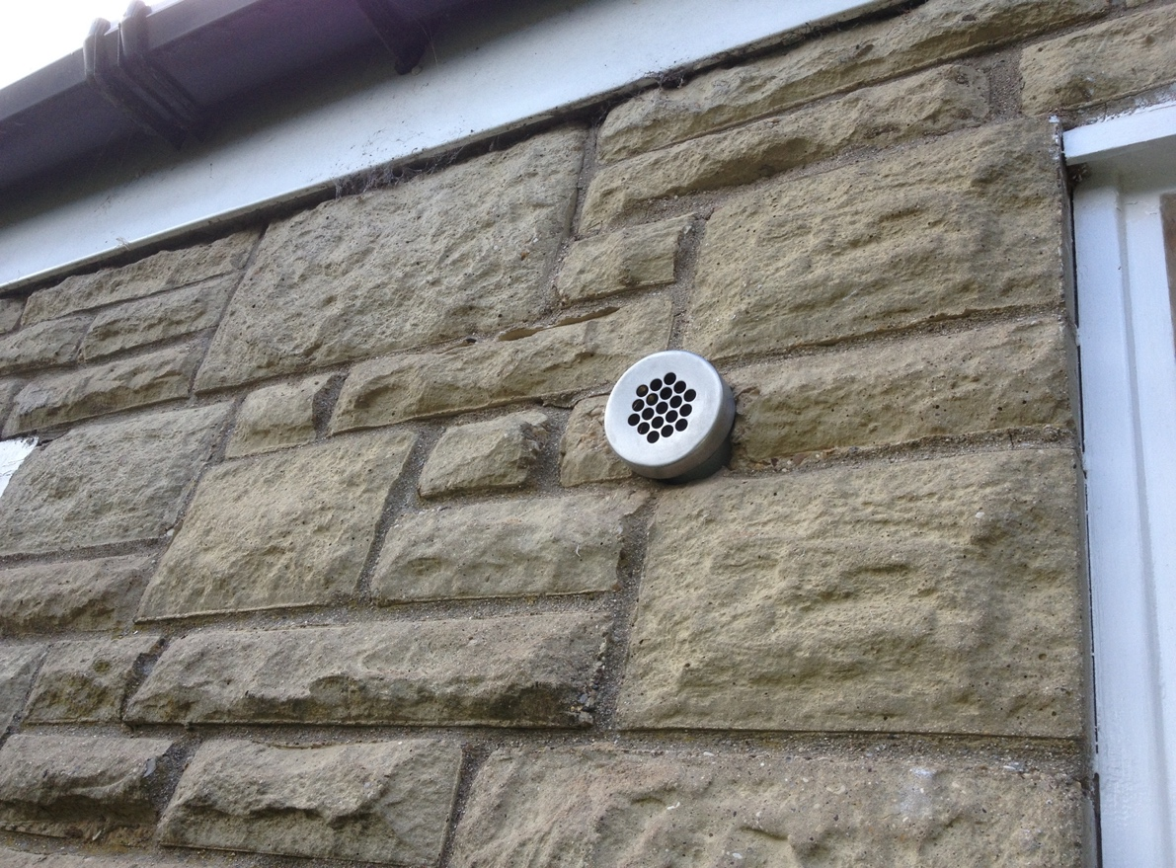

Concealed Option features 2 x Stainless Steel Ends 1 @ 2000mm from Ground Level  
1 @ 500mm from Ground Level

Can be painted to match existing Furniture

