**BELSIZE FIRE STATION**

[Be the first to contribute](https://historicengland.org.uk/listing/the-list/list-entry/1379277#contributions-banner)

**Overview**

Heritage Category:

Listed Building

Grade:

II*

List Entry Number:

1379277

Date first listed:

14-May-1974

Date of most recent amendment:

12-Nov-2009

Statutory Address:

BELSIZE FIRE STATION, 36, LANCASTER GROVE

**Map**

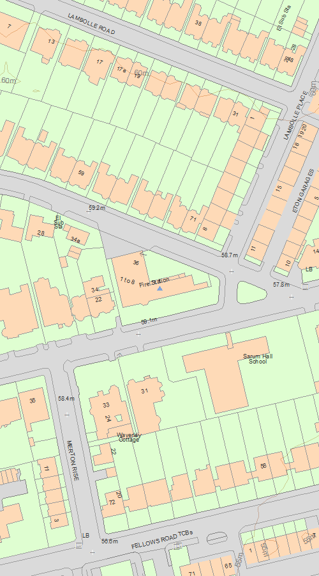

© Crown Copyright and database right 2020. All rights reserved. Ordnance Survey Licence number 100024900.  
© British Crown and SeaZone Solutions Limited 2020. All rights reserved. Licence number 102006.006.  
Use of this data is subject to [Terms and Conditions](https://historicengland.org.uk/terms/website-terms-conditions/).

The above map is for quick reference purposes only and may not be to scale. For a copy of the full scale map, please see the attached PDF - [1379277.pdf (opens in a new window)](http://mapservices.HistoricEngland.org.uk/printwebservicehle/StatutoryPrint.svc/421143/HLE_A4L_Grade|HLE_A3L_Grade.pdf)

The PDF will be generated from our live systems and may take a few minutes to download depending on how busy our servers are. We apologise for this delay.

This copy shows the entry on 25-Feb-2020 at 14:07:10.

**Location**

Statutory Address:

BELSIZE FIRE STATION, 36, LANCASTER GROVE

The building or site itself may lie within the boundary of more than one authority.

County:

Greater London Authority

District:

Camden (London Borough)

National Grid Reference:

TQ 27257 84525

**Details**

798-1/51/1012 LANCASTER GROVE 14-MAY-74 36 Belsize Fire Station (Formerly listed as: LANCASTER GROVE BELSIZE FIRE STATION)   
  
GV II* Fire station 1912-5, by Charles Canning Windmill of the Fire Brigade Branch of the London County Council Architects Department.   
  
MATERIALS: Brick with tile roof and tall brick chimney-stacks. Stone-clad appliance bay frontage and raised basement of the accommodation range. Tile-hung dormer windows, tile lintels and brick relieving arches to other windows. Decorative metalwork castellated hoppers and cresting along the gutters of the roof terrace and appliance bays.  
  
PLAN: L-shaped with accommodation range to Eton Avenue and appliance room facing Lancaster Grove, large brick tower at the hinge for drills and hose-drying. EXTERIOR: A clever interpretation of an Arts and Crafts-style house, adapted to meet the requirements of the fire brigade. The elevation to Eton Avenue could be mistaken for a terrace of cottages with its tall chimneys, casements with leaded lights, canted timber bays sitting just under the deep eaves, and ground-floor bay with moulded brick mullions and transoms. Its rear, facing the yard, is a more typical LCC design with deck-accessed fireman's flats. The elevation to Lancaster Grove accommodates the three appliance bays, the most functional element of a fire station, in a similarly rustic design with a steeply pitched roof that flares at the low-hanging eaves and tall hipped dormer windows. Also impressive is the monumental tower, which does not disrupt the domestic character despite its height and breadth; the segmental arched and lattice work recessed panels in the brickwork soften its bulk.   
  
INTERIOR: The appliance room retains its original watch-room and cream glazed brick wall. Stairwell also has cream glazed bricks; stair with metal balustrade and sliding-pole chamber and doors survives intact; watch tower retains its iron spiral stair and hose-drying chamber. The first-floor single men's dormitory, now the gym, has an open truss roof and a second pole house which leads directly to the appliance room. Next to this room, the former single men's mess room, now the kitchen, has an original fireplace in russet glazed brick with overmantle inlayed with Delft-style tiles. The ground floor recreation room has the original panelling and fireplace. There are also numerous original fireplaces and timber doors in the accommodation sections of the station. Even to the detail of numbered pegs in the gear room, the survival of original features is notable.   
  
HISTORY: Belsize Fire Station was constructed in 1912-5, at the end of the most creative period of design in the Fire Brigade Branch of the London County Council Architects' Department, during which the Brigade's most characterful buildings were built. Since 1896, new stations were designed by a group of architects led by Owen Fleming and Charles Canning Winmill, both formerly of the LCC Housing Department. They brought the avant-garde approach which had evolved for new social housing to the Fire Brigade Division, as the department was called from 1899. While some stations were built to standardised plans, others were highly experimental, sensitive to local context, and designed to a bespoke plan. The exemplars from the earliest years are Perry Vale, Euston, East Greenwich and West Hampstead. This is one of the last designs produced by the Department before the outbreak of WWI, yet (no doubt due to Windmill's authorship) it is more characteristic of the earlier stations in its distinctive architecture, attention to detail, and sensitivity to its setting. The station occupies a prominent site, on the apex of two roads lined with high-quality Edwardian houses and the sensitivity of the design to this context is marked. The generous plot size accommodates the fireman's flats in a separate two storey range and the view from the junction is strikingly picturesque.   
  
The area had formerly been served by stations at St John's Wood (built 1870), Hampstead village (built 1874) and West Hamptead (built 1901); this station replaced that at St Johns Wood. The foundation stone for Belsize Fire Station records that the station was opened on the 22 May 1915 by Percy C Simmons, Chairman of the Fire Brigade Committee of the LCC.  
  
SOURCES: Andrew Saint, London's Architecture and the London Fire Brigade, 1866-1938(Heinz Gallery RIBA, Exhibition Catalogue, 1981) Will Reading, L.C.C. Fire Stations, 1896-1916, their History, Condition and Future Use (Architectural Association, Graduate School, 2007) John B Nadal, London's Fire Stations (Huddersfield, 2006) Hampstead: Public Services, A History of the County of Middlesex: Volume 9: Hampstead, Paddington (1989,138-145 Historic photographs held by the London Fire Brigade Museum.   
  
REASONS FOR DESIGNATION: Belsize Fire Station is designated at Grade II* for the following principal reasons: * It is one of the most distinctive and original of a remarkable series of fire stations built by the LCC between 1896-1914, each executed to a bespoke design, which are widely admired as being among the most accomplished examples of LCC civic architecture of this rich and prolific period; * High architectural quality - as manifest in design, detail, materials and sensitivity to context; * It is also one of the most intact, having not been extended externally, and retaining its original timber appliance bay doors, plan form and numerous other features; * In the wider context of Edwardian architecture, this station is an exemplar of the use of a domestic idiom, the Arts and Crafts style, in a municipal building; * The building groups well with its neighbours in this area noted for its concentration of distinctive Arts and Crafts houses, including the many listed houses on Eton Avenue.

**Legacy**

The contents of this record have been generated from a legacy data system.

Legacy System number:

478645

Legacy System:

LBS

**Sources**

**Books and journals**  
The Victoria History of the County of Middlesex: Volume IX, (1989), 138-145  
Nadal, J, Londons Fire Stations, (2006)  
Reading, W, L C C Fire Stations 1896-1916 their History, Condition and Future Use, (2007)  
Saint, A, Londons Architecture and the London Fire Brigade 1866-1938, (1981)

**Legal**

This building is listed under the Planning (Listed Buildings and Conservation Areas) Act 1990 as amended for its special architectural or historic interest.

End of official listing