**NUMBERS 1-7 AND ATTACHED RAILINGS AND LAMP HOLDER**

[2 contributions](https://historicengland.org.uk/listing/the-list/list-entry/1244596#contributions-banner)

**Overview**

Heritage Category:

Listed Building

Grade:

II

List Entry Number:

1244596

Date first listed:

24-Oct-1951

Date of most recent amendment:

11-Jan-1999

Statutory Address:

NUMBERS 1-7 AND ATTACHED RAILINGS AND LAMP HOLDER, 1-7, BEDFORD ROW

**Map**

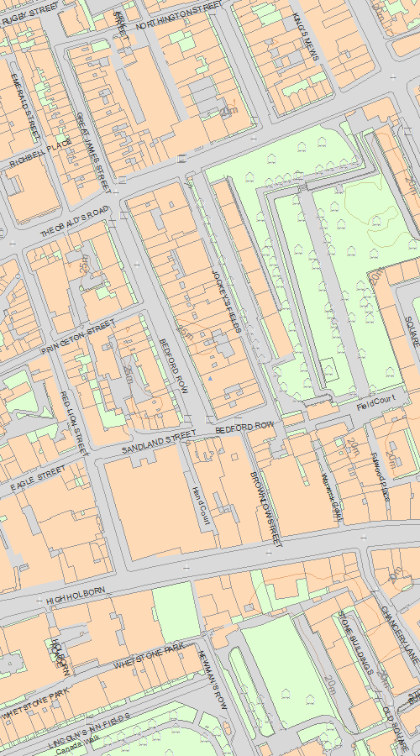

© Crown Copyright and database right 2020. All rights reserved. Ordnance Survey Licence number 100024900.  
© British Crown and SeaZone Solutions Limited 2020. All rights reserved. Licence number 102006.006.  
Use of this data is subject to [Terms and Conditions](https://historicengland.org.uk/terms/website-terms-conditions/).

The above map is for quick reference purposes only and may not be to scale. For a copy of the full scale map, please see the attached PDF - [1244596.pdf (opens in a new window)](http://mapservices.HistoricEngland.org.uk/printwebservicehle/StatutoryPrint.svc/408000/HLE_A4L_Grade|HLE_A3L_Grade.pdf)

The PDF will be generated from our live systems and may take a few minutes to download depending on how busy our servers are. We apologise for this delay.

This copy shows the entry on 10-Mar-2020 at 14:04:44.

**Location**

Statutory Address:

NUMBERS 1-7 AND ATTACHED RAILINGS AND LAMP HOLDER, 1-7, BEDFORD ROW

The building or site itself may lie within the boundary of more than one authority.

County:

Greater London Authority

District:

Camden (London Borough)

National Grid Reference:

TQ 30848 81737

**Details**

CAMDEN  
  
TQ3081NE BEDFORD ROW 798-1/101/65 (East side) 24/10/51 Nos.1-7 (Consecutive) and attached railings and lamp-holder (Formerly Listed as: BEDFORD ROW Nos.1-9 AND 11-17 (Consecutive))  
  
GV II  
  
7 terraced houses. 1717-18. Built by Robert Burford, carpenter, on land granted to him and George Devall, plumber, in 1716 by Margaret Skipwith. Brown or yellow stock brick with some refacing of upper storeys. Brick bands at 1st floor level. 4 storeys and basements. 3 windows each. Gauged red brick arches and dressings to flush frame sash windows. Parapets. Nos 1-4, wood doorcases with pilasters carrying entablature, patterned fanlights and panelled doors. Nos 5-7, wood Doric doorcases, mutule open pediment, patterned fanlights and panelled doors. Some houses with original lead rainwater heads inscribed 1718. INTERIORS: No.1 with cornices and ground-floor buffet alcove. Panelled dados. Stair with stick balusters, grouped at ground-floor newel. Upper floors not inspected. No.2. C19 sashes. Ground floor with egg-and-dart cornice, buffet alcove, panelled dado, C18 fireplace. Staircase much restored. Nos 3, 4 and 5 in single occupancy with suspended ceilings. Not inspected. Nos 6 and 7 not inspected but noted to retain original staircases, first floor shutters and box cornices. SUBSIDIARY FEATURES: attached cast-iron railings to areas, some with urn or torch flambe finials. No.1 with wrought-iron lamp-holder.   
  
  
  
  
  
Listing NGR: TQ3084881746

**Legacy**

The contents of this record have been generated from a legacy data system.

Legacy System number:

476649

Legacy System:

LBS

**Legal**

This building is listed under the Planning (Listed Buildings and Conservation Areas) Act 1990 as amended for its special architectural or historic interest.

End of official listing