**OBJECTION TO 2019/5835/P 4B Hampstead Hill Gardens, NW3 2PL – J.Williams**

I am writing to object strongly to this application. I own (since 2002) and live in the attached property, 4A and this will be seriously affected by the development. The applicant seeks to demolish 4B and rebuild this two storey house on four levels, with a basement and a third floor. A planning consultant, Peter Kyte ('Enabling') has lodged a well-evidenced objection on my behalf. This gives attention, for example,to the ways in which the proposed building fails to meet the standards set out in London and Camden planning policies and notes that permission could create a precedent both as regards height and infilling. I here highlight some matters which are of particular concern to me.

The house, built in 1955, was carefully designed to make an attractive but unobtrusive addition to the road. The erection of No 4B, attached to 4A on the site of the original garage extended the building line at the rear to an extent over-shadowed No 4's patio garden and from the road, reduced the attractiveness of the original building, but did maintain the two-storey height and was built in similar bricks.

The proposed building, doubling the volume of the existing one and ostentatiously out of keeping in bulk, height and style with the attached dwelling, downgrades 4A to an anomaly in the street, little more than an outbuilding.

The street map, below (taken from the current application document) illustrates the position of 4A and 4B in the road and its relationship with nearby buildings. The two storey semi-detached buildings, set back from the footpath, with the hornbeam and flower bed of 4A, creates a quiet pause where the sharp bend effectively divides the road in two.

The height of the original house, 4A, was clearly kept low so as not to impinge of the outlook of the listed buildings opposite, Nos 3, 5, 7, 9, 11, and No 4 which faces the rear of the house. The diagram below shows the position of 4A and 4B in this curved street

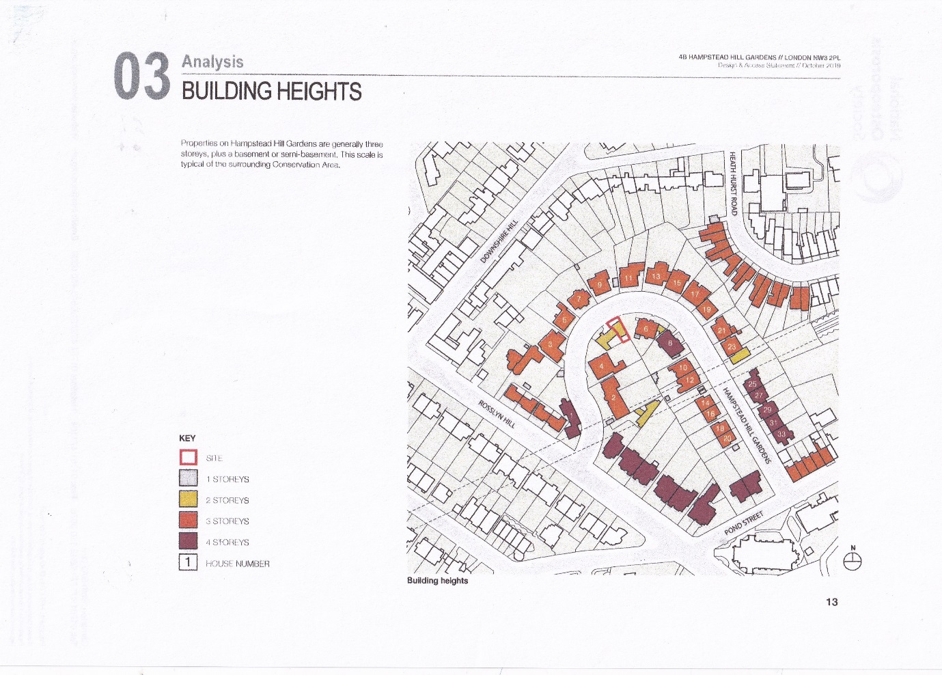

Image (A) shows the relationship between 4A and 4B (beyond the white wall) on the sharp bend in the road between 6 and 4. Fig(B) shows 4A and 4B in the context of the road, facing the listed houses, Nos 5,7,9 and 11, with their elegant, understated design. The proposed new building, with its third storey, attention-demanding façade and overall bulk dwarfing 4A, will change the harmonious character of the road

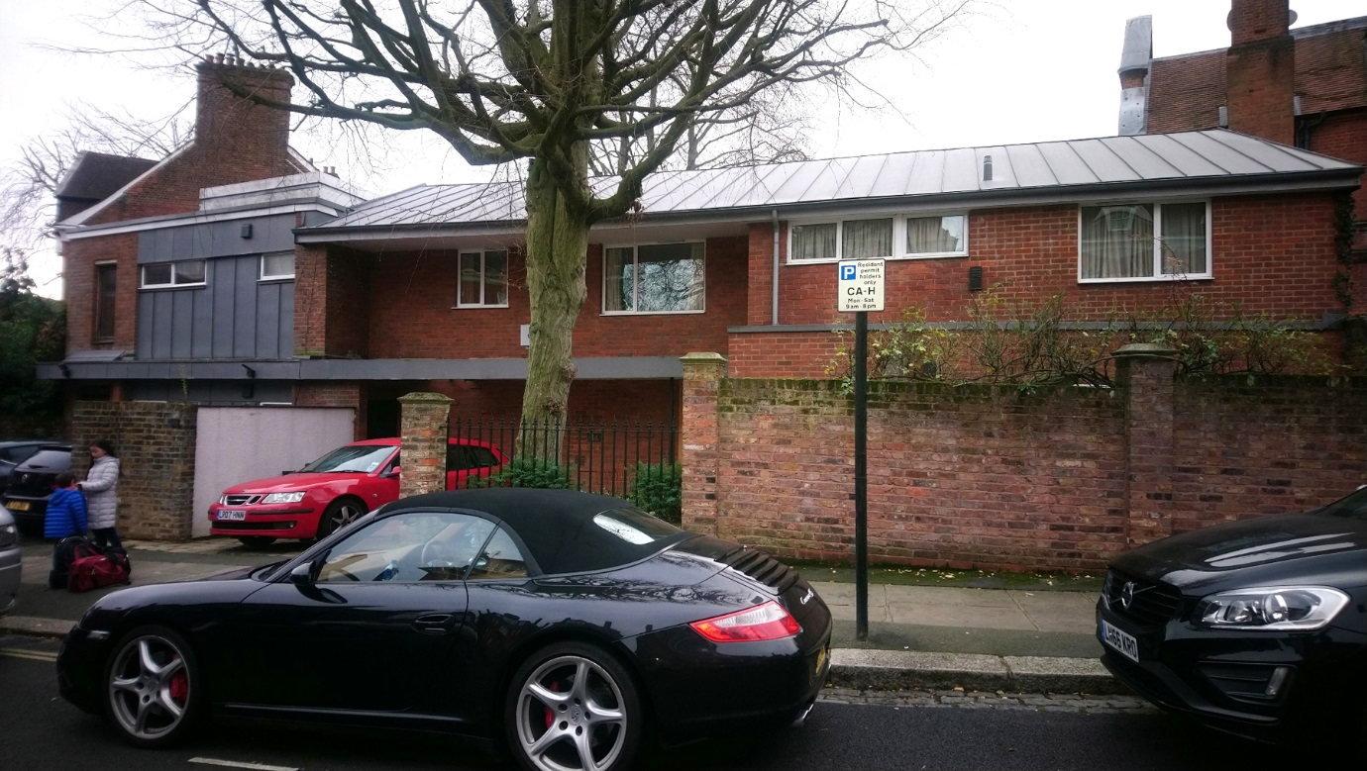

A) 4B and 4A showing current proportions and position on sharp inner curve of the road.

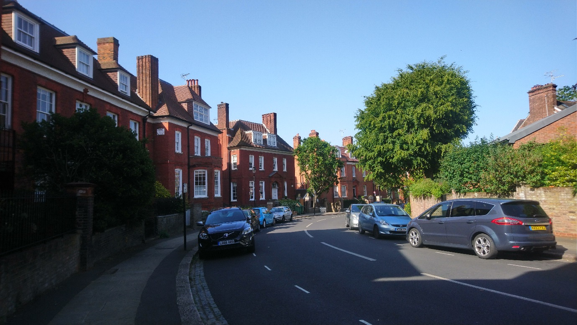

Hampstead Hill Gardens 4A (flank wall on rt) on inner curve opp. Nos 5,7,9,11

**Effect of proposed building on living areas**

All the living space on the ground floor of 4A looks onto the patio garden, which is accessed by large French windows and a glazed door. This small, attractive area affords the only access to sky and daylight; it has furniture and should be regarded as a valuable amenity and for policy purposes be treated as a room. A bulky three storey building, almost touching the massive copper beech (in No.6, see photo), will result in this key area being hemmed in and darkened and the outlook blocked.

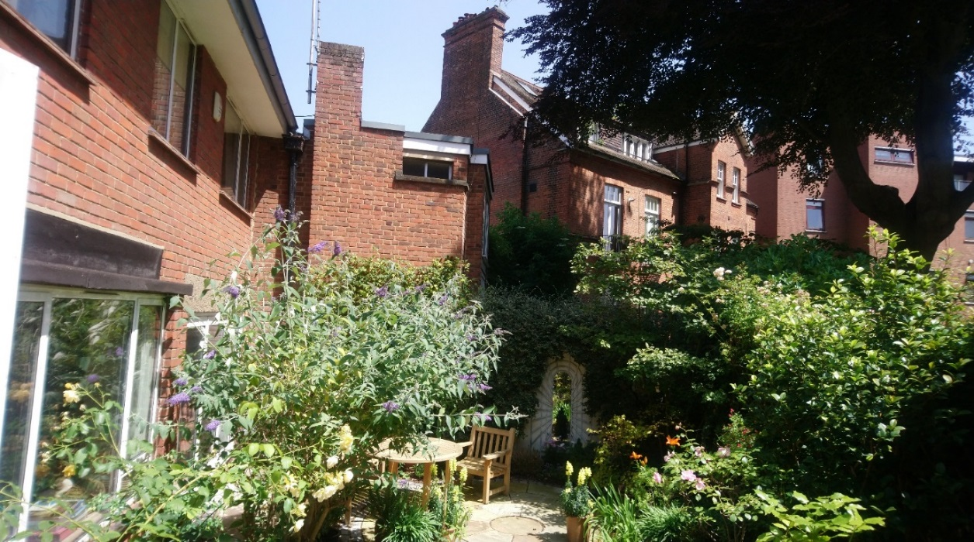

As an aside, the disproportion between 4A and 4B, the massing and the commercial design will inevitably and permanently lower the attraction and adversely affect the value of 4A.

**Basement**

The likelihood of substantial damage to 4A as a result of the major excavation) is a matter of considerable concern. 4A has suffered subsidence damage and is affected by drought. Conclusions about the suitability of the site for excavation should be based on boreholes from the site of 4B but those on which the BIA is based relate to a survey of No 1 HHG, wholly unrepresentative of the specifics of 4B. The whole area has subsidence issues.

**Conclusion**

There is certainly an argument for rebuilding 4B and an attractive and appropriate design and mass could well enhance the street, but only if

* the new build were of the same height as 4A
* the design were to be sympathetic, with regard to scale, style and materials with the dominant property at 4A, to which it is attached,
* the patio garden of 4A continued to provide an attractive outlook, with the benefit of daylight and skyscape and be a pleasant extension of the living space of the house
* the building did not reduce the light and block the outlook from some living areas,
* maintained the present foot print at the front of the building thus keeping a similar distance from the footpath as the other houses in the road,
* enhanced and preserved the character and appearance of the area.
* the basement were to be smaller, kept strictly within the footprint of the existing building and not cause material damage to 4A or neighbouring properties.