

**Job Profile**

**Customer Service Officer**

**Level 2, Zone 2**

***It is for use during recruitment, setting objectives as part of the performance management process and other people management purposes. It does not form part of an employee’s contract of employment.***

**Role Purpose**

Represent the Council by providing the first point of contact to customers through multiple contact channels; phone, email, face to face and social media. The role will provide advice and apply sound judgement in assessing customer needs across all service areas. This includes resolving customer queries directly or escalating appropriately where necessary.

**Example outcomes or objectives that this role will deliver:**

**You’ll be able to…**

* Deliver a high level of customer services experience – in accordance with the ‘Contact Camden way’ (quality framework)
* Be multi-skilled and have a good/ excellent knowledge of the majority of services within their core group e.g. people, place and business
* Deliver high quality services across a number of core service areas
* Work seamlessly across a number of customer service access channels; telephony, face to face, twitter, emails and web
* Move across services and channels to respond proactively to changes in customer demand, this includes being flexible to work our core shift patterns; 8am-4pm, 9am-5pm or 10am-6pm
* Make high quality decisions on the frontline to ensure that enquires are resolved at the first point of contact with minimal supervision
* Manage complex cases and case-work with a high skill level
* Contribute to service improvements through ideas and participating in projects as required
* Provide support to entry level and other less experienced Customer Services Officers

**People Management Responsibilities:**

No line management (*Apprentices - where undertaking existing staff development opportunities)*

**Key relationships:**

* Contact Camden Team Managers, Senior CSO’s and other CSO’s, Customer Service Manager, Performance Coaches & Performance Analysts

**Work Environment:**

The job is office based at Contact Camden’s Contact Centre located at The Crowndale Centre, Mornington Crescent.

Travel to King’s Cross office may be required.

**Technical Knowledge and Experience:**

* Delivering an excellent customer service experience by providing advice and wherever possible resolution at the first point of contact
* Maintain accurate records and information at all times relating to the call/service
* Be customer focussed, empathetic and understanding when dealing with challenging situations
* Be flexible and adaptable to change including technological changes and changes in channel demand from customers
* Take ownership of customer service delivery and outcomes across the department using relevant and appropriate systems
* Demonstrate a good understanding of the importance of working collaboratively with other teams across the council in order to build relationships and provide an effective seemless service to the customer.
* Desirable – general understanding of relevant public service mandates – e.g. customer focus, personalisation, safeguarding etc

**The Camden Way for teams**

'The Camden Way' is how we describe the way we work in Camden. The Camden Way can be applied to be individuals and teams. This is a useful tool to support team conversations that can identify areas for development, facilitate conversations and help teams work in a positive way.   
  
The five ways of working are:

1. Deliver for the people of Camden
2. Work as one team
3. Take pride in getting it right
4. Find better ways
5. Take personal responsibility

For further information on the Camden Way please visit: <https://camdengov.referrals.selectminds.com/togetherwearecamden/info/page1>

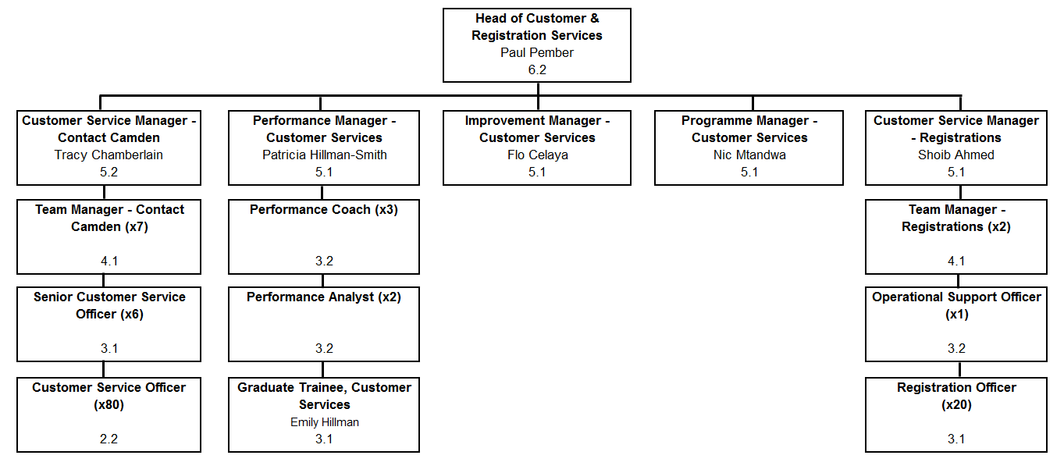**Structure Chart:**