ARichardson, Architect |  | 27 East Field, Oxford OX3 7SH  07860 919562  anthonyrichardson2@hotmail.co.uk

Design and Access Statement
Single storey rear extension;
76A Belsize Road
London
NW6 4TG
17 February 2020
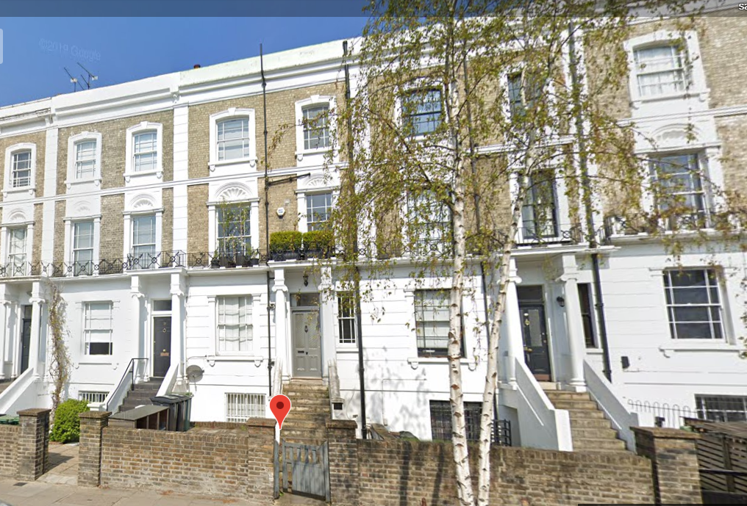
No.78 No.76A No.74
Introduction
This Design and Access Statement has been prepared in support of a householder planning submission for a single storey rear extension. The extension will be 2.2m deep to match the corner of the rear wall of the neighbour No.78. All materials will match the existing and the flat roof will be grey felt.
Drawings:
933-01 Location Plan (A3) 1to1250 and Block Plan 1to500
933-02 Block Plan (A3) 1to500
933-03 Existing Lower Ground Floor Plan (A3) 1to50
933-04 Existing Upper Ground Floor Plan (A3) 1to50
933-05 Existing Section (A3) 1to50
933-06 Existing Rear Elevation (A3) 1to50
933-07 Existing Front Elevation (A3) 1to50

933-08 Proposed Lower Ground Floor Plan (A3) 1to50
933-09 Proposed Upper Ground Floor Plan (A3) 1to50
933-10 Proposed Section (A3) 1to50
933-11 Proposed Rear Elevation (A3) 1to50

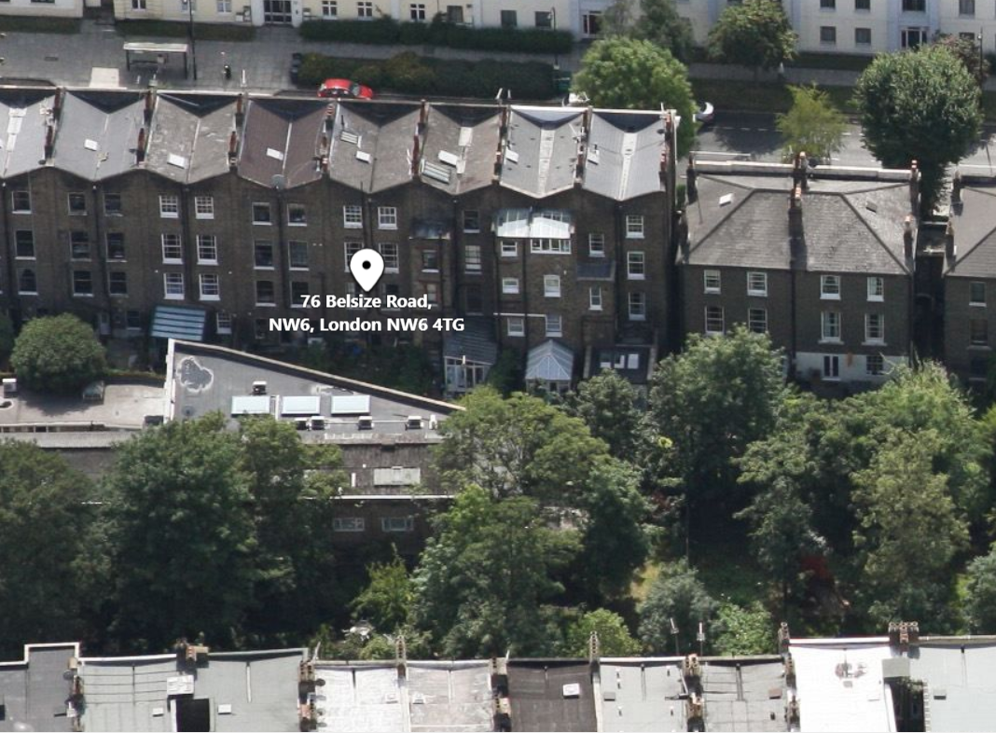
Rear Elevation

Access
There will be level access into the extension and garden

