DECISION

Planning (Listed Building and Conservation Areas) Act 1990

Approval of Details (Listed Building) Granted

Address:
1st & 2nd Floor Maisonette
131 Drummond Street
London
NW1 2HL

Proposal:
Approval of details pursuant to condition 5 of listed building consent ref 2019/5702/L granted on 03/12/2019 for installation of temporary internal secondary glazing to 4 windows to front elevation and mechanical ventilation units, for noise mitigation works during construction of HS2 railway.
Drawing Nos: WPI P066 NI - 131 DrS-EX-EL-01.

The Council has considered your application and decided to grant Approval of Details (Listed Building) subject to the following condition(s):

Conditions And Reasons:

Informative(s):

Reasons for granting listed building consent (approval of details):

This application is for approval of details pursuant to condition 5 of listed building consent ref 2019/5702/L granted on 03/12/2019 for installation of temporary internal secondary glazing to 4 windows to the front elevation and mechanical ventilation units, for noise mitigation works during the construction of the HS2 railway.

The application site is the first and second floor maisonette of a grade II listed 1820s mid-terrace house and shop of three storeys raised on a basement, constructed from stock brick with a timber shopfront at ground floor, timber sash windows on upper floors, and a slated roof behind a parapet.

Condition 5 requires the submission to the Council of a proposed front elevation drawing showing the exact location, dimensions, materials, finishes and colours of all new ventilation grilles, fully annotated at a scale of 1:50.

The submitted drawing shows the required details and demonstrates that, as a temporary installation for the duration of the HS2 construction works, the ventilation grilles will cause no harm to the special interest of the grade II listed building.

No public consultation was necessary for this application. The site's planning history was taken into account when arriving at this decision.

Special regard has been attached to the desirability of preserving the listed building and its features of special architectural or historic interest, under s.16 of the Planning (Listed Buildings and Conservation Areas) Act 1990 as amended by the Enterprise and Regulatory Reform Act (ERR) 2013.

As such, the proposal is in general accordance with policies D1 and D2 of the Camden Local Plan 2017. The proposed development also accords with the London Plan 2016 and the National Planning Policy Framework.

You are advised that all conditions relating to listed building consent ref 2019/5702/L granted on 19/12/2019 which need details to be submitted, have been approved.

In dealing with the application, the Council has sought to work with the applicant in a positive and proactive way in accordance with paragraph 38 of the National Planning Policy Framework 2019.

You can find advice about your rights of appeal at:

http://www.planningportal.gov.uk/planning/appeals/guidance/guidancecontent

Yours faithfully

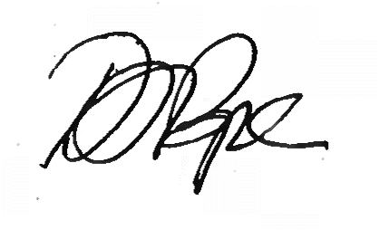
Daniel Pope
Chief Planning Officer

