**Installer:**  **UK Security Shutters** **Address:** West Hampstead

Security House West End Lane

342 Waterloo Road West Hampstead

Cobridge London

Stoke on Trent NW6 2LJ

ST1 5EH

Tel no: 01782 285888

Email: info@securityshutters.co.uk

**Contents:**

1. Roller Shutter System

* Introduction
* Important information
* Legal and Maintenance Responsibilities
* CE Compliance Certificate
* Commissioning Certificate
* Roller Shutter Schematic
* Asset Serial Numbers

1. Operation and Maintenance

* Operating Instructions
* Daily user Maintenance Information
* General maintenance Information
* Replacing Transmitter Batteries
* Safety
* Power Failure
* Service and Maintenance Record
* Trouble Shooting

1. Service and Maintenance Record
2. Warranty
3. Call out Contact Details

**Introduction**

The information within this document should enable you to safely and efficiently operate the roller shutter. Your safety, your colleagues’ safety and that of the general public are our primary concern. To that end, please read and follow our operating and safety advice

# Important Information

UK Security Shutters Ltd does not assume responsibility for any accidents, injury or damage, which may occur due to user negligence or failure to comply with these instructions.

Rectification work must only be carried out by a suitably qualified door engineer. Any alterations to the operating characteristics or the door itself should only be carried out after consultation with the manufacturer.

This manual contains information to comply with the European Union Machinery Directive, which has been implemented in the UK and covered under the following statutes;

* S.1.1992 No 3073 The Supply of Machinery (Safety) Regulations 1992 and subsequent amendments
* S.1.1994 No 2063 The Supply of Machinery (Safety) (Amendment) Regulations 1994 and subsequent amendments

The legislation requires that all power operated doors comply with the essential safety requirements of the regulations and that the manufacturer of the door is required to CE mark its product and issue a Declaration of Conformity for each door supplied.

This manual incorporates our declaration that the door(s) conform to the above European Directive.

It is imperative that this door, like all machinery, receives adequate maintenance carried out by competent and qualified personnel. This is to enable you to meet your responsibilities under the Provision and Use of Equipment Regulations (1993), to maintain the door and to maximise its service life and minimise repair costs.

# Instructions

A roller shutter is a large piece of moving machinery and should be treated with respect. *All users of the door need to be trained in its operation* - just like any other piece of industrial machinery. Adherence to the instructions will ensure the safe and reliable operation of the roller shutter door. The following safety instructions ***must***be complied with;

* Keep openings clear at all times.
* Operate the door whilst watching its movement.
* Do not operate a damaged door, or one which appears to have difficulty operating. If this is the case; isolate the power, lock off the door, cordon if required, leave a sign and ensure the door is inspected by a qualified person.
* Do not lean ladders or any other objects against the door, guide channels or shutter housing.
* Stand well clear of the opening whilst the door is being operated.
* Operate the door only by the means originally installed.
* Do not perform any kind of maintenance without first isolating the power and locking off the door to prevent inadvertent operation.
* Do not use the door to lift anything other than itself.
* Do not rush through a moving door.

# Legal Maintenance Responsibilities

Under the Workplace (Health, Safety and Welfare) Regulations 1992, anyone in control of a workplace is required to ensure that doors are safe (see regulation 18) and are maintained in a safe condition (see regulation 5).

Under section 3 of the Health and Safety at Work Act 1974, all businesses have a general duty of care to anyone who might be affected by their activities but is not their employee. Among the consequences of this are;

* A managing agent or a landlord must ensure that doors under their control are safe, even if they are not in a workplace.
* A contractor installing, maintaining or repairing any door must ensure that they always leave it in a safe condition, whoever owns it or whatever it is used for.

Where access to safety critical elements of a door due to boxing in or lack of safe access to areas above ceilings cannot be achieved, the safety of the door cannot be assured and hence cannot be known if the door is safe to use or not. The head-gear of a door often contains many of the safety critical elements;

* Fixings and attachments, bearings, key steels, steel wire ropes, springs, barrel retention elements, door curtain attachments, safety brakes, drive chains and belts, electrical wiring.

All elements of a door need regular inspection, adjustment or lubrication to ensure its ongoing safety.

The most frequent cause of failure, injury and numerous deaths has involved some problem with the safety and security of the head-gear of the door. It is for this reason that access to the head-gear is crucial for maintenance. If the head-gear of a door cannot be accessed, it cannot be maintained in a safe condition.

The legal responsibilities of neither the owner nor the maintainer can be satisfied.

Where door head-gear is not accessible for maintenance;

* The owner should be informed that the safety of the door cannot be assessed and that it is not known if it is safe to use or not.
* Hazards may exist when operating or simply passing beneath the door.
* Steps must be taken by the owner to make regular safe access to the head-gear possible.
* Use or passage under the door should be prevented or otherwise protected.

Repairing or otherwise working on the door could be in breach of health and safety law and, in the event of an incident, the owner and the maintainer could both face criminal proceedings. There is also the possibility of civil proceedings for negligence affecting either party.

Any attempt to transfer the legal responsibilities of maintainers/repairers to the owner via a disclaimer document is liable to fail as transferring a criminal responsibility via a civil contract is not possible under UK law.

# CE Compliance Certificate

|  |  |
| --- | --- |
| Date of installation | 9th April 2019 |
| Unique serial number/job reference | Door Id: 7884a and 7884b |
| Item reference |  |
| Location | West Hampstead Station, West End Lane, West Hampstead NW6 2lj |
| Installation by | UK Security Shutters Ltd, 342 Waterloo Road, Cobridge, Stoke on n |
| Contact details:  ***Emergency: 07789488895 Robert Hoskins***  Office – 01782 285888  Email – [info@securityshutters.co.uk](mailto:info@securityshutters.co.uk)  Web - [www.securityshutters.org](http://www.securityshutters.org) | |

West Hampstead Station Date of completion: 09.04.2019

West End Lane Installation completed by UK Security Shutters Ltd

West Hampstead Reference Number: 7884

NW6 2LJ Certificate Number: 19415

**Commissioning Certificate**

Types of works completed at the above station:

* Roller Shutter Doors
* Roller Shutter Controls
* Communications Panels

This work conforms to the British Standards of EN 13241-1 and EN12453 standards

Commissioner Name: Robert Hoskins

Commissioner Signature: R Hoskins

Date issued: 29th April 2019

I hereby certify that this is a true and exact copy

Gemma Roberts

Gemma Roberts

Quality Manager

For and on behalf of UKSS Ltd

**Roller Shutter Schematic**

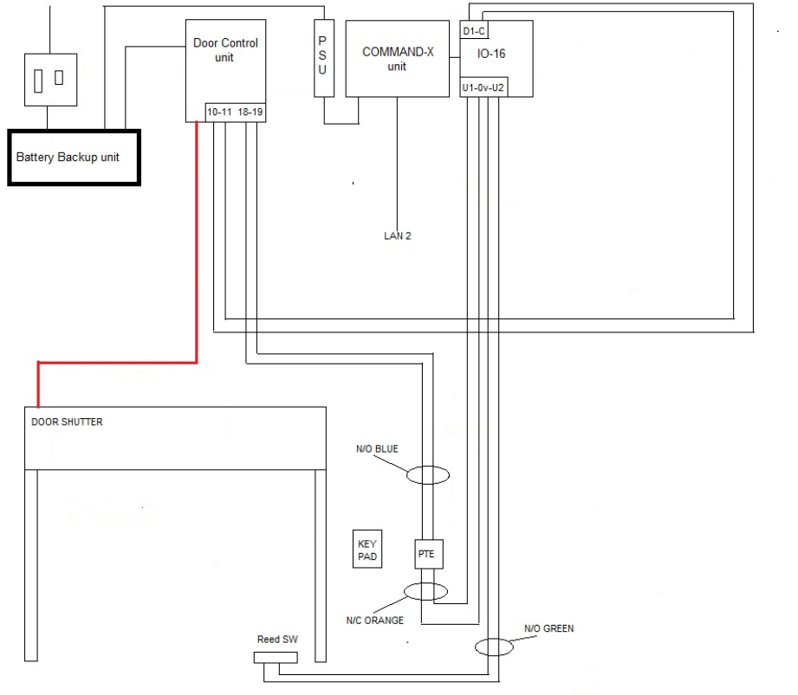

**Asset Serial Numbers**

Station: West Hampstead Installation Date:09.04.2019

Shutter 1 :7884-A-19415-A1

Shutter 2 :7884-A-19415-A2

Controller 1: 7884-B-19415-B1

Controller 2: 7884-B-19415-B2 Security Code: 2307

Comms Panel: 7884-C-19415-C1

**Operation and Maintenance**

**Operating Instructions**

Whenever possible the roller shutter door should be operated when it is in view, making sure it is not obstructed. Ensure when the curtain is running, that you and any other person stands clear of the curtain and keeps hand away from the moving parts.

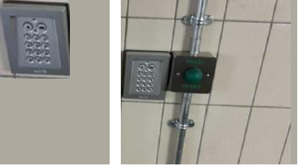

The operation of the shutter is controlled by a key pad as shown in the above photo; it is located by the shutter.

The code for the keypad is 2307, this will activate the shutter.

When you have inputted the code, you will then need to press the top left button (single dot) to confirm the code you have entered.

Pressing the same button repeatedly in this order will lock/unlock the shutter without the need to re-enter the code.

In the event of a power loss the shutter has a backup battery supply to local operation.

There is also a green emergency release button as seen in the photo above to open the shutter from the inside of the station in an emergency. To operate: Press the button and release when door is in motion, the door will continue upwards and automatically stop on the integral limit situated in the motor.

Before closing the station at night, the member of staff securing the station must conduct a physical check of the station prior to closing the shutter to prevent customers being trapped.

When arriving in the morning the shutter should be opened but if found in the open position this should be reported immediately to the station manager.

In the event of any equipment failure or difficulties in opening the shutter these must be reported immediately to the Station Delivery Manager or, out of hours helpdesk.

The code to the keypad should not be provided to anyone without the permission of the Station Delivery Manager.

**Control Unit**

Please note the front of the control unit should only be removed by an authorised engineer.

**Please note**

When opening, or closing the roller shutter door you must monitor the product until it has completed its operation. If the product is fitted with a safety device this could be activated during its operation which would cause the door to stop and reopen a short distance leaving the door partly open.

**Maintenance Requirements**

Tips on maintenance for your Roller Shutter Door:

* The power to the roller shutter door should be isolated before washing or repairing the paintwork (if needed)
* The motor and curtain have been designed to be lubrication free so you must not oil or grease the guide rails
* Make sure no foreign items get collected in the guides i.e. stone, sticks paper etc.
* Any anti drop devices must be inspected on a regular basis

**Please note**

Always isolate the power before attempting to make any adjustments or repairs. Untrained operators are advised to contact UK Security Shutters on 01782 285888 or alternatively Robert Hoskins on 07789 488895. Email: [info@securityshutters.co.uk](mailto:info@securityshutters.co.uk)

**Safety**

The safety edge is fitted to the bottom of the door and is activated when the door starts to close. If it comes into contact with an object while the door is closing, it transmits a signal to the wall mounted control unit, the door will then stop and reopen a short distance.

The safety edge also works as a weather seal, designed to be pressed against the ground.

**Power Failure**

In the event of disruption to the power supply, or the motor temporarily over heating (the motor is protected by a thermal cut off), the door can be operated manually. Isolate power supply before using the manual hand chain override.

Manual Hand Chain Gear:

**To Open** – *disengage locking devices. The hand chain should be operated by pulling smoothly and vertically in line with eh sprocket wheel. Always use two hands one on the upside and one on the down. Always raise to the fully open position and engage the chain in the cleat where fitted*.

**To Close** – *Pull smoothly on the chain using two hands one on the up side, one on the down until the door has reached the fully closed position. Engage the chain keeps where fitted. Engage lock devices*.

Trouble Shooting

|  |  |  |
| --- | --- | --- |
| **Fault** | **Possible Cause** | **Solution** |
| Transmitter Not Working | Batteries Flat | New Batteries Needed |
| Door Closes but immediately re-opens | Safety Edge Activated | Sweep the floor to ensure it is clear of obstructions and check the integrity of the safety edge |
| Door only comes down partially before re opening slightly | Safety Edge Fault | Check Batteries in bottom slat transmitter |

**Service and Maintenance Record**

# We recommend that your roller shutter door is serviced by UK Security Shutters ltd once every 6 months Recommended service period as failure to keep the door regularly and adequately maintained will compromise safety, reliability, efficiency of operation and could invalidate the warranty.

|  |  |  |  |
| --- | --- | --- | --- |
| Date: |  |  |  |
| Work carried out: |  |  |  |
| Work performed by: |  |  |  |
| Print: |  |  |  |
| Signed: |  |  |  |
| Company Name: |  |  |  |
| Notes: |  |  |  |
| Date: |  |  |  |
| Work carried out: |  |  |  |
| Work performed by: |  |  |  |
| Print: |  |  |  |
| Signed: |  |  |  |
| Company Name: |  |  |  |
| Notes: |  |  |  |
| Date: |  |  |  |
| Work carried out: |  |  |  |
| Work performed by: |  |  |  |
| Print: |  |  |  |
| Signed: |  |  |  |
| Company Name: |  |  |  |
| Notes: |  |  |  |

**Warranty**

**Warranty Information**

All Security Shutters are guaranteed against defect of material or workmanship by UKSS, subject to correct installation, service, maintenance, and operation, for a period of 12 months from the date of installation. The Motor carries a 5-year guarantee.

**Call Out Contact Details**

**Office: UKSS, Security House, 342 Waterloo Road, Cobridge, Stoke on Trent ST1 5EH**

**Tel: 01782 285888 Fax: 01782 285222**

**Email:** [**info@securityshutters.co.uk/rob@securityshutters.co.uk**](mailto:info@securityshutters.co.uk/rob@securityshutters.co.uk)

**Out of hours contact: Robert Hoskins 07789 488895**