Enforcement Delegated Report |  |  | Receipt date: | 1st April 2019
Officer |  | Enforcement Case
Raymond Yeung |  | EN19/0296
Breach Address |  | Photos & Other material
39 Camden High Street, London, NW1 7JH |  | 

Authorised Officer Signature
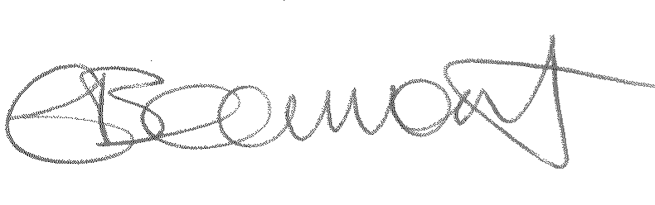14.11.19

Alleged Breach
Without planning permission: Installation of recessed shopfront creating a front terrace.

Recommendation(s): | Issue an enforcement notice  That the Borough Solicitor issue an Enforcement Notice under section 172 of the Town & Country Planning Act 1990 as amended, and officers be authorised in the event of non- compliance to prosecute under section 179 or appropriate power and/or take direct action under section 178 in order to secure cessation of the breach of planning control.

Assessment
This report is an addendum to the delegated officer’s report under application ref: 2019/0645/P dated 13th September 2019, which fully assessed the alleged breach outlined above. It was refused for the following reason;
The shopfront, by virtue of its fully glazed and recessed design has resulted in an unsympathetic and incongruous frontage that is detrimental to the host building, the streetscape and the conservation area contrary to policies D1 (Design), D2 (Heritage) and D3 (Shopfront) of the Camden Local Plan 2017.
Recommendation:

That the Borough Solicitor issue an Enforcement Notice under section 172 of the Town & Country Planning Act 1990 as amended, and officers be authorised in the event of non- compliance to prosecute under section 179 or appropriate power and/or take direct action under section 178 in order to secure cessation of the breach of planning control.

The notice shall allege the following breaches of planning control:

Without planning permission: Installation of recessed shopfront creating a front terrace.

WHAT ARE YOU REQUIRED TO DO:

1. Completely remove the recessed shopfront and reinstate a shopfront to match the pre-existing in terms of its position, design and materials as per plan within Appendix A

PERIOD OF COMPLIANCE: 3 months

REASONS WHY THE COUNCIL CONSIDER IT EXPEDIENT TO ISSUE THE NOTICE:
1. It appears to the Council that the above breach of planning control has occurred within the last 4 years.
2. The shopfront, by virtue of its fully glazed and recessed design has resulted in an unsympathetic and incongruous frontage that is detrimental to the host building, the streetscape and the conservation area contrary to policies D1 (Design), D2 (Heritage) and D3 (Shopfront) of the Camden Local Plan 2017.

Appendix A: Pre-existing shopfront

