**NUMBER 52 AND ATTACHED RAILINGS**

[2 contributions](https://historicengland.org.uk/listing/the-list/list-entry/1378809#contributions-banner)

**Overview**

Heritage Category:

Listed Building

Grade:

II

List Entry Number:

1378809

Date first listed:

14-May-1974

Statutory Address:

NUMBER 52 AND ATTACHED RAILINGS, 52, STANHOPE STREET

**Map**

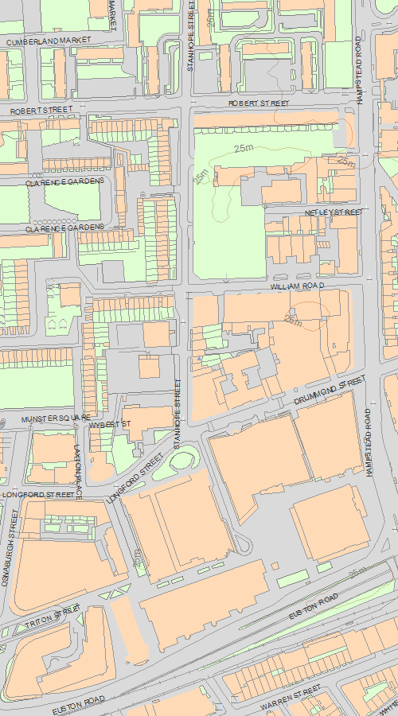

© Crown Copyright and database right 2020. All rights reserved. Ordnance Survey Licence number 100024900.  
© British Crown and SeaZone Solutions Limited 2020. All rights reserved. Licence number 102006.006.  
Use of this data is subject to [Terms and Conditions](https://historicengland.org.uk/terms/website-terms-conditions/).

The above map is for quick reference purposes only and may not be to scale. For a copy of the full scale map, please see the attached PDF - [1378809.pdf (opens in a new window)](http://mapservices.HistoricEngland.org.uk/printwebservicehle/StatutoryPrint.svc/341806/HLE_A4L_Grade|HLE_A3L_Grade.pdf)

The PDF will be generated from our live systems and may take a few minutes to download depending on how busy our servers are. We apologise for this delay.

This copy shows the entry on 29-Jan-2020 at 11:17:41.

**Location**

Statutory Address:

NUMBER 52 AND ATTACHED RAILINGS, 52, STANHOPE STREET

The building or site itself may lie within the boundary of more than one authority.

County:

Greater London Authority

District:

Camden (London Borough)

National Grid Reference:

TQ 29078 82495

**Details**

CAMDEN  
  
TQ2982SW STANHOPE STREET 798-1/93/1528 (East side) 14/05/74 No.52 and attached railings   
  
GV II  
  
Terraced house. c1804. Yellow stock brick, 2nd floor rebuilt. 3 storeys and basement. 2 windows. Round arched doorway with stucco impost blocks and keystone, blocked fanlight and panelled door with top panels glazed. Gauged brick flat arches to recessed sashes. 1st floor sill band. Parapet. INTERIOR: not inspected. SUBSIDIARY FEATURES: attached cast-iron railings with urn finials to areas.   
  
  
  
Listing NGR: TQ2907882495

**Legacy**

The contents of this record have been generated from a legacy data system.

Legacy System number:

478164

Legacy System:

LBS

**Legal**

This building is listed under the Planning (Listed Buildings and Conservation Areas) Act 1990 as amended for its special architectural or historic interest.

End of official listing