**NUMBERS 14-20 AND ATTACHED RAILINGS**

[1 contribution](https://historicengland.org.uk/listing/the-list/list-entry/1245247#contributions-banner)

**Overview**

Heritage Category:

Listed Building

Grade:

II

List Entry Number:

1245247

Date first listed:

14-May-1974

Statutory Address:

NUMBERS 14-20 AND ATTACHED RAILINGS, 14-20, CONWAY STREET

**Map**

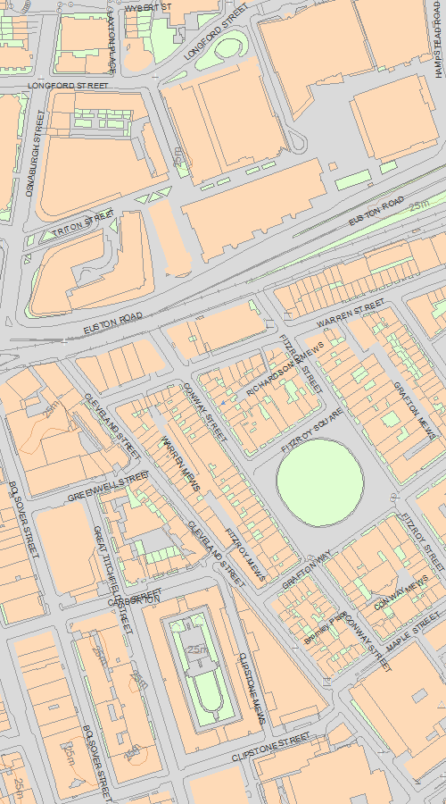

© Crown Copyright and database right 2020. All rights reserved. Ordnance Survey Licence number 100024900.  
© British Crown and SeaZone Solutions Limited 2020. All rights reserved. Licence number 102006.006.  
Use of this data is subject to [Terms and Conditions](https://historicengland.org.uk/terms/website-terms-conditions/).

The above map is for quick reference purposes only and may not be to scale. For a copy of the full scale map, please see the attached PDF - [1245247.pdf (opens in a new window)](http://mapservices.HistoricEngland.org.uk/printwebservicehle/StatutoryPrint.svc/224987/HLE_A4L_Grade|HLE_A3L_Grade.pdf)

The PDF will be generated from our live systems and may take a few minutes to download depending on how busy our servers are. We apologise for this delay.

This copy shows the entry on 27-Jan-2020 at 17:09:05.

**Location**

Statutory Address:

NUMBERS 14-20 AND ATTACHED RAILINGS, 14-20, CONWAY STREET

The building or site itself may lie within the boundary of more than one authority.

County:

Greater London Authority

District:

Camden (London Borough)

National Grid Reference:

TQ 29060 82147

**Details**

CAMDEN  
  
TQ2982SW CONWAY STREET 798-1/93/274 (East side) 14/05/74 Nos.14-20 (Even) and attached railings   
  
GV II  
  
4 terraced houses. c1793. Multi-coloured stock brick. Rusticated ground floor with plain 1st floor sill band. Stucco cornice and blocking course. 4 storeys and basements. 2 windows each. Segmental arched ground floor openings. Doorways with pilaster-jambs carrying cornice-heads; patterned fanlights and panelled doors. Gauged, reddened brick flat arches to recessed sashes. Nos 18 and 20 with patterned glazing bars to ground floor windows. Continuous cast-iron balconies at 1st floor level. INTERIORS: not inspected. SUBSIDIARY FEATURES: attached cast-iron railings with tasselled spearhead finials to areas. (Survey of London: Vol. XXI, Tottenham Court Road and Neighbourhood: London: -1949: 49).   
  
  
  
  
  
Listing NGR: TQ2906282148

**Legacy**

The contents of this record have been generated from a legacy data system.

Legacy System number:

477020

Legacy System:

LBS

**Sources**

**Books and journals**  
'Survey of London' in Survey of London - Tottenham Court Road and Neighbourhood St Pancras Part 3: Volume 21, (1949), 49

**Legal**

This building is listed under the Planning (Listed Buildings and Conservation Areas) Act 1990 as amended for its special architectural or historic interest.

End of official listing