271 Royal College Street, London NW1 9LU
DESIGN AND ACCESS STATEMENT

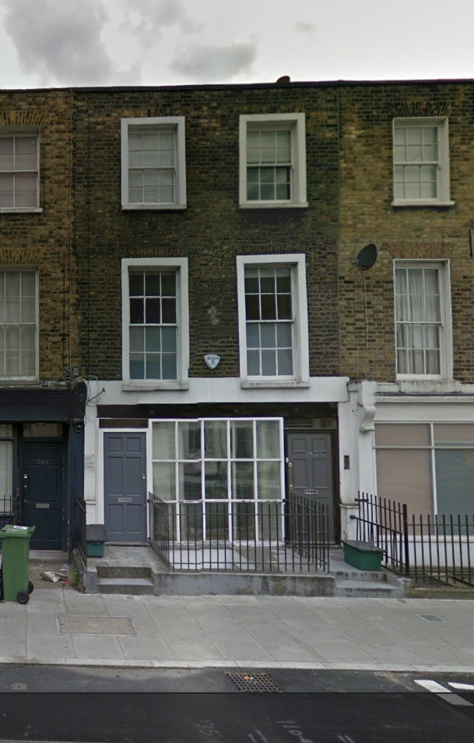

EXISTING BUILDING
271 Royal College Street is a mid nineteenth century terraced house. It is in the Jeffery’s Street Conservation Area.

The property originally had a shop on the ground floor which was latterly used as an office and which was converted to the current maisonette on ground and lower ground floors after a planning approval dated 5nd February 2007 (ref. 2006/4764/P).

PROPOSALS
The proposals are to convert the flat into a family home on the ground and lower ground floors by extending the lower ground floor at the rear and by upgrading the area between the closet wings, which is currently disused and paved, into a courtyard garden and at the front into the front light well. The intermediate ground floor area at the rear is going to be extended to provide a new sitting room. It is also proposed to replace the damaged window and door arrangements that front the street at ground floor level to restore and improve the appearance of the building.

The intention of the design is to identify the new building work as being contemporary rather than trying to imitate the existing building but at the same time being complementary to it.

Planning Issues:
The property is in the Jeffreys Street Conservation Area. The conservation area guidelines state that:

JS13 ‘In all cases, existing/original architecture features and detailing characteristic of the Conservation Area should be retained and kept in good repair and only be replaced when there is no alternative…’

The existing ground floor windows and door onto Royal College Street are of recent date and are not of good quality or a cohesive design. It is proposed to replace these with a more considered design in better quality materials.

JS19 ‘Rear extensions should be as unobtrusive as possible and should not adversely affect the character of the building or the Conservation Area.’

The rear extension is of modest single storey height, and is complementary to the existing building in terms of the materials used.

ACCESS
Disabled Access will remain unchanged.

PARKING
Parking arrangements are to remain the same, as the parking demand will not increase as a result of the development. From the planning approval of 2007 there is a Section 106 agreement in force which says that no parking permits will be given for the property. It is not proposed to change this.

FLOOD RISK ASSESSMENT
The site is not in a designated flood zone.

