[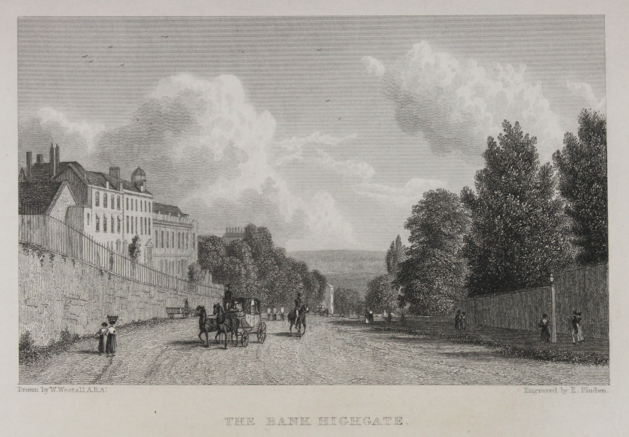](https://www.google.com/url?sa=i&url=https://www.sandersofoxford.com/shop/product/the-bank-highgate/&psig=AOvVaw1m5XnCaMzxsSzzfEnXooqS&ust=1572623959518000&source=images&cd=vfe&ved=0CAIQjRxqFwoTCKjs5f_uxuUCFQAAAAAdAAAAABAJ)

Highgate Hill c 1820-30

[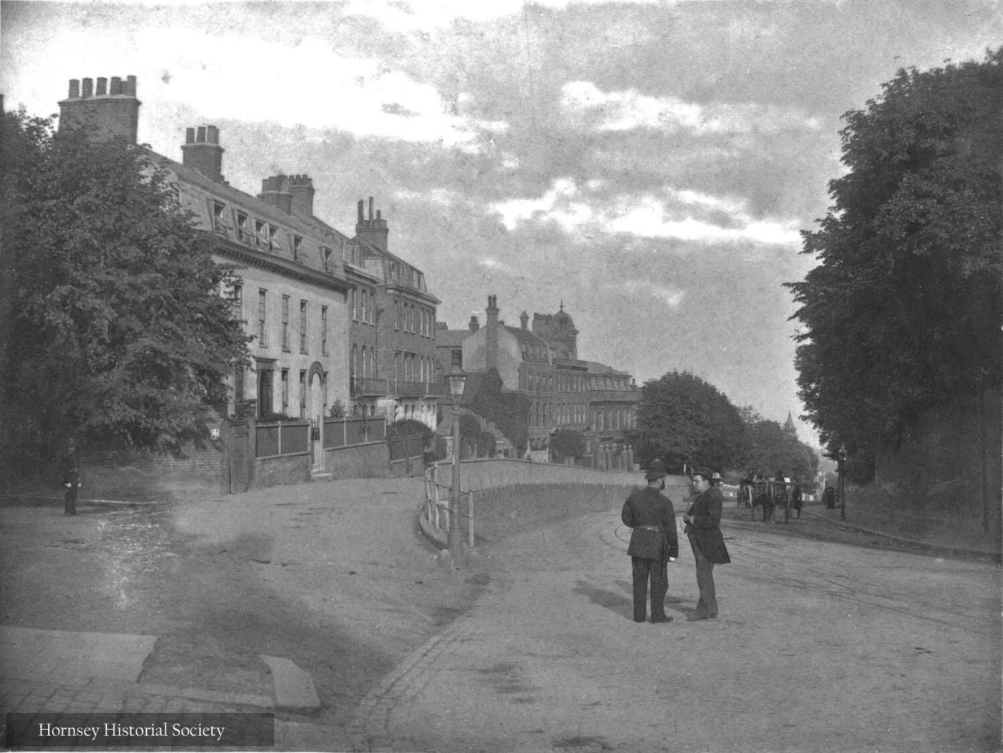](https://www.google.com/url?sa=i&url=https://hornseyhistorical.org.uk/north-middlesex-photographic-society-gallery-2/&psig=AOvVaw1m5XnCaMzxsSzzfEnXooqS&ust=1572623959518000&source=images&cd=vfe&ved=0CAIQjRxqFwoTCKjs5f_uxuUCFQAAAAAdAAAAABAN)

Highgate Hill c 1900