**Photographs of the Mews:**

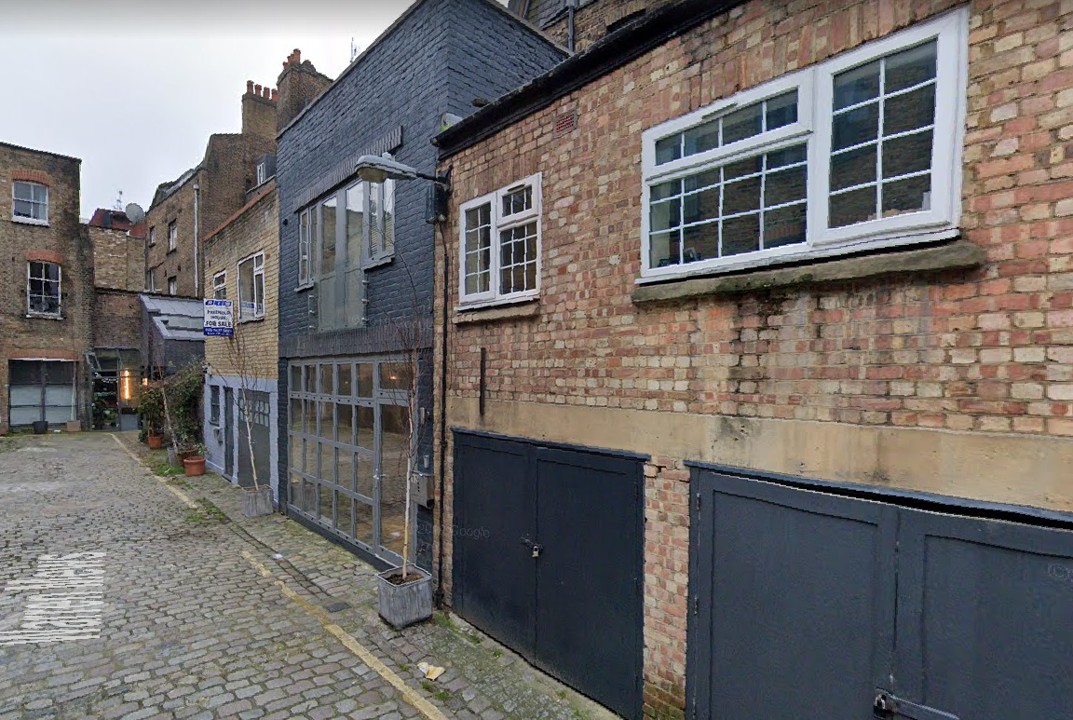

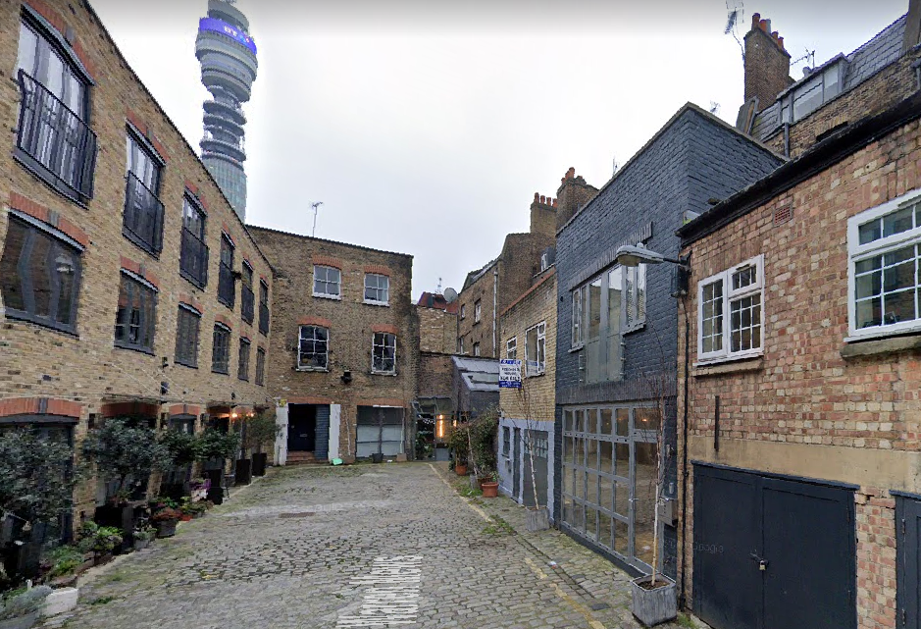

*(Photographs: Extracts from Google Maps)*