Delegated Report (Members Briefing) |  |  | Analysis sheet |  |  |  |  |  | Expiry Date: |  |  | 07/06/2019
 |  |  | N/A |  |  |  |  |  | Consultation Expiry Date: |  |  | 25/11/2019
Officer |  |  |  |  |  |  | Application Number(s)
David Fowler |  |  |  |  |  |  | 2019/4937/P
Application Address |  |  |  |  |  |  | Drawing Numbers
Land at Southern Car Park  Royal Free Hospital  Pond Street  London  NW3 2QG |  |  |  |  |  |  | See Draft Decision Notice
PO 3/4 | Area Team Signature |  |  | C&UD |  |  | Authorised Officer Signature

Proposal(s)
Erection of new building to provide a Maggie's Centre (435sqm net floorspace) non-residential institution (ancillary to Royal Free) - and associated landscaping works.
Recommendation(s): |  | Grant conditional planning permission
Application Type: |  | Full application
Conditions or Reasons for Refusal: |  | Refer to Draft Decision Notice

Informatives:

Consultations
Adjoining Occupiers: |  | No. notified |  |  | 00 | No. of responses |  |  |  | 04 | No. of objections |  | 04
Summary of consultation responses: |  | Site notices were displayed from 10/10/2019 (expiring on 03/11/2019) and a press notice was displayed on 09/10/2019 (expiring on 02/11/2019).  4 objections were received on the grounds laid out below.  Land use  - Existing building better suited for needs of clients  - Concerns about reduced yoga area from within existing building  - Absence of treatment rooms  - No counselling rooms by the entrance – distressed patients would need to walk through the building and up the stairs, people have to be counselled in open plan area with people coming and going, counselling space unnecessarily large – should be intimate  - Comments to Maggie’s have been ignored  - Proposals fall short of the existing Cancerkin facilities  - Inadequate toilets  Landscape  - Benches outside will be used by smokers and Maggie’s clients will need to walk past them.  Transport  - Lacks consideration of parking impacts within South End Green and South End Close  Officer response: See sections on ‘Land use’, ‘Trees and landscaping’ and ‘Transport’.
Statutory consultees: |  | Metropolitan Police  - Two entrances to the building from two different locations may cause issues if no access control and no main reception.  - Building perimeter is vulnerable due to changes in levels and no natural surveillance.  - Landscaping needs to provide a clear line of sight.  - Lighting.  Officer response: See section on ‘Safety and security’.  Thames Water  No objections subject to Informatives.  Transport for London  No comments.
Heath and Hampstead Society: |  | If the matters raised below can be resolved, then support not be withheld.  Land use  - Overall positive  Design  - Overall positive  - Forms seems somewhat arbitrary, flown in from somewhere else  - Opening out of shape could give overbearing impression to parents as they approach  - Presentation is whitewashed and doesn’t show site clearly  - Exterior materials are too vague and need more explanation, abstracted use of timber, not clear what fins are from  - Will need high level of technical resolution to pull off successfully and deal with weathering  - How does fenestration serve/relate to interiors?  - Brave and refreshing approach  Trees and landscaping  - Loss of trees is a significant negative and will impact quality of local environment and in particular neighbouring housing and the Rosary School  - Otherwise, landscaping is potentially very successful, though private external seating could be increased  - Sequence of arrival for visitor could be explained.  Officer response: See sections on ‘Design’, ‘Trees and landscaping’, the submitted plans are considered sufficient to assess the proposals, it is important to note that the maintenance of the building will be funded directly by Maggie’s rather than the NHS.
Camden Design Review Panel (DRP): |  | The Design Review Panel meeting took place on the 21st of June 2019. Comments from the panel are below.  - Applauds aspiration to create a Maggie’s at the RF and the client’s ambition for the highest architectural quality  - Scope to refine design to create warmer/more welcoming interior  - Location and legibility of main entrance questioned  - Landscaping will be important  Officer response: See sections on ‘Design’ and Trees and landscaping’, interior has been amended since DRP, Maggie’s wish to have a relatively informal and discreet entrance.

Site Description
  - The site is located at the rear/south of the Royal Free Hospital site, off Rowland Hill Street. The site is currently used for parking for the hospital. There is vegetation on the southern boundary of the site.

  - The site is bounded on its southern side by the rear of residential properties facing Aspern Grove and Woodland Walk. There are no listed or locally-listed buildings on the parts of the site in question. The site is not located within any conservation areas.

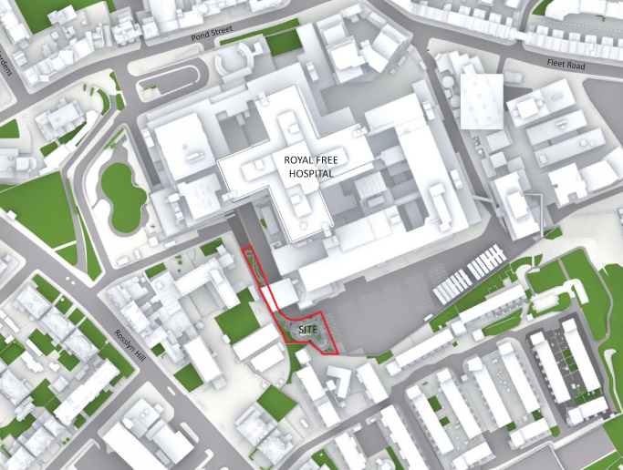
Figure 1: the location of the site within the Royal Free complex

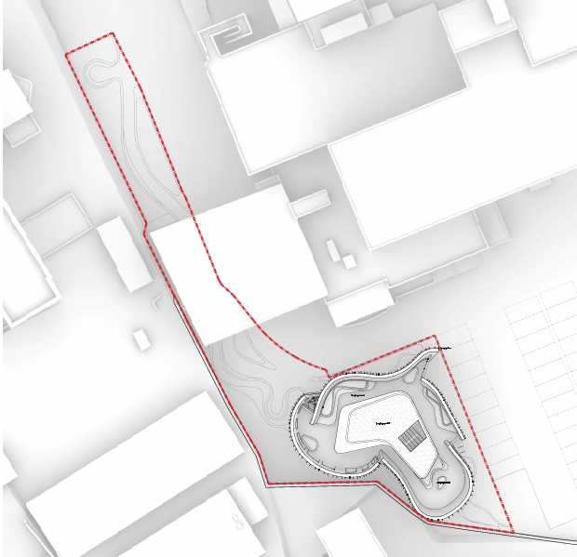
Figure 2: the proposed site

Relevant History
The Royal Free opened on this site in 1974 and since there has been natural growth of hospital functions on the site.

Relevant policies
NPPF 2019

London Plan consolidated with alterations 2016

Draft London Plan 2019

Camden Local Plan 2017
Policy A1 Managing the impact of development
Policy A3 Biodiversity
Policy A4 Noise and vibration
Policy C1 Health and wellbeing
Policy C2 Community facilities
Policy C5 Safety and security
Policy C6 Access for all
Policy D1 Design
Policy D2 Heritage
Policy CC1 Climate change mitigation
Policy CC2 Adapting to climate change
Policy CC3 Water and flooding
Policy CC4 Air quality
Policy CC5 Waste
Policy T1 Prioritising walking, cycling and public transport
Policy T2 Parking and car-free development

Hampstead Neighbourhood Plan
Policy DH1: Design
Policy DH2: Conservation areas and listed buildings
Policy DH3: The urban realm
Policy NE2: Trees
Policy NE3: Biodiversity Corridors
Policy NE4: Supporting biodiversity
Policy BA3: Construction Management Plans
Policy TT1: Traffic volumes and vehicle size
Policy TT2: Pedestrian environments
Policy TT4: Cycle and car ownership
Policy HC2: Community facilities
Policy HC3: Enhancing street life through the public realm

Assessment
- Proposal

  - The proposal is for a Maggie’s Centre on the Royal Free Hospital site. The Maggie’s Centre would be an ancillary use to the main Royal Free Hospital (Class C2 – Residential Institution). Maggie’s is a charitable trust which builds Maggie’s Centres in the grounds of NHS cancer hospitals to provide free support to people with cancer and their family and friends. Maggie’s Centres are often renowned for their architecture and aim to create ‘warm and welcoming places, full of light and open space’. They are designed by leading architects who create uplifting places where professional staff can offer the support people need’.

  - The proposed site for the Maggie’s Centre is located on the lower southwest corner of the Royal Free Hospital in the corner of the southern carpark. The existing site encompasses 12 car parking spaces and a planted bank to the hospital boundary. The site is bounded on its southern side by a party wall and Argenta House, a residential property facing Aspern Grove and Woodland walk. On its western side there are school buildings associated with the Rosary Catholic Primary School.

  - The site is accessed from Rowland Hill Street off Rosslyn Hill. It is also easily accessible from the Rowland Hill Street Hospital Entrance where the Oncology Ward is located and the Southern Carpark.

  - The building would consist of a ground floor, one internal upper storey and then a second floor which would be enclosed at the sides but open to the sky, with a covered area in the centre of this floor, housing a winter garden, storage and plant. The building would have a floor area of 435sqm. The building is designed to encompass Maggie’s Centres’ design philosophies for a welcoming and light space. Extensive landscaping is proposed in the lead-up to and around the building.

- Assessment

  - The following issues are relevant to the determination of this application:

3. Land use
4. Design
5. Trees and landscaping
6. Amenity
7. Land contamination
8. Transport
9. Safety and security
10. Accessibility

- Land use

  - Camden Local Plan policy C1 and Hampstead Neighbourhood Plan policy HC2 promote local health, social and cultural wellbeing.

  - The area is currently ancillary parking to the Royal Free Hospital use, which is Class C2 (Residential Institution). The Maggie’s Centre would have a Class D1 (Non-residential institution) character, however it would operate on an ancillary basis to the main hospital building, replacing facilities within the Cancerkin unit within the main hospital building. Therefore, no change of use is proposed, but rather an intensification of the existing use. Maggie’s Centres provide free emotional and social support to people with cancer as well as their families and friends. The Maggie’s Centre would have undoubted benefits for the wellbeing of the community and is strongly supported in principle.

  - Objections have been received on the grounds of the loss of facilities from the existing Cancerkin and insufficient counselling and toilet facilities. The exercise spaces and the toilets have been designed around the needs and requirements of the Maggie’s Centre. It is proposed to have more frequent/smaller yoga classes to meet demands. Similarly, the counselling spaces have been designed around the specific needs of Maggie’s Centres, who have found that flexible spaces allow them to provide more varied and dynamic support. Large areas are required for supports groups.

  - No housing is required, under the mixed use policy, given that the site is not located within a town centre or the Central London Area.

- Design

Policy review
  - Policies D1 and D2 of the Camden Local Plan and policies DH1 and DH2 of the Hampstead Neighbourhood Plan are relevant with regards design.

Design
  - The proposed building is limited to a small site due to the space constraints of the Royal Free Hospital. Therefore, the proposed building is small in scale yet the proposal is for an iconic building, of distinctive architectural quality. This is important in terms of encouraging visitors as well as helping attract funding. The footprint is limited in size (170sqm) at ground level and expands out to 204sqm at roof level. This allows the building to make the most of the tight sight and gives over space for soft and hard landscaping around the building. The undulating curved form and use of timber gives the building a distinct appearance, which is in contrast to the institutional concreate buildings of the hospital. The proposed building has a more domestic scale within a landscaped setting creating some respite in the hospital context and the creative form is unique and eye catching offering a memorable and welcoming area to the hospital campus.

Materials
  - The use of the vertical timber fins gives the building a distinct appearance and helps to create a sense of approachability and warmth aligning with the Maggie’s Centres’ aspirations. The timber fins would allow light and filtered views out from the centre while also providing privacy.

Layout and entrances
  - The building would be located in a relatively discreet part of the Royal Free site, in line with the wishes of Maggie’s, and would not be visible from any roads.

  - Two building entrances are designed and located to invite people in a legible and welcoming way. An entrance to the north is directly accessed from the landscaped walkway for people coming from Rowland Hill Street and the Rowland Hill Street hospital entrance, including the Oncology ward. The second entrance is accessed from the existing carpark and a new vehicular drop off zone. The multiple access points allows the building to be welcoming from multiple directions and futureproofed for a potential change in hospital layout.

  - Internally, the ground floor is focused around a communal kitchen area and the two floors provide a number of nooks and break out spaces. The roof space provides a winter garden and planted areas.

Scale and Mass
  - The building would consist two storeys with a roof garden reaching 11.16 meters high to the top of the parapet. The building would be much lower in height than the main hospital and sits lower than the neighbouring residential block. The height is considered appropriate within this context and allows the building to appear approachable and welcoming within the wider context of the hospital site.

- Trees and landscaping

  - Policy A3 of the Camden Local Plan and policies NE2 and NE3 are relevant with regards trees and landscaping.

  - A Biodiversity Impact Assessment, an Ecological Survey and landscape plans have been submitted as part of this application, which has been assessed by a Council Tree Officer.

  - Part of the site currently has an area of somewhat low-quality shrubs and bushes. In terms of existing trees there are no high value specimens and they have low visibility from outside the site. There is some visibility from neighbouring residential blocks, however this would view would be improved with high-quality landscaping.

  - The scheme proposes to create a new walkway along the western side of Rowland Hill Street connecting the hospital entrance to the Maggie’s Centre. This walkway would help direct people and provide a clear legible and welcoming route to the centre.

  - Due to spatial limitations planting is located in a narrow and heavily sloped area along Rowland Hill Street and around the proposed building. During design development the landscaping plan has progressed to respond to the challenges of the site. Planting is limited under the hospital bridge where it would not be viable with more space created for pedestrians. Retaining walls are used to provide areas for planting, enhance the walkway and carve out space for seating and appropriate planting is chosen specifically for the steep site around the centre helping to achieve dense planting and provide a green setting and outlook from within the building. Landscaping will also help to provide a buffer between the centre and its neighbours outside the hospital site. Freestanding planters along Rowland Hill Street and the west of the building help to create a high quality edge that acts as a buffer for pedestrians to the car park.

  - The landscaping is considered to be an important part of the scheme as it offers a setting to the centre, provides a clear link between from the Hospital, and much needed greenery in a hard environment improving the overall appearance of the Royal Free Hospital Site.

  - The proposed landscaping is considered high quality and would represent an improvement in terms of biodiversity. A condition is attached requiring full details of the landscaping and to ensure their implementation.

  - The hospital operates a policy of no smoking in some external areas and it would be up to Maggie’s/the Royal Free to police smoking outside the proposed centre.

- Amenity

  - Camden Local Plan policies A1, A4 and A5 are relevant with regards to the impact on the amenity of residential properties in the area.

  - The nearest residential properties are located to the south of the site at Argenta House and Christie Court. The building stands 3.6 meters away at its closest point of Argenta House. Belle Vue retirement flats are located to the north-west. A daylight/sunlight assessment has been submitted as part of this application. This report considered 146 windows, serving 46 rooms, all within the three buildings mentioned above. Only three windows would experience transgressions above the BRE guidelines on Vertical Sky Component (VSC). These all serve a single room, within Argenta House. It should be noted that this window serves a bedroom and is not considered as important as living rooms or dining rooms. Furthermore, there are overhanging balconies above two of these window which means that the design of Argenta House results in less daylight to this room. The VSC tests have been run removing these balconies, and both windows pass. The remaining window only marginally falls below BRE guidelines, with a transgression of 20.9% as opposed to 20%. This is considered a very minor transgression and the proposals are therefore considered acceptable in terms of daylight and sunlight. No objections have been received on loss of light.

  - Under the proposals there would be one window at first floor level which would materially impact the privacy of a room in Argenta House, which would be just 4.5m away, albeit at an oblique angle. Officers consider that this window should be obscured to mitigate this impact and a condition is attached accordingly. Due the curvature of the building, other windows other windows at first floor level are located much further away and with much more oblique views and would not affect the privacy of Argenta House. Ground floor windows would be located behind the existing boundary treatment and would have no impact. There are opening proposed at second floor level, serving the terrace. However, officers are not concerned given the small external area of terrace on the southern side of the proposed building (adjacent to Argenta House), and given its size and layout, do not consider that this area would be used intensively enough to result in a material amenity impact.

  - Plant would be located within the centre of the roof at second floor level. This plant would be house. A Noise Officer was consulted on this application and has no objections subject to conditions requiring further noise investigation and the standard noise condition.

  - No objections have been received on amenity grounds.

- Land contamination

  - The site is located within an area of potential contamination. Camden Local Plan policy A1 is relevant with regards land contamination.

  - A report on land contamination was submitted as part of the application. The Council’s Environmental Health Team have assessed the proposals with regards land contamination and consider the proposals acceptable subject to a condition on further investigation and risk assessment.

- Transport

Policy review
  - Policies T1 and T2 of the Camden Local Plan 2107 and policies TT1, TT2 and TT3 of the Hampstead Neighbourhood Plan are relevant with regards Transport.

General
  - A Transport Statement has been submitted in support of this application. The site has a PTAL rating of 4 (with 1a indicating the lowest level of accessibility to public transport and 6b indicating to the highest level) indicating a ‘Good’ level of public transport accessibility. The proposal will result in the loss of 12 of the existing car parking spaces, which is welcomed.

Trip generation
  - The proposal would replace an existing Cancerkin centre within the hospital site. The new centre would have a floor space 27% greater than the existing, which could potentially lead to a future increase the number of visitors to the centre, compared to the Cancerkin. This potential increase in car journeys (taxi and private car) would be 5 per day, which is not considered to be significant. Notwithstanding the above, the centre is aimed to cater for existing patients and not attract additional visitors.

Cycle parking
  - T1 in Camden’s Local Plan requires developments to provide for accessible, secure cycle parking facilities to the minimum standards outlined within the London Plan and design requirements outlined within our supplementary planning document. For a health centre, use class D1, the London Plan requires 1 long-stay space per 5 FTE staff and 1 short-stay space per 3 FTE staff. Long-stay cycle storage should be covered and secure provided in accordance with the standards mentioned above.

  - There is no cycle storage indicated on the plans although the Transport Statement states that the proposal will provide four cycle parking spaces via two Sheffield Stands located outside of the main entrance, which does not meet the minimum requirements. However, there is not expected to be an increase in visitors under the proposals or an increase in staff, as the Maggie’s Centre will replace the existing Cancerkin Centre within the main hospital building. The Maggie’s Centre is proposed as an ancillary use to the hospital. The current cycle parking facilities will remain available for staff members. Given the above, the provision of cycle parking is considered acceptable in this instance.

Mitigating the impact of construction
  - In order to manage and mitigate the construction impact of this scheme, the Council will require a Construction Management Plan (CMP). A draft CMP has been submitted with the application. The CMP confirms that no on-street loading and unloading will be required and vehicles will be able to enter and leave the site in a forward direction.

  - If planning permission were to be granted, a more detailed CMP would need to be prepared once a Principal Contractor has been appointed and it would need to be approved by the Council before construction works commence. This would be secured via a Section 106 legal agreement. A CMP implementation support contribution would also be secured.

- Safety and security

  - Policy C5 of the Camden Local Plan 2017 is relevant with regards safety and security.

  - The hospital has its own CCTV and security 24 hours a day. Officers are satisfied that the site will be properly managed.

- Accessibility

  - The premises would be full accessible as would the proposed landscaping leading to the building and the connection to the main hospital building.

- Conclusion

  - The proposed Maggie’s Centre is strongly supported in land use terms.

  - The architecture would be high quality and iconic.

  - Under the proposals there would be improvements in terms of landscaping and biodiversity.

  - The centre is not expected to result in a significant increase in visitors to the Royal Free site. The transport impacts have been taken into account and mitigated.

- Recommendation

  - Grant conditional planning permission.

DISCLAIMER
The decision to refer an application to Planning Committee lies with the Director of Regeneration and Planning. Following the Members Briefing panel on Monday 9th December 2019, nominated members will advise whether they consider this application should be reported to the Planning Committee. For further information, please go to www.camden.gov.uk and search for ‘Members Briefing’.

