**DESIGN AND ACCESS STATEMENT**

**Application for planning permission for the erection of a garden room at 96 Albert Street**

**August 2019**

**Introduction**

This statement supports the application for a garden room at the end of the garden of 96 Albert Street, Camden, London NW1 7NE.

The reason for this garden room is to provide space for the occupants of the main dwelling house to pursue hobbies, exercise and possibly work from home, in a space measuring 3.5 meters by 4.1 meters internally. It is an ancillary use of the existing home. It does not provide any additional sleeping accommodation, nor does it have any sanitary facilities or running water.

This statement will demonstrate what particular designs and concepts have been applied to this project and how they take the particular garden site into consideration. The Heritage Statement considers how the project complies with the London Plan and architectural and heritage concerns.

As such this statement should be read in conjunction with the Heritage Statement and other supporting documents.

**Design**

Drawings of the design have also been submitted.

The garden room would be built by a reputable, experienced firm. Fine quality materials will be used including structural grade Redwood with premium grade external Thermowood cladding to the sides and back and a slate feature at the front. Grey bi-fold doors will be double glazed and incorporate integrated Venetian Blinds. This structure will be largely grey in appearance and blend in with the dark colours of green trees and shrubs, brown brick garden walls and grey patio stones already present in this and nearby properties, see photo below.

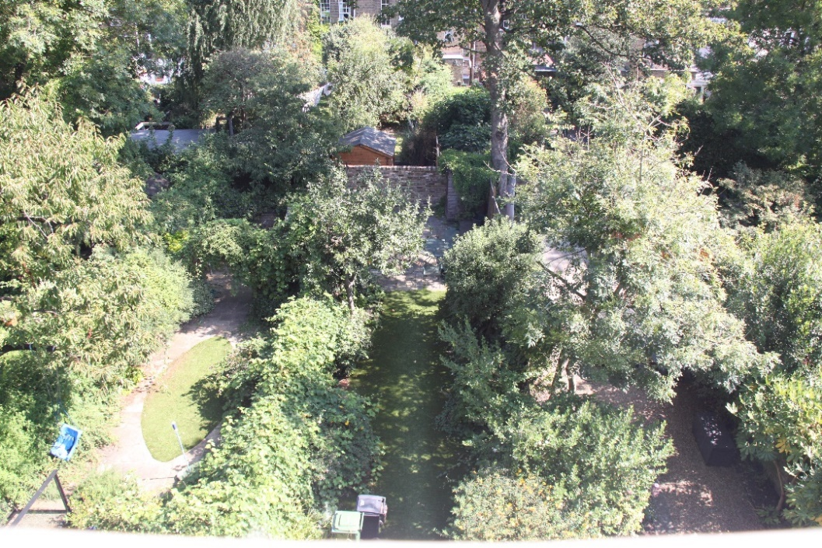

Photo of gardens of 98, 96 and 94 Albert Street with Arlington Road behind

**Water Run-Off**

The water on the roof of the garden room would be channeled into French drains by gutters.

**Site and Appearance**

The garden room will measure 4 X 4.5 meters externally, occupying only 16% of the total back garden space. Gardens in this block of Albert Street and those on Arlington Road backing onto Albert Street gardens, are very long, typically 25 metres and 31 metres respectively. As such the room will be 20 metres from the original houses on Albert Street.

The areas at the end of these gardens have trees, shrubs, garden walls, wooden fences and trellising. Therefore, the structure will be substantially concealed amongst these items. The back garden wall is 1.65 metres and in the property behind there is a shed bringing the total height to 2.35 metres. On the side with 94 Albert Street there is a cement bench and wooden fence at a height of 1.95 metres. On the side with 98 Albert Street there is a garden wall and trellis at a height of 1.9 metres. Therefore, there are no existing sight lines into the garden of 96 which would be impacted by the addition of the garden room.

To reduce the visual impact a green biodiverse Sedum roof will be used. The roof will consist of succulent drought resistant plants selected as suitable for the Camden location and to encourage local insect life. The roof plants require minimum maintenance but may need occasional watering during the initial period or during exceptional drought conditions.

The view from first story and higher windows of adjacent houses in Albert Street and Arlington Road will now be presented with a view of green area replacing the existing stone patio and garden shed.

It will also not be possible for anyone inside the proposed garden room to look out over adjacent properties.

There will be no light pollution as the glass in the doors will be fitted with integrated Venetian blinds.

**Landscaping and Root Protection**

No trees will be removed in the construction of this garden room. The room will be constructed over existing patio area and replace a cement bench and garden shed. The existing patio, cement bench and shed, which have been in place for at least 25 years, will be removed with care to avoid any possible root damage. The foundation to the structure will use a “screw base” method and care will be taken when inserting the screws to avoid root damage to existing trees.

The existing artificial lawn will be used as lay down during construction to avoid any damage to the existing garden landscaping.

**Access**

Access at the front of the property remains unchanged and access to the garden room would be via the back doors of the main dwelling house.

**Summary**

This proposed garden room would significantly enhance the space for family use, by providing an attractive room at the far end of a long garden. Due to the small proportion of the garden to be occupied by the room, the green roof and the surrounding trees and greenery, it would have a minimal impact to this area.