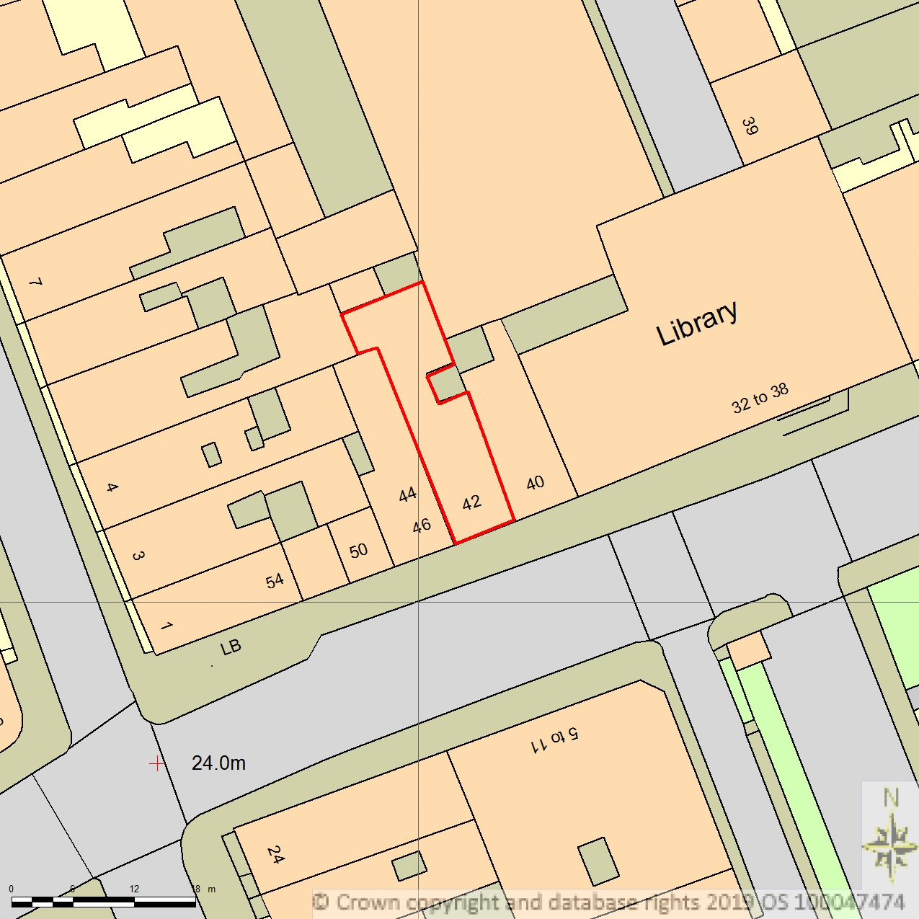
42 THEOBALDS ROAD WC1X 8NW
AREA 90m x 90m
SCALE 1:500 on A4
CENTRE COORDINATES: 530804, 181914



Supplied by Streetwise Maps Ltd
www.streetwise.net
Licence No: 100047474
29/07/2026 10:47:34

