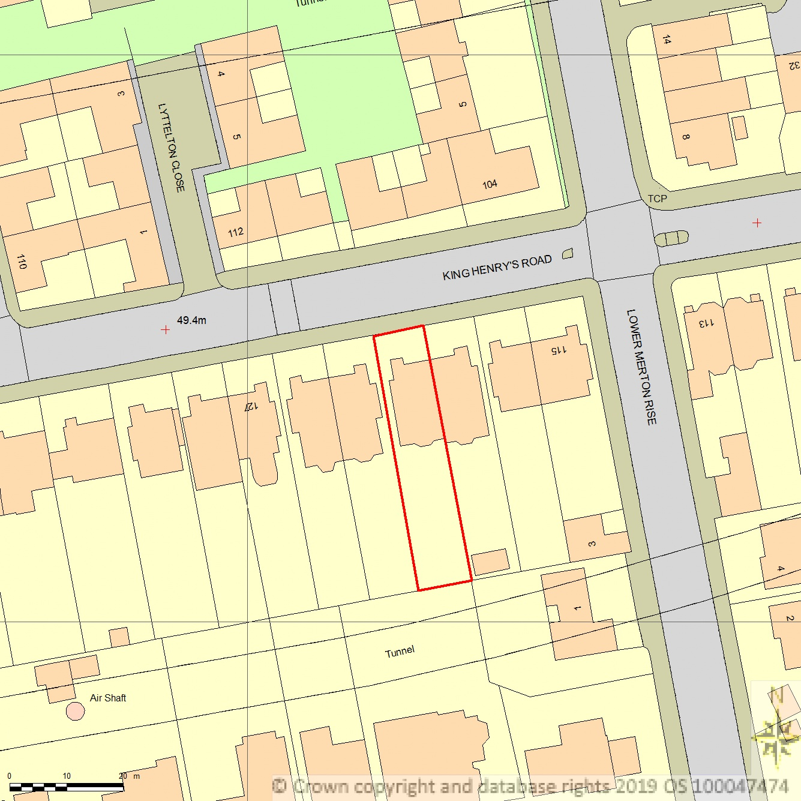
SITE LOCATION PLAN
AREA 2 HA
SCALE 1:1250 on A4
CENTRE COORDINATES: 527227, 184139



Supplied by Streetwise Maps Ltd
www.streetwise.net
Licence No: 100047474
30/07/2026 02:43

