**WORKS TO FRONT ELEVATION OF 10A SOUTH GROVE. LONDON N6**

**SPECIFICATION OF WORKS AND PHOTOGRAPHS**

**RAKING OUT**

Any existing defective pointing must be raked out to a depth usually equal to twice the width of the joint, but not less than 20 mm. The back of the joint should be roughly square in profile. The use of a [plugging chisel](https://www.mikewye.co.uk/product/plugging-chisel/) ensures that the stone or bricks aren’t forced apart. Do not use an angle grinder or similar type of equipment that may destroy the masonry.

**Damping**

After brushing out any loose material the joints must be dampened, with enough time left for the stone or brick faces to dry to prevent smearing. The mortar should be as dry as it is practicable to point with. This allows maximum compaction, reduces shrinkage and reduces the tendency to smear on the face of the masonry.

**MIXING**

Use natural hydraulic lime with mix of 3 parts sharp sand to 1 part NHL3.5 in areas designated to receive lime putty (arches etc.) with finish to match existing. Allow mortar to rest for an hour or two before knocking up prior to use. Pointing to be flush to match existing

**PHOTOGRAPHS**

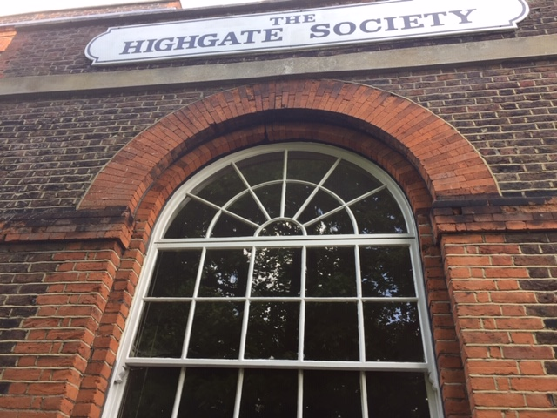

Photo 1. showing arch over front window

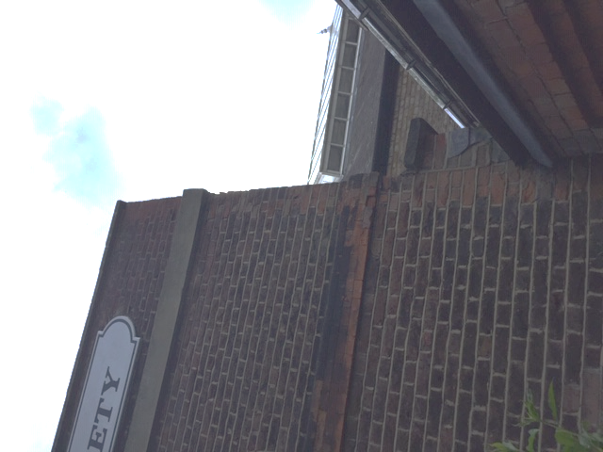

Photo no. 2 - showing spalled bricks on front elevation

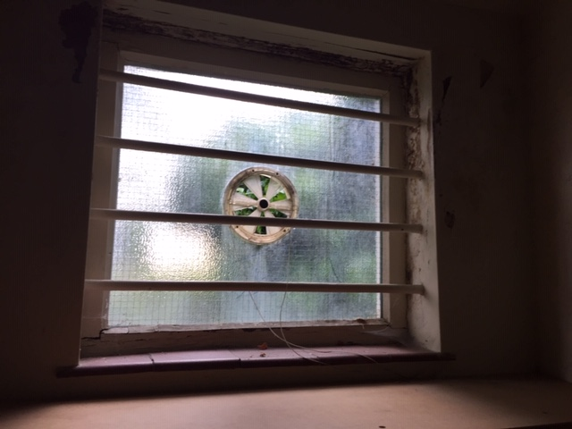

Photo no. 3 - window in rear lobby to be replaced (bars and vent will not be replaced)