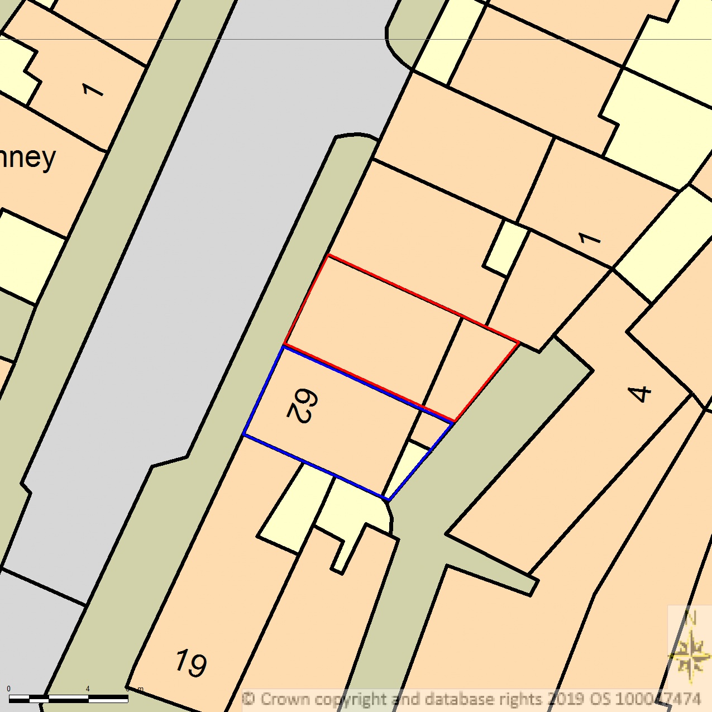
BLOCK/SITE PLAN
AREA 36m x 36m
SCALE 1:200 on A4
CENTRE COORDINATES: 526556, 185684



Supplied by Streetwise Maps Ltd
www.streetwise.net
Licence No: 100047474
28/07/2026 23:16:13

