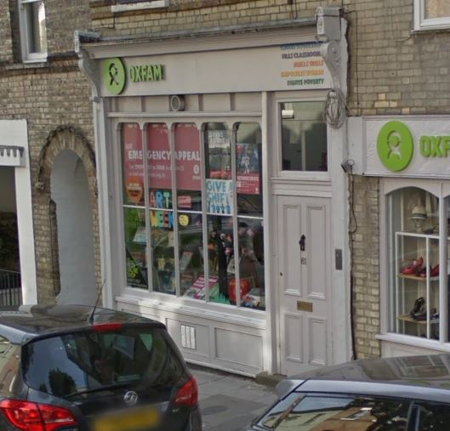

Onyx (Building Consultancy) LLP
Oxfam Store, 61 Gayton Road, Hampstead, NW3
Shopfront Alterations – Photo of existing shopfront
Scale: N/A Date: Nov 2019Drawing No. Ox/Hamp/05

