# Heritage and Planning Statement.

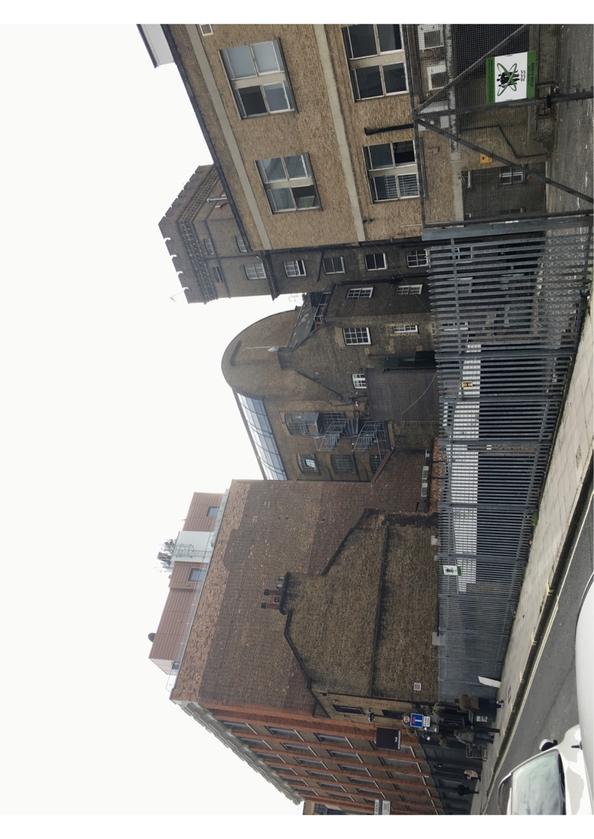

Description of Development:

The replacement of two timber windows at the rear of the property with new uPVC windows

Site:

16 Vine Hill,

Ragged House,

flat D,

EC1R 5DX

# Content Page

Site location and description

Pg. 3

Planning Policy

Pg. 4

Planning History

Pg. 4

Development Description

Pg. 4

Assessment

Pg. 5

Conclusion

Pg. 6

# Site location and description

The application site is located at the bottom of Vine Hill and positioned on its eastern frontage. The four-storey residential building is sandwiched between two larger buildings, The Ragged School to the north and a large office block to the south. The two adjoining properties are roughly two storeys higher than the one on the application building.

The application site consists of self-contained residential flats and this application relates to flat D, which is on the second floor of the building. As mentioned above the flats front onto Vine Hill with the rear of the site being visible from Eyre Street Hill.

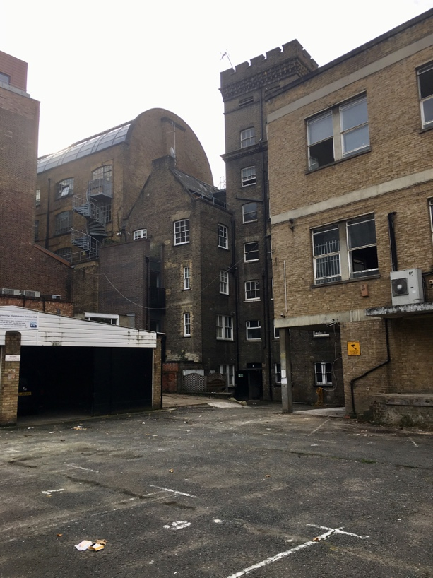 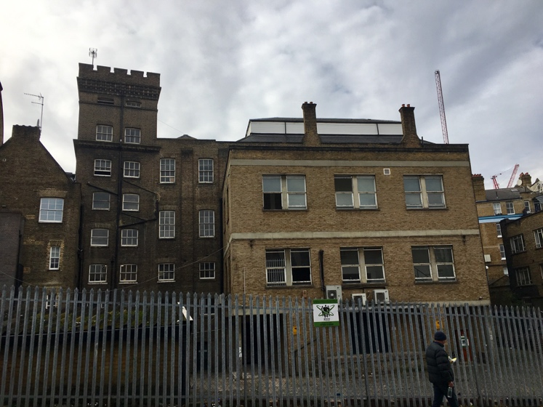

(Photos from the rear of the site, where the two windows are located)

Conservation area

The application site is not a listed building, but it is located within Hatton Garden Conservation Area. The Hatton Garden Conservation Area Appraisal (2017) acknowledges that the character of the conservation area derives much of its character from its robust detailed industrial, commercial and residential buildings of the late nineteenth to mid twentieth centuries.

The application site falls within sub-area 1: Rosebery Avenue which consists of a dense pattern of short, narrow, hilly streets, contained within a framework of three major thoroughfares. Th architectural character is strongly defined by the late nineteenth-century housing blocks and the large industrial. Overall the architectural character of this particular part of the conservation area is robust and strongly articulated though not highly decorative.

# Planning policy

National Planning Policy Framework (2012)

* Chapter 7

London Plan

* Policy 7.4 and 7.6

Camden Local Plan (2017)

* D1 Design
* D2 Heritage

Camden Planning Guidance

* Design CPG (2019)
* Altering and extending your home CPG (2019)

# Relevant planning history

Reference No: 2018/6016/P

Description: Erection of an 8 storey building comprising a 153 bed hotel (Class C1) with ancillary ground floor restaurant/cafe facilities (Class A3) and 10 flats (7 x 1 bed and 3 x 3 bed) (Class C3), excavation works to enlarge the lower ground floor level and create a lift pitt, following demolition of the existing rear annex and garages at 18 Vine Hill, together with refurbishment of 18 Vine Hill and the erection of a 3 storey extension to provide additional office accommodation (Class B1(a)), hard and soft landscaping and other associated works.

This proposed development would be located at the rear of the application site on the existing parking space for the adjoining properties.

# Development description

Full planning permission has been sought to replace two existing timber windows (see annotation on photograph below), with new uPVC windows at second floor level on the rear elevation. The existing windows are currently in a very poor condition and have become unsightly. The condition of windows along the entire rear elevations are all in a poor condition and the context is similar on the adjoining site at The Ragged School. Therefore, the replacement seeks to improve the appearance of the rear elevation.

The proposed uPVC windows are purposefully designed for conservation areas and aim to mimic the appearance of timber windows. Please see accompanying documents for further details.

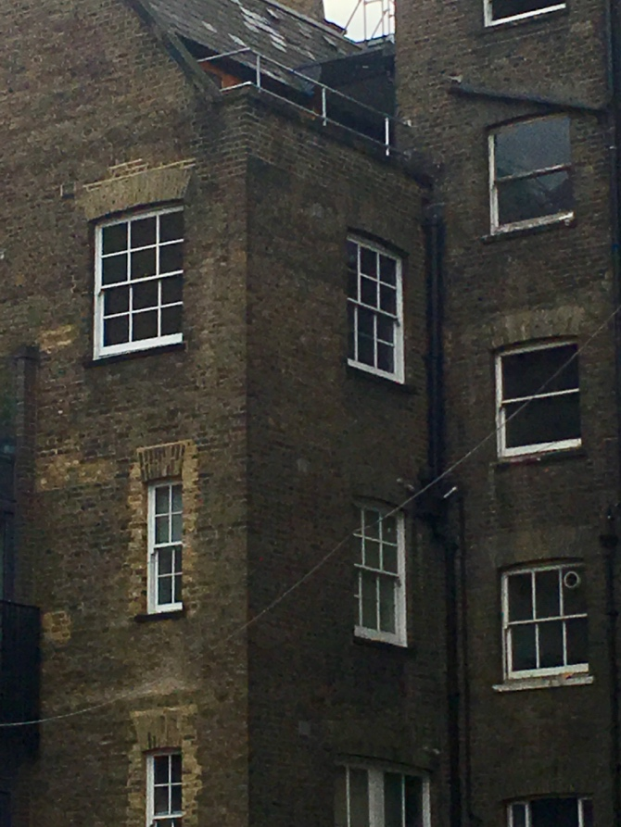 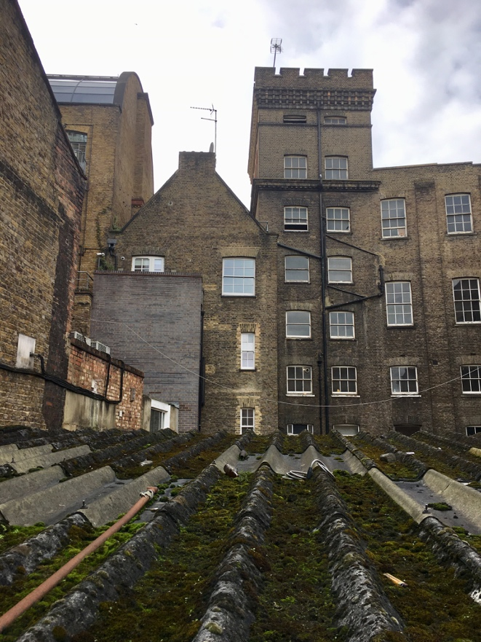

**1**

**1**

**2**

(rear elevation showing window 1 and window 2 to be replaced)

# Assessment:

Full planning permission has been sought for the replacement of two timber windows on the rear elevation of the second floor flat. The replacement windows would be uPVC that has been specifically designed for conservation areas.

Principle

The proposed development would not result in a change of use at the application site. Therefore, there are no land use issue. The principle material considerations that need to be determined for this application are specifically;

* The visual impact upon the character and appearance of the street scene and the Conservation Area
* The impact upon the neighbouring properties amenity.

Design and Conservation

As previously mention in this document, the site is located within the Hatton Gardens Conservation Area and falls within the Rosebery Avenue. The two windows that would be replaced are located at the rear of second floor flat, an area of the building that is not considered to be a prominent feature of the building nor is it easily seen from the street scene.

The rear of the building is significantly set back from the Eyre Street Hill. In addition to this, the rear of the application site is largely tucked behind the much larger ‘The Ragged’ building which has a part three storey rear extension which projects much further out than the rear elevation of the application site.

It is acknowledged that the two windows that will be replace would be partially visible from Eyre Street Hill, however, the immediate context needs to be taken into account. The windows on both the application site and the Ragged building are all in poor condition. This coupled with the fact that these windows all look out over an unsightly car parking/servicing area would suggest that the replacement windows would firstly be largely unnoticed and secondly be an improvement to this area of the conservation area.

The Hatton Gardens Conservation Area appraisal does acknowledge that the industrial character to the area does add value to its appearance. However, this specific part of the Conservation area is not considered to be located within a prominent part nor offer key attributes to its designation.

Policy D1 notes that, wherever possible, architectural features on existing buildings should be retained and that insensitive replacement of windows can spoil the appearance of the building. Policy D2 (Heritage) states that in order to maintain the character of Camden’s Conservation Areas, the Council will require that development within Conservation Areas preserves or where possible enhances the character or appearance of the area.

As previously mentioned, the context at the rear of the property comprises of a series of poor-quality windows, all of which have a harmful impact on its setting. The new conservation style windows would enhance the appearance of the flat and its setting within the Hatton Gardens Conservation Area. Therefore, the proposed replacement of timber to uPVC windows is not considered to have a harmful impact on the character of the host building nor the Hatton Garden Conservation Area.

Impact on the neighbouring properties amenity space

The proposed development would not introduce any new viewpoints from the application site. The outlook from both of the windows are already established and the size of the window would not change. As such, the propose development would not result in overlooking, other than what is already established. The proposed development would not have a detrimental impact upon the amenity of the neighbouring properties.

# Conclusion

Full planning permission is sought for the replacement of two timber windows on the rear elevation of the second floor flat. The replacement windows would be conservation styles upvc. It is considered that the replacement windows would not have a harmful impact on the setting of the application site nor harm the character of the Hatton Garden Conservation Area. In addition to this the proposed development would not have a harmful impact on the neighbouring properties amenity space. As such, is considered that this application acceptable and that planning permission should be granted.