Hampstead Hill School, Pond Street NW3 2PP

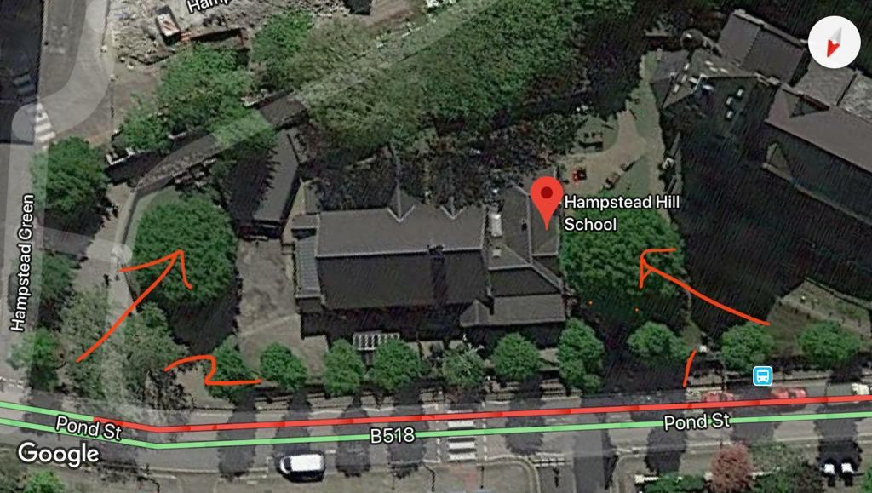

T1: Oak

T2: Oak