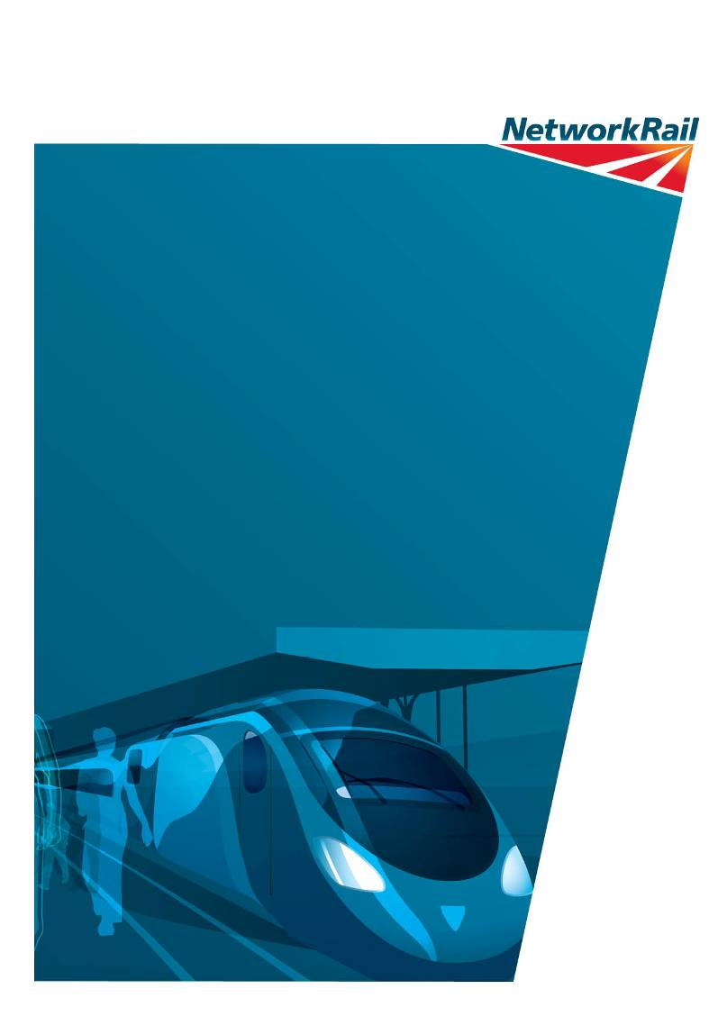
November 2019

design & access and heritage statement in support of proposed Installation of weatherproof covering structure over collapsed vault ceiling and access stairwell from track level to the interior for inspection and maintenance purposes to camden winding vaults, gloucester avenue, camden
Introduction
This document is intended to outline the programme of works proposed to be undertaken at the Grade II* Camden Winding Vaults. The scheme proposals involve the installation of a weatherproof concrete covering structure over a collapsed vault ceiling and the installation of an access stairwell from track level to the interior for inspection and maintenance purposes.
The ‘proposals’ section below explains the works in further detail, setting out the rationale and justification for the proposals. This will also include analysis of the proposals’ heritage implications to satisfy the requirements of the National Planning Policy Framework and relevant local planning policy.

Planning Policy
Relevant National and Local planning policy is outlined below:
National Planning Policy Framework
The NPPF sets out the Government’s vision for planning to help achieve sustainable development. Central to this is that economic, social and environmental gains should be sought through the planning system. The NPPF’s approach to Heritage is fundamentally unchanged from that of PPS5, in that there is still a focus on the identification of ‘heritage assets’, outlining their ‘significance’ and considering any impact upon that significance as a consequence of any proposed works.
NPPF paragraph 128 establishes the information requirements for an application for consent affecting a heritage asset. Local Planning Authorities (LPAs) should require an applicant to describe the significance of any heritage assets affected, including any contribution made by their setting. The level of detail should be proportionate to the assets’ importance and no more than is sufficient to understand the potential impact of the proposal on their significance.

Paragraph 129 details the policy principles that should guide LPAs in determining applications in relation to heritage assets. It states that in considering the impact of a proposal on any heritage asset, Local planning authorities should identify and assess the particular significance of any heritage asset that may be affected by a proposal (including by development affecting the setting of a heritage asset) taking account of the available evidence and any necessary expertise. They should take this assessment into account when considering the impact of a proposal on a heritage asset, to avoid or minimise conflict between the heritage asset’s conservation and any aspect of the proposal.

When determining applications, LPAs should take account of (paragraph 131):
- the desirability of sustaining and enhancing the significance of heritage assets and putting them to viable uses consistent with their conservation;
- the positive contribution that conservation of heritage assets can make to sustainable communities including their economic vitality;
- the desirability of new development making a positive contribution to local character and distinctiveness.

Paragraph 132 states that when considering the impact of a proposed development on the significance of a designated heritage asset, great weight should be given to the asset’s conservation.

National Planning Practice Guidance (2014)
The NPPG underpins national policy set out within the NPPF. Further guidance in relation to Conserving and enhancing the historic environment states that:
In the case of buildings, generally the risks of neglect and decay of heritage assets are best addressed through ensuring that they remain in active use that is consistent with their conservation. Ensuring such heritage assets remain used and valued is likely to require sympathetic changes to be made from time to time.

Camden Local Plan

Policy D2 - Designated heritage assets

Designed heritage assets include conservation areas and listed buildings. The Council will not permit the loss of or substantial harm to a designated heritage asset, including conservation areas and Listed Buildings, unless it can be demonstrated that the substantial harm or loss is necessary to achieve substantial public benefits that outweigh that harm or loss, or all of the following apply:
a. the nature of the heritage asset prevents all reasonable uses of the site;
b. no viable use of the heritage asset itself can be found in the medium term through appropriate marketing that will enable its conservation;
c. conservation by grant-funding or some form of charitable or public ownership is demonstrably not possible; and
d. the harm or loss is outweighed by the benefit of bringing the site back into use.
The Council will not permit development that results in harm that is less than substantial to the significance of a designated heritage asset unless the public benefits of the proposal convincingly outweigh that harm.

Listed Buildings

Listed buildings are designated heritage assets and this section should be read in conjunction with the section above headed ‘designated heritage assets’. To preserve or enhance the borough’s listed buildings, the Council will:
i. resist the total or substantial demolition of a listed building;
j. resist proposals for a change of use or alterations and extensions to a listed building where this would cause harm to the special architectural and historic interest of the building; and
k. resist development that would cause harm to significance of a listed building through an effect on its setting.

Significance of Heritage Asset
In order to assess the heritage significance of the site, in accordance with the provisions of the NPPF, it is important to make reference to heritage values as defined in the Historic England document Conservation Principles, Policies and Guidelines, which can be summarised as follows:
- Evidential value – the potential of a place to yield evidence about past human activity (i.e. archaeological interest)
- Historical value – the ways in which past people, events and aspects of life are connected through a place.
- Aesthetic value – the ways in which people draw sensory and intellectual stimulation from a place (i.e. architectural and artistic interest)
- Communal value – the meanings of a place for the people that relate to it.

Having regard to the above, the Winding Vaults can be said to provide significant and notable historical value, as noted in the List Description, by virtue of the site’s association with engineer Robert Stephenson, by being a notable engineering feature of the London and Birmingham Railway. The winding engine vaults represent, as one of the very last uses of rope haulage on a public railway, a relatively brief transitional stage in the technological development of railway transportation;.
Having regard to the site’s historic value, the Historic England document ‘Designation Listing Selection Guide: Transport Buildings’ (2017) is of particular importance when assessing the historic value associated with railway infrastructure. This sets out four ‘ages’ of railway construction which, in descending importance, is as below:
- • The pioneering first phase, 1825–41;
- • The heroic age, 1841–50;
- • The third phase 1850s–1870s, the consolidation of the network; and
- • The fourth period, up to 1914, the completion of the network.

Given the construction date of 1833-8, it is apparent that the site stems from the very first ‘heroic’ phase of railway construction. Therefore, by virtue of the structure’s age and, by extension, its association with the very first wave of railway construction, there is strong historic significance attributable to it. Further historical significance is attributable to the association between the site and the engineer responsible for overseeing its design and construction – Robert Stephenson, who is most famously associated with his father, George Stephenson – know as ‘The Father of Railways’
Turning to the aesthetic value attributable to the site, there is clear significance by virtue of the structure’s scale, materials and architectural detailing. The site was listed at Grade II* in June 1990. The List Description (see Appendix below) sets out full details of these qualities.

Proposals and Assessment of Impact upon Heritage Significance
The Camden Winding Vaults are a complex series of vaulted masonry arch and concrete structures located in the Borough of Camden, North West London. The Vaults are located below ground level between Euston and South Hampstead Stations and to the North side of the Grand Union Canal (OS Ref: TQ 2810 8420).

The Vaults were designed by Robert Stephenson and is a Grade II* listed status. The vaults were
opened in 1837 and ran for 7 years until their closure in July 1844. • The vaults were built to house steam winding engines powering a rope haulage system. The system was used to pull carriages from Euston to Camden up the steep grade track over Primrose Hill to ease concerns of polluting locomotives. The vaults have since been flooded and silted. Once the winding engine operation had ceased, the steam engines were sold and removed via the north-east boiler room. The vaulted roof above the boiler room was demolished to allow their removal.

The engine house consists of four parallel vaulted underground chambers beneath the railway track, each approximately 35m long by 4.5m wide and 7m high, with a 2m wide central passage between the two inner vaults with seven arched openings into the main chambers. At the north-west end, there is a large longitudinally spanning engine chamber arch which housed the twin steam engines and 20ft diameter drive wheels. The engine chamber is flanked by two boiler chambers with workshops attached.

Intrusive works have been carried out by consultants instructed by Network Rail to determine barrel thicknesses, the status of HCE’s and topside fill levels and to undertake a topographical and laser cloud surveys of the Vaults and supported rail infrastructure.

Nature of Defect:
Pumping systems are in operation to dewater the vaults and a lighting system has been installed. A large volume of silt which was present on the Vaults floor following dewatering, has been removed to improve accessibility for works. Structurally the vaults appear to be in fair condition. The high-water level marking is evident throughout the vaults and there is little evidence of mortar loss throughout. There are isolated areas of spalled brickwork throughout the vaults, although these are mainly in the collapsed boiler room. The main defect is the collapsed roof which leaves a void approximately 6m wide x 7m long. The original brickwork arch was 4No rings thick.

Priority (effect of no action or deferred)
The on-going maintenance and repair of Camden Vaults is considered a high priority due to the planned passage of heavy loaded freight trains carrying spoil as part of HS2 works over the structure. Furthermore, due to the existing poor access provision and a structure which has been largely flooded and silted for years, maintenance works have not been adequately carried out to date.

Options Commentary:
The following options have been considered:

- 5no feasible solutions are proposed for the LEC1/10B superstructure reconstruction
- 3no solutions for provision housing for control panels and equipment
- 3no solutions for provision of improved access in to the North-East boiler room

Solutions have been compiled following site works carried out in December 2017 (TOPO, Laser Scanning and Ecology Inspection by AECOM) and March 2019 (HCE and Trial Pits by Bridgeway). It is assumed for all solutions that the existing structure shall remain in place and a minimal level of demolition will occur, purely to facilitate construction works and assist in preserving the significance of the Grade II* listed structure

.
DECK SOLUTIONS:
All deck solutions have been developed considering the local environment and in particular the site constraints, re: the presence of adjacent boundary fence to Morrisons Yard, proximity to the electrified lines running to/from Euston Station and condition of the existing listed structure.

Option 1.1 – Brickwork Arch Reconstruction
The proposal to reconstruct the collapsed ceiling in the form of the original vaulted brickwork arch. The existing brickwork around the collapsed ceiling are to be repaired and modified where required, to allow construction of the new brickwork arch. The new arch will be pinned at the spandrel wall and springer level to ensure stable connections.

The main advantage to this solution is; the potential to provide an industry leading solution for innovation and renovation to a historic Grade II* listed arch structure. The solution however requires a high degree of workmanship which is not common in modern construction techniques/skills, therefore incurring higher construction costs and an extended programme.

Option 1.2 – Reinforced Concrete Arch
Provision of a Reinforced Concrete arch supported on the existing pier supports. Remnants of the existing collapsed arch are to be broken out down to springer level along with the pier on the collapsed side. Cast insitu reinforced concrete springer beams will be located above the existing piers by forming needlebeams/springers doweled into the existing brickwork.

The main advantages to this solution are; retaining of an arch profile to match the existing structure and provision of a load path through the structure in keeping with the intended arch structure, therefore ensuring suitability of the existing piers. The solution however will present a restricted and complex construction programme in a very restricted site when attempting to land precast arch beams. Additionally, due to the mechanics of arch stability, the size of void/hatch available through the structure for access is limited.

Options 1.3 – Two-way Composite Slab
Construction of a composite concrete/steel slab with provision for future access void/opening. Concrete pad footings will be installed at ground level around the extents of the boiler room and spiral staircase to support steel beams crossing the collapsed space. A composite slab with access hatches will be constructed and installed on to the steel beams. The main advantages to this solution are; the versatility of the solution which can be adapted from standard details to suit the site and the potential ‘reversibility’ of the solution through use of bolted connections. The solution however, due to its metallic frame form, will increase the maintenance frequency of the structure over RC alternatives. The solution additionally requires modification to the existing boundary fence line which is currently in the wrong location and spans over the remaining structure.

CONTROL PANEL HOUSING OPTIONS:
The following are options for housing of the Camden Vaults lighting and pumping system control panels. There is a Network Rail requirement that options should provide a secure and watertight solution to mitigate the risk of damage and/or tampering.

Option 2.1A- Building and Vault Ceiling Reconstruction
This involves the provision of a lightweight building sat directly on top of a reconstructed arch ceiling. The provision of such a system will require the integration of an access solution into the ceiling reconstruction itself, accessible from the Building. The purpose of the building is to provide a secure access point for inspection/maintenance team with consideration of plant/equipment and for locating of lighting and pumping systems.

The main advantage of the solution is the integrated use of a building and ceiling reconstruction solution to contain the access within as small an area as possible, therefore decreasing the utilised lineside space. The solution reversely however, whilst fulfilling all of the clients and Historic England’s requirements, is costlier than option 2.1B below due to the increase in material volume and construction period.

Option 2.1B – Building over Collapsed Vault Ceiling
The erection of a lightweight building spanning the entirety of the collapsed roof to provide permanent security and weatherproofing to the Vaults. In such an instance, a ceiling reconstruction is not required. To facilitate access of personnel and equipment/plant, access into the building is gained directly onto a raised modular industrial platform which is located within the Vaults itself on RC spread footings.

The main advantage of the solution is the reduced construction costs associated with a lightweight building in omission of a ceiling reconstruction. The solution is additionally entirely reversible due to its modular connected form. Comparatively, the disadvantages to this solution are as follows; realignment of the existing boundary fence is required along in addition to any access solution (and winch/lift) being fully self-supporting in absence of a ceiling reconstruction.

Option 2.2 – Trackside Cabinet
The provision of trackside cabinets on Reinforced Concrete spread footings to house the Vaults Lighting and Pumping system control panels. The provision of a trackside cabinet is utilised in the event that the arch ceiling is made watertight without the provision of a lightweight shed/building on top/over the existing collapse.

The main advantages of this solution are; the potential to reduce construction costs with no lineside building, reduced loads on any deck reconstruction and the reduced lineside space utilised in absence of a building. The solution however omits a key element of the clients remit in that, by providing a lineside cabinet and no building over a ceiling access hatch, difficulty remains in access the vaults with large equipment for maintenance.

ACCESS PROVISION OPTIONS:
The following are options for access into the vaults in conjunction with reconstruction of the collapsed ceiling and/or control panel housing solutions. Lifts/platforms and staircases are considered as the primary access function. For safety reasons, ladders with application of safety caging have been considered but only as a secondary/emergency form of access in the event that the primary access is not functioning or is inaccessible.

Option 3.1 – Renovation of Existing Staircases
The proposal to carry out maintenance and repair/renovation to the existing spiral staircase. Located to the Low Mileage of the collapsed arch vault (Chamber I) and providing access directly into Chamber I2. The use of the existing staircase will mitigate the requirement for any ceiling reconstruction to have an access chamber/void, therefore producing a more efficient design and reducing material requirements. Renovation of the existing staircase would also reduce the need for a trackside building for secure system controls.

The main disadvantage of renovating the existing staircase, in comparison to new access solutions however, is the limited access of larger equipment. Alternative solutions provide significantly improved access into the Vaults of larger equipment/plant for future maintenance, this was a key client requirement. Whilst the solution is therefore by far the cheapest access solution, it does not fulfil the remit in its entirety.

Option 3.2 – Modular Industrial Staircase with Winch System
Construction of a manufacture standard modular staircase system to provide access from topside to ground level within the Vaults. Upon selection of control housing Option 2.1B, a modular staircase can be incorporated directly into a self-supporting lightweight structural platform which is supported on spread footings from within the Vaults. Where Option 2.1A is selected and a ceiling is reconstructed, steps can be provided directly from the void/access opening within the constructed ceiling roof. To facilitate entry to the vaults of larger equipment
and plant, not suitable for carrying down stairs, a winch system is to be installed. It is considered that only a small electric chain type hoist is required for the purpose of lowering the likes of; scaffolding, small generators, coring rigs, etc. into the vaults.

The main advantages to this solution are; design flexibility of a lightweight modular system to suit the chosen ceiling/building configuration, lower associated installation and maintenance costs in comparison to lift solutions and the reduced risk of failure due to water within the silted and partially flooded Vaults. The solution is however required to support a winch system. Whilst only a small winch system is proposed, the manufacturer will have to take this into a count and will likely cause the system to stray away from any available standard details/solutions. In addition, it is believed that a winch system imposes safety risks whilst in operation not present with an alternative lift option.

Option 3.3 – Industrial Lift/Platform and Emergency Ladders
Provision of an industrial lift/platform for use of inspection/maintenance team and for entry of larger equipment/plant into the Vaults. The proposed includes a fully self-contained and self-supporting lift system with no requirement for the Winding Vaults or any ceiling reconstruction to support loads from the system. It is proposed that a modular steel lift shaft is specified for design and construction.

The main advantage of lift provision is the significantly improved access capability of large plan, far superior to that provided with a stepped and winch system configuration. The main advantage of lift provision is the significantly improved access capability of large plan, far superior to that provided with a stepped and winch system configuration.

Option Selection
Following a review of the available options and taking account of various factors for design suitability, future loading conditions and ongoing maintenance, the combinations of options defined below are considered the most appropriate interventions.

Option 1.4: Two-Way Reinforced Concrete Slab
The main reasons for recommending this option are the simple design and that it will require minimal future maintenance when compared to the composite slab and steel deck option. A two-way reinforced concrete slab will likely be heavier than a composite slab or steel deck and this may help stabilise the spandrel walls on the rail side bearing load from open lines of rail traffic. Provision for an access hatch can also be accommodated within a two-way slab with relative simplicity in comparison to a one-way spanning arch system of which would require significantly increased section depths and reinforcing.

Option 2.1A: Building and Vault Ceiling Reconstruction
By providing a small modular trackside building, secure, waterproof lineside access to the Vaults can be provided as per the Clients remit. The structure may be designed to accommodate various forms of access, including provision of equipment/plant entry to the Vaults and house the Lighting and Pumping system controls in a small cabinet prior to descent. Other solutions available either; don’t facilitate suitable secure, waterproof access (Option 2.1 and 2.2) or, require a far greater area of land take therefore obstructing movements down the Main Line 4ft (Option 2.1B). A backup system is to be located in a secure cabinet, as per Network Rail’s requirements within the horse tunnel to facilitate control of systems from the alternate access.

Option 3.2: Modular Industrial Staircase with Winch System
Provision of a modular industrial staircase with a Winch system is deemed the most suitable access method for numerous reasons including; a reduced construction fee in comparison to a lift/platform solution, flexible quick access method for of use by inspection/maintenance teams with smaller hand-held tools and equipment and minimal founding requirement for light weight solution.
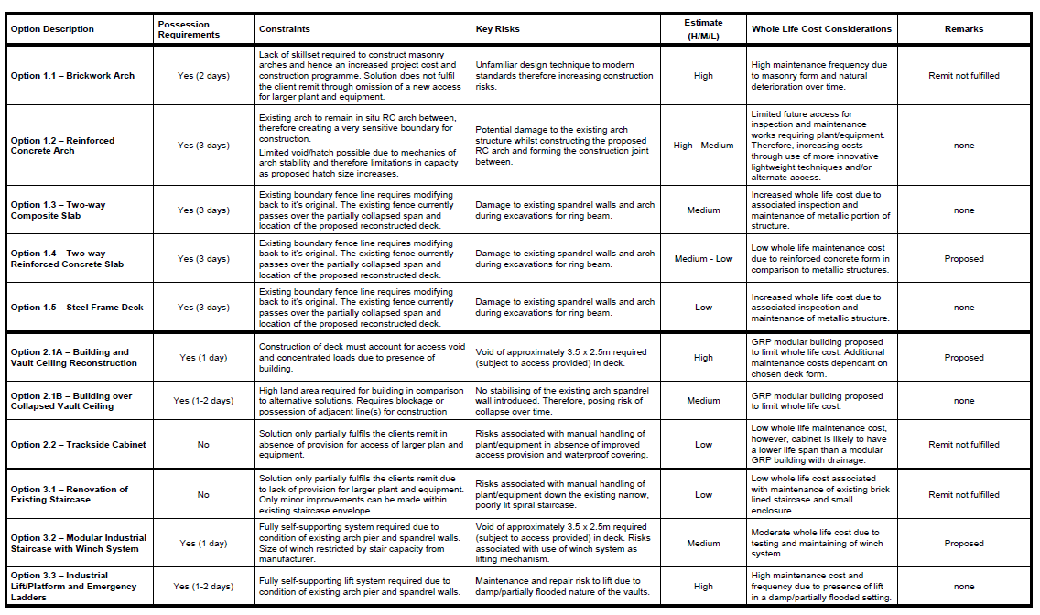
Throughout the design process, Network Rail has sought to ensure that the intervention to this important historic structure achieves the most appropriate balance between preserving the site’s significance and the need to address observed defects explained above. As part of this, Network Rail sought the input of Historic England at pre-application stage. Positive feedback was received that was supportive of the principle of intervention and also the specific design option selected.

The scheme proposals will remedy a long-standing defect with the structure. Once complete, the works will ensure that the structure is adequately weatherproofed, which will therefore result in a positive achievement for the site’s longer-term preservation. The works will not cause undue harm to the site’s heritage significance and the proposals are therefore considered to accord with the provisions of Camden Local Plan Policy D2.

To summarise, it is considered that the proposals will not generate harm to the overall context of the site’s architectural qualities, and its historical significance will in no way be harmed by the scheme proposals.

At the national level, the scheme is considered to be in conformity with the general thrust of relevant legislation, including paragraphs 131 and 132 of the NPPF.

Conclusion
It is considered that the works proposed are respectful to the character and appearance of the listed structure. There is a sound justification for the proposed works. This will be done in a manner that is respectful to the heritage significance of the site.

In light of the above, the proposals are considered to be in accordance with relevant policy. Consequently, it is requested that Listed Building Consent be granted for the proposed development.
Appendix: List Description
Winding engine house, now railway vaults. 1837. By Robert Stephenson for the London and Birmingham Railway.
DESCRIPTION: The engine house, built of brick to a symmetrical plan, consists of four parallel vaulted underground chambers beneath the railway track, each approximately 35m long by 4.5m wide and 7m high, with a 2m wide central passage between the two inner vaults with seven arched openings into the main chambers with groined vaulting. At the north-west end the parallel vaults connect two transverse vaults. The larger, approximately 23m long by 9m wide and 5.5m high, housed the twin 60 horse power condensing engines and 20 foot diameter drive wheel. Directly to the south-east, the smaller transverse vault originally housed parts of the winding mechanism consisting of two pulley wheels (of 20 and 12 foot diameter) with the drive rope emerging via the south-east vault and re-entering through the north-east. The engine chamber is flanked by two boiler chambers with workshops attached to the south-east and the bases of the demolished chimneys to the north-west. The boilers appear to have originally been housed in unvaulted pits (contemporary colliery boilers were often housed in the open for greater ventilation), surrounded on the surface by tall walls and either open to the sky or, possibly, with a flat roofed covering. The boiler chamber vaults probably date from the closure of the engine house and the vault to the north-eastern boiler chamber has partially collapsed.
The two central parallel vaults housed the rope tightening mechanism; they have wells at the south-east end for the counterweights which kept the ropes taught (now filled with debris) and a line of four circular openings in the crown of each vault, possibly to provide ventilation when the vaults were sealed in 1849. The outer vaults contained chambered coal stores. These have ten cast-iron beams across the vault, approximately 3m above floor level, and cast-iron brackets of unknown purpose fixed along the walls. All machinery has been removed.
The vaults were reached from track level by spiral stone stairs to the engine room, which have been damaged and infilled with rubble. These originally emerged in a small hut used by the operator who signalled for the engines to start on receipt of a pneumatic signal from Euston. There are also smaller extant spiral stairs to each boiler room. Coal was taken from the canal through a tunnel to the engine room (which was subsequently blocked off).
HISTORY: The London and Birmingham Railway (L&BR) was the first truly long distance passenger railway in the world, following the successful experiment of the shorter Liverpool and Manchester Railway in 1830, on which locomotive traction for passenger and goods traffic was demonstrated to be feasible. Engineered by Robert Stevenson (1803-1859), the L&BR received its first Act in 1833 with a terminus at Camden station. Subsequently, a site became available in Euston Square, and the company obtained an additional Act in July 1835 to extend the railway to the New Road, with Camden Depot subsequently used for goods traffic, including livestock. The first section of railway was opened from Euston to Boxmoor, near Hemel Hempstead, on 20 July 1837 and in October that year it was operational as far as Tring. The whole line from London to Birmingham was opened on 17th September 1838, becoming the first main line trunk railway with a London terminus.
Hilly terrain to the north of London posed an obstacle, and major excavations were required to bring the line through it, especially Primrose Hill tunnel and Primrose Hill cutting. Despite these works, the last mile of the line had to descend to Euston on an average gradient of 1 in 85. There is debate about the reason for the construction of the steam-powered winding engine to haul trains up the incline. It was either thought necessary over fears that it was too severe a gradient for railway's early locomotives to tackle, although they were used on similar gradients on the earlier Bolton and Leigh and Warrington and Newton railways, or alternatively it was due to opposition to locomotives from local interests.
Cable haulage using fixed engines had been used as early as 1803 on the otherwise horse-drawn Preston and Walton Tramway, prior to the invention of the locomotive. Subsequently, the majority of early steam railways used fixed-engine cable haulage for steep gradients including the Stockton and Darlington (1825); Springwell Colliery Railway (Bowes Railway - 1825); Canterbury to Whitstable (1830); at Edge Hill on the Liverpool and Manchester; and the Cromford and High Peak (1831). The alternative reason for the use of rope haulage at Camden was given by Peter Lecount, an assistant L&BR engineer, in his 'History of the Railway connecting London and Birmingham' (1839) - "It is not because locomotives cannot draw a train of carriages up this incline that a fixed engine and endless rope are used, for they can and have done so, but because the Company are restricted, by their Act of Parliament, from running locomotive engines nearer London than Camden Town". The clause in the Act is thought to have been introduced by Lord Southampton, an important local landowner, who feared that smoke-belching locomotives would reduce property values. However, an accommodation was clearly soon reached as locomotives were in use on the incline from its opening in July 1837 until the winding engine came into operation in October of that year, and thereafter when the winding engine was out of action.
The steam-powered winding engine apparatus, hauling an endless rope to draw trains out of Euston, was established at the top of the incline, at Camden station, close to the Regents Canal. The engines were placed underground in a barrel-vaulted chamber. These consisted of two 60hp engines and associated boilers and winding machinery, supplied by the firm of Maudsley's of Westminster Bridge Road. Two chimneys, over 132ft (40m) tall, stood adjacent to the engine chambers, flanking the railway on either side. The rope was 3744 yards (3423.5m) long (claimed to be the longest unspliced rope on record), of 7 inches in circumference and weighed 11.5 tons; to keep it taught it was passed round a pulley on a moveable counterweighted carriage before emerging on the surface between the rails. The engines were supplied with coal via a tunnel which ran from the vaults to a dock on the Regent's Canal. Trains of up to 12 carriages were hauled up from Euston to Camden station (at a speed of between 15 and 20 miles per hour), where locomotives waited to take the trains onwards.
The construction of the London and Birmingham Railway was depicted by the artist John Cooke Bourne and published as lithographs in 1839. They include a view of the construction of the stationary engine house as it appeared in April 1837, with the walls partially completed and centering being erected for the vaults. This print has often been referred to as illustrative of the energy and large-scale enterprise of the early railway age.
The winding engine operation ceased in July 1844, after a debate in 1843 between the Company and Robert Stephenson as to their continuing viability. The Company decided that savings in time and money could be made by using larger locomotives on the incline, albeit with two locomotives usually required. Stephenson argued that the savings were minimal but he lost the argument and in 1847 the winding engines were sold and removed with the chimneys being demolished in 1849. The vaulted chambers survive underneath the modern electrified railway trackbed, and were listed at Grade II in 1990.
SOURCES Camden Railway Heritage Trust, Camden Railway Heritage Trail - Primrose Hill to Camden Lock and Chalk Farm (2009) Morriss, R, The Archaeology of Railways, Tempus (2003) Simmons, J and Biddle, G, The Oxford Companion to British Railway History (2003) Smith, D, Civil Engineering Heritage: London and the Thames Valley, London (2001) Royal Commission on the Historical Monuments of England - Historic Building Report on the Camden Incline Winding Engine House (1995)
REASONS FOR DESIGNATION: The Camden Incline Winding Engine House is designated at Grade II* for the following principal reasons: * Historical and technological Interest: as a remarkable survival of international importance, of a notable engineering feature of the London and Birmingham Railway, the first of all modern main line railways to London (1833-8). The winding engine vaults represent, as one of the very last uses of rope haulage on a public railway, a relatively brief transitional stage in the technological development of railway transportation; * Architectural interest: for the grand scale and unique design of their underground brick construction; * Group value: with the nearby and associated London to Birmingham Railway structures of Primrose Hill tunnel and the Roundhouse, both listed at high grades.

Network Rail
One Eversholt Street
London
NW1 2DN

www.networkrail.co.uk

