**MB DESIGN & BUILD LTD**

Chartered Architects & Planning Consultants



                                        





Our ref: 9232-16.9/MB/FB

August 2019

## DESIGN & ACCESS / HERITAGE STATEMENT – CHANGE OF USE OF 1NO. BT PHONEBOX TO 1NO. RETAIL UNIT @ OUTSIDE “THE BRITISH MUSEUM”, GREAT RUSSELL STREET, LONDON, WC1B 3DG.

1. Use

1.1 The proposal involves a change of use.

2. Amount

2.1 The proposal does not involve any increase in the size of the development.

3. Layout

3.1 The proposal does not involve any changes to the layout of the site.

3.2 As per previous planning consents for similar developments in several locations around the UK, no external paraphernalia will be added to the site.

4. Scale

4.1 The footprint of the site remains unaltered by the proposal.

5. Landscaping

5.1 The landscaping remains unaltered by the proposal.

6. Appearance and Design

6.1 The K2 and K6 red phone boxes are iconic pieces of both engineering and architecture. The aim of this proposal is to redefine their usage to suit modern-day needs and requirements without compromising their external appearance on the street scene.

6.2 The box is Listed and is in a conservation area, so careful consideration has been given to preserving both the box and its relationship to the conservation area. No external alterations are proposed and so the relationship with, and effect on, the conservation area remains unchanged by the proposal.

6.3 Given its Listed status, careful consideration has been given to update the use of the phone box but at the same time maintain its character. The external appearance of the phone box(es) remains unaltered by the proposal, with the exception of the introduction of a piano-style hinge installed behind the existing “PULL” plate in order to allow access to the locking mechanism. The lock will be a five-lever mortice lock providing out-of-trading-hours security.

6.4 Externally, the phone box(es) will remain painted in BT phone box red (BS381 539 “Currant Red”), and a rolling maintenance programme will see the kiosks fully refurbished every two years. The maintenance programme will entail a complete overhaul, to include all exterior and interior paint and associated works, carried out by Alpha Group Ltd, http://www.alphaukgroup.com, or by Decor Facilities Management Ltd, www.decorfm.co.uk. All paint used will be the same as that currently used by BT. The method statement for refurbishment will be as follows:

1)      Sugar soap wash the boxes throughout after stripping the phone apparatus.

2)      Strip back frame and lead fill and micro resin bond any cracks and imperfections on the frame and panels.

3)      Apply one coat zinc oxide metal primer undercoat.

4)      Apply one coat of BS referenced BT approved red paint, and then key surface to receive a final coat of topcoat over the entire kiosk.

1. Apply one coat Hammerite Metalshield paint, colour black, to the skirt.

6.5 The existing glass panels will be replaced with 4mm-thick thermally toughened soda lime silicate safety glass to BS EN 12150-1:2000 in order to provide security and longevity of use. The glass used is supplied by Piper Glass and has been fitted in phonebox restorations for the last 27 years by Unicorn Kiosk

Restorations, Unicorn Estate, Nutfield Road, Merstham, Surrey, RH1 3ER; www.unicornkiosks.com. Case study reference:

<http://www.piperglass.co.uk/case-study-unicorn-kiosk-restorations.php>

6.6 Internally, the existing telephones and associated equipment will be removed back to the original shell. The new fully self-contained modular kiosk unit will not have any fixings to the carcass or floor plate of the phone box and can easily be moved in and out manually within minutes. The door of the kiosk will remain closed unless a customer is being served.

6.7 The modular kiosks will be serviced every day in respect of dry stock, water and / or saleable goods. In conjunction with the delivery of goods, waste removal will be part of the same daily process, whereby the operators will remove any waste at the end of each day.

6.8 The units will be staffed at all times, with staff working on a shift basis to allow for comfort breaks and lunch breaks. During such times as a member of staff may have to leave a unit unattended, the phonebox will be locked and all monies will be kept on the member of staff’s person in a money belt, in the manner of other street traders. At no time will any cash be left on the premises.

7. Access

7.1 The existing access to the phone box(es) is almost level, with one low step up, and remains unaltered by the scheme.

7.2 The site is close to public transport links and shopping areas, and parking is not required.

8. Appraisal

8.1 The concept of a public telephone box is now outdated as the majority of people own a mobile phone. The proposed new use maintains their iconic appearance but re-invents their use to suit the 21st century. The concept of adapting phone boxes to different uses has been adopted throughout the country with over 2000 to date adapted to varied uses.

8.2 This is a scheme to convert a number of disused iconic BT Kiosks into small retail outlets, selling ice cream, coffee and other products suited to street sale. Planning Consent has been granted in many cities to date

8.3 The formula is simple and Miles Broe Architecture LLP brings their planning experience to bear on rolling out these proposals nationwide.

8.4 The units will be run within normal business hours and in accordance with all Health and Safety at Work, licensing and hygiene requirements. Opening hours are detailed on the application form.

8.5 The kiosks will vend either pre-prepared packed, cold drinks, ice cream or hot beverages, and no food will be prepared or handled on the purposes. No alcohol will be kept on the premises or sold from the premises.

8.6 There will be no seating, parasols or other paraphernalia outside the box at any times. The kiosks are being marketed at the commuter, who will want to stop briefly to pick up a drink or snack and then move on to work, their train etc.

8.7 Consent was granted under delegated powers on 10th September 2013 by Brighton and Hove City Council (BH2013/01316) for a change of use for a pair of telephone boxes on New Road, Brighton. The only conditions were the standard ones about implementation of the consent within three years; implementation in accordance with the approved drawings; hours of operation to be between 08.00 and 21.00 Mondays to Sundays, Bank Holidays and Public Holidays; and no tables, seating or other paraphernalia to be located outside the boxes.

8.8 Consent and Listed consent was granted under delegated powers on 28th April 2014 by Plymouth City Council (14/00402/FUL and 14/00485/LBC) for a change of use for a pair of telephone boxes on Quay Road, Plymouth, PL1 2JZ. The only conditions were the standard ones about implementation of the consent within three years; implementation in accordance with the approved drawings; no alcohol to be supplied or sold from the units; prohibition of use of the area outside the box for seating, congregation etc.; hours of operation to be between 08.00 and 18.00 Mondays to Fridays, between 08.00 and 19.00 on Saturdays, and between 09.00 and 18.00 on Sundays and Bank Holidays; and no food to be handled or prepared on the premises, other than ice cream and hot beverages.

8.9 Consent and Listed consent was granted under delegated powers on 19th May 2014 by Nottingham City Council (14/00746/LLIS1 and 14/00540/PFUL3) for a change of use of one box on Low Pavement, Nottingham. The only condition was that no advertising or goods are to be displayed on the exterior of the box or in its vicinity.

8.10 In various parts of the UK, change-of-use consent has been granted to telephone boxes for various alternative uses. One such use is in Hexham, where a phonebox has been converted into an art gallery: http://www.thejournal.co.uk/news/north-east-news/robson-green-opens-regions-smallest-6437349. In Cheltenham, another organisation has converted four adjacent boxes on a pedestrianised area into an art gallery, which has both browsers and shoppers congregating around it. Similarly, in Lewisham, an organisation has converted a phonebox into a library: http://www.standard.co.uk/news/london/lewisham-phone-box-turned-in-to-londons-smallest-library-9218293.html. This is a Listed box and sited on the A20 into London, which is a major thoroughfare.

9. Stock Deliveries and Waste Disposal

9.1 Due to the size of the stock and the small stock levels required, deliveries would be by bicycle or foot in pedestrianised areas, and by car or small van in non-pedestrianised areas. All stock would be sourced from local suppliers.

9.2 Waste disposal would be by the same means as stock delivery, normally taking place at the same time as deliveries are made. In any case, a collection will be arranged on a daily schedule, seven days a week and preferably between the hours of 04.00 and 11.00.

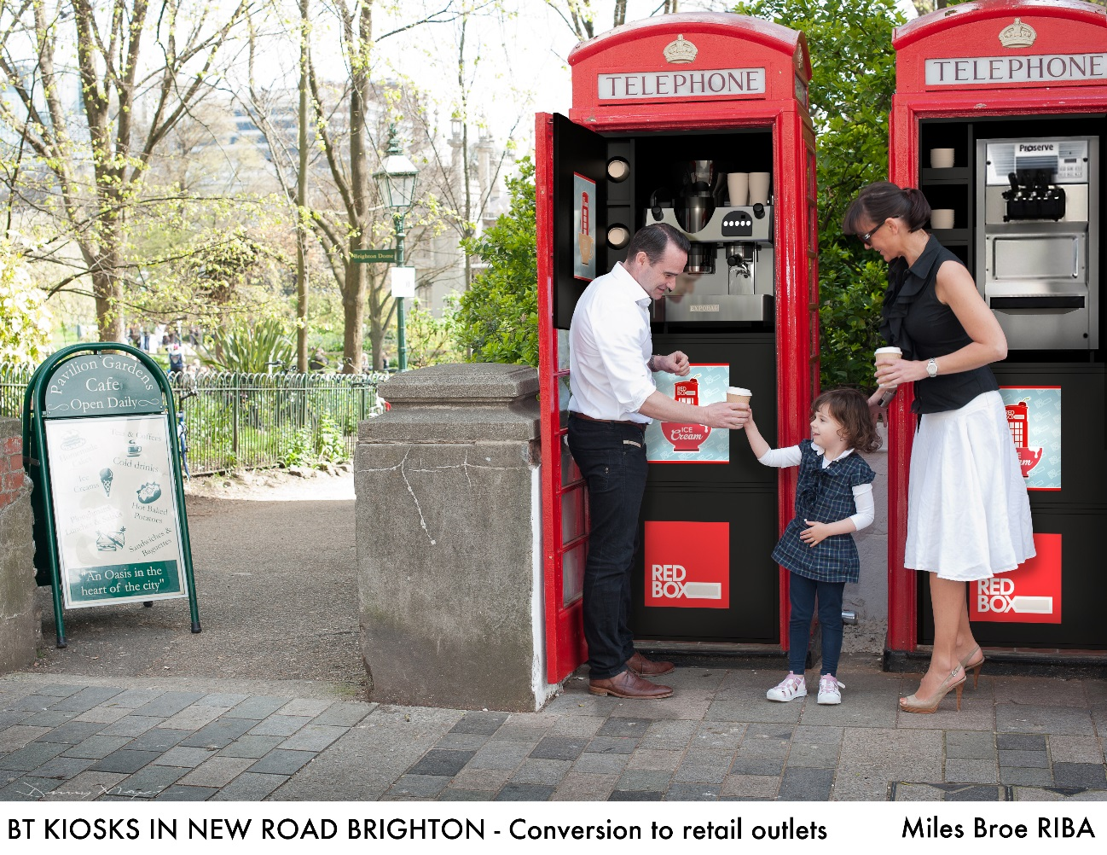

**MB Design & Build Ltd**