**Dead and dying trees that need removing at Beechwood house**

1. 1 x Oak by the lower ponds that you refused permission to remove earlier in the year has now died so will need removing.

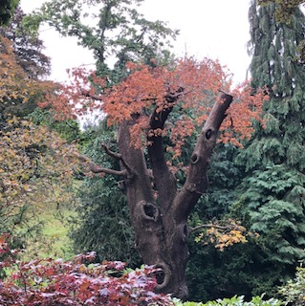

1. 1 x Silver birch by compost heap dead

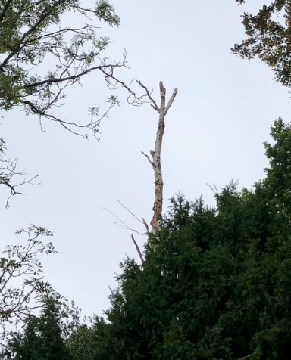

1. 1 x Ash tree by compost heap dead.

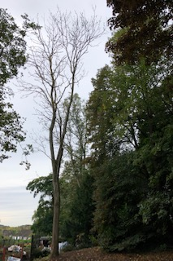

1. 6 x holly trees at the back of gate house border dead.

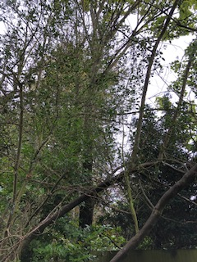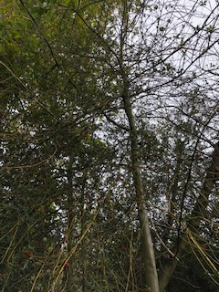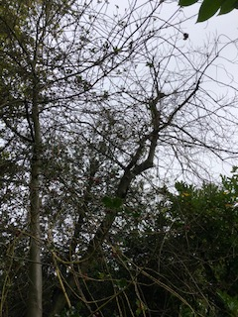

1. 3 x cherry trees by bungalow dying infected with fungus it also has some dead branches that over hang a footpath.

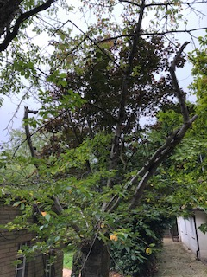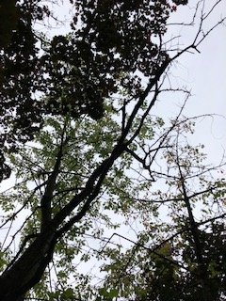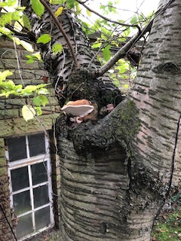

1. 1 x silver birch by Caenwood court wall dead very close to adjoining building.
2. 1 x cherry tree by Caenwood court wall dead very close to adjoining building.
3. 1 x beech tree by Caenwood court wall dead very close to adjoining building.

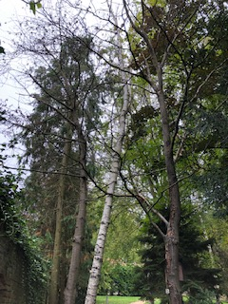

1. 2 x elm trees by ice house dead.

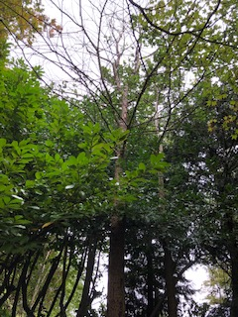

1. 1x Acer tree on the corner of the main lawn is in decline it also has damage to the base as well as a fungus infection.

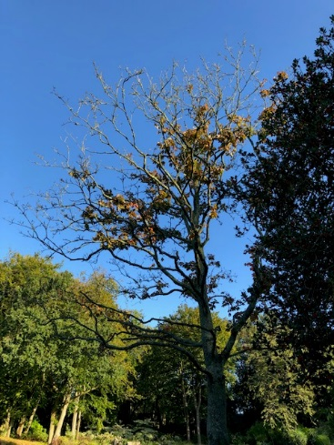

1. 1 x holly tree by the S bend has been in decline for many years now and needs to be removed.

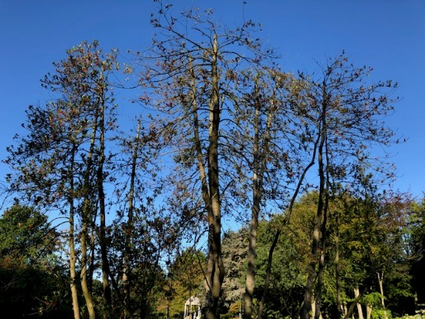

**Location of trees**

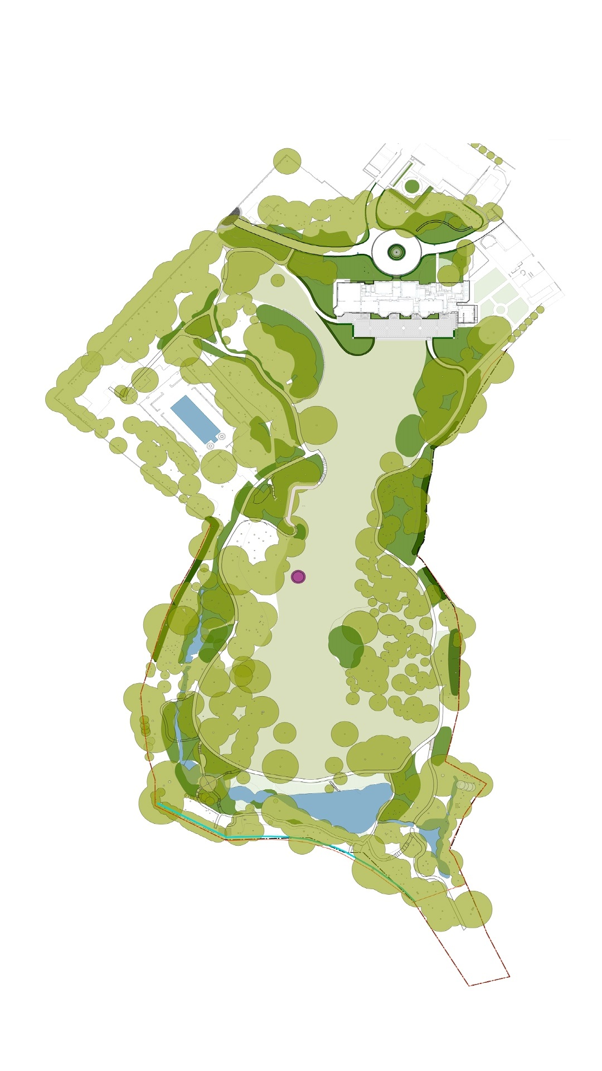

2

3

9

1

10

11

6-8

4

**5**