26 Grove Terrace
London NW5 1PL
Proposed addition of buttresses to north boundary wall at rear of house
Application for Listed Building and Conservation Area Consent
- Design and Access Statement 7th October 2019
The works to repair and conserve the boundary wall at number 26 Grove Terrace (Listed Building Consent ref 2019/2548L dated 1st July 2019) are about to be undertaken in accordance with the consent noted above.

Following collapse of the boundary wall to the Grove Terrace Mews access road at number 21 Grove Terrace during the summer of 2019, we have consulted with our client and propose to add supporting buttresses to the high section of the north wall at the west end of 26 Grove Terrace garden as drawing 26-GT-LBC-2-04, which is included with the application for Listed Building Consent.

This project proposes to strengthen the high section of the north boundary wall to the garden of the property at 26 Grove Terrace NW5. The wall also forms the south boundary wall to the garden at number 27 Grove Terrace, London NW5. The whole of the wall is in The Dartmouth Park Conservation area and the properties at 26 and 27 Grove Terrace are Grade II* Listed. The Grove Terrace properties date from 1795.
The wall which we are proposing to strengthen dates from 1795. This section of the wall has a slight lean in towards the garden of 27 Grove Terrace.
We propose to add three 440 x 105mm buttresses, equally spaced, to the section of the wall adjacent to the house. This section of wall is approximately 2.6m high and 11m long. The buttresses have been designed with chamfered tops to match Pier 2 further along the garden wall. This design will allow for recently replaced stone copings to be retained. Bricks will be carefully selected to match those in the existing wall in keeping with the historical context of the surrounding properties. All new brickwork will be bedded in lime mortar, flush pointed as works progress, tied back to the existing wall using stainless steel ties. The design of the foundations for the new buttresses will be finalised after preliminary excavation to investigate the footings to the original wall.
The garden to number 26 Grove Terrace, where disturbed by the works, will be reinstated on completion of the new construction, including backfill to trenches and topsoil to finish. Mature plants will be retained where possible or removed and saved for re-planting at completion.
Access to the site is through the Client’s property at 26 Grove Terrace. The client will make provision for parking of contractors’ vehicles and siting of skips if required.
It should be noted that the photographs below were taken prior to the repairs approved in July being undertaken. These works are planned for October 2019. The existing drawings (26-GT-LBC-2-02 and 03) attached with the application show the design of the wall as it will be at the start of this project.

- Site Photographs
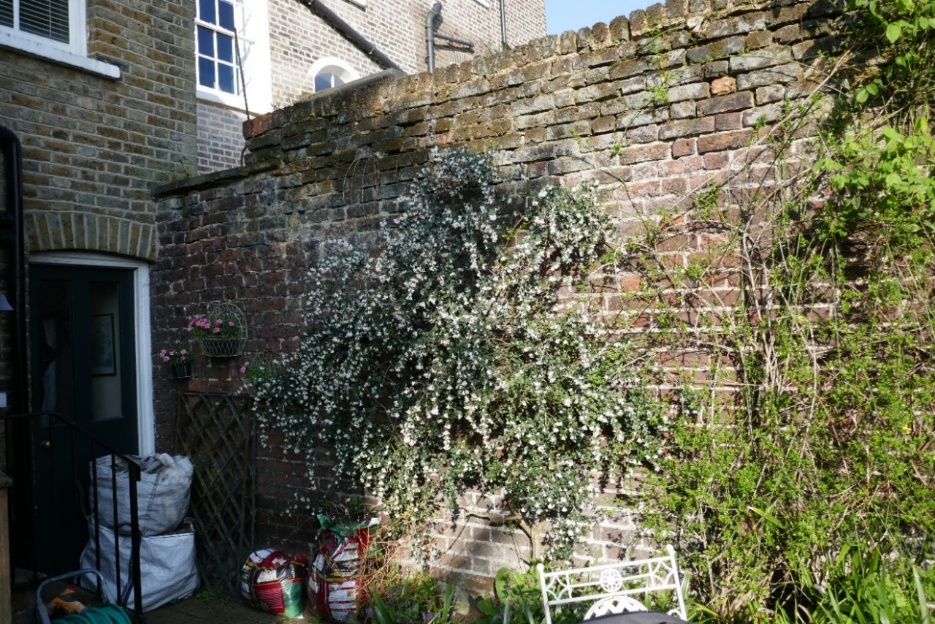

2.1 West end of wall adjoining house, this section will be reduced in height in October 2019, as the 1st July approval.

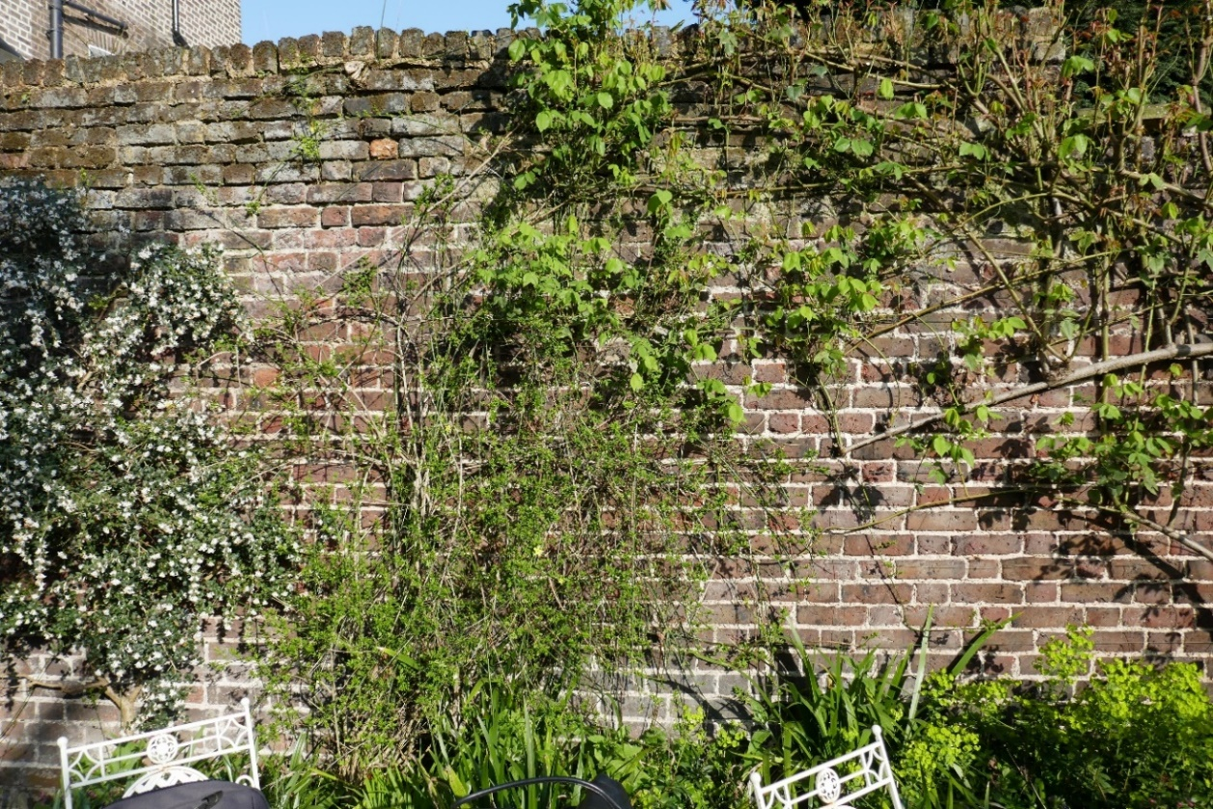

2.2 High section of wall adjacent to house, this section will be reduced in height (brick on edge and 4 courses below to be removed) in October 2019.

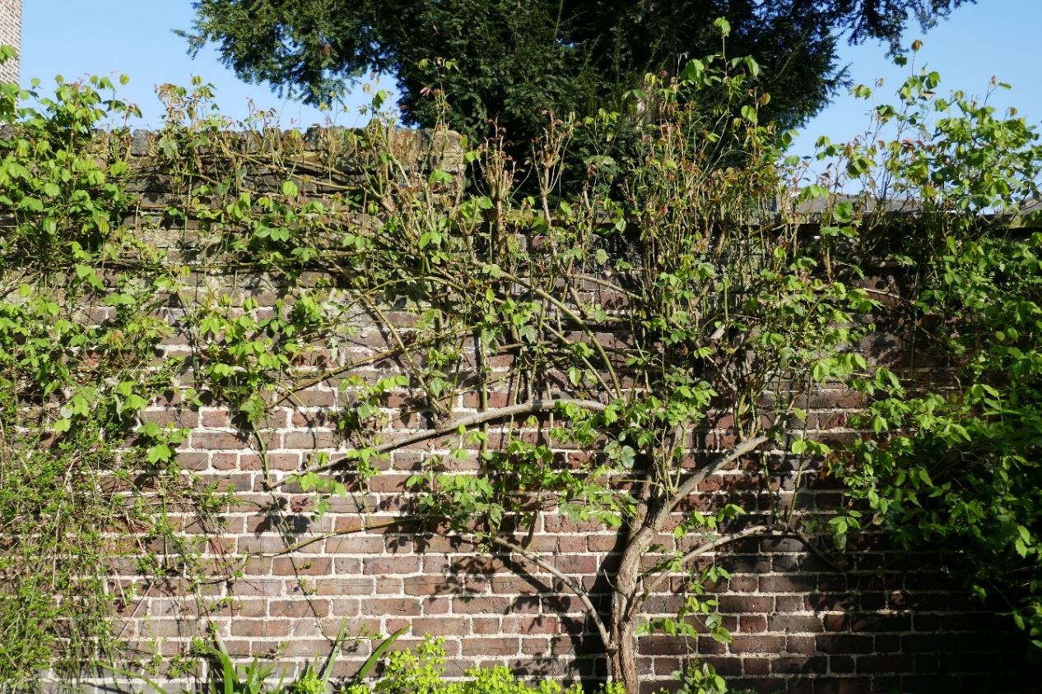

2.3 East end of high section of wall, brick on edge and four courses below to be removed and new stone copings to be added in October 2019.

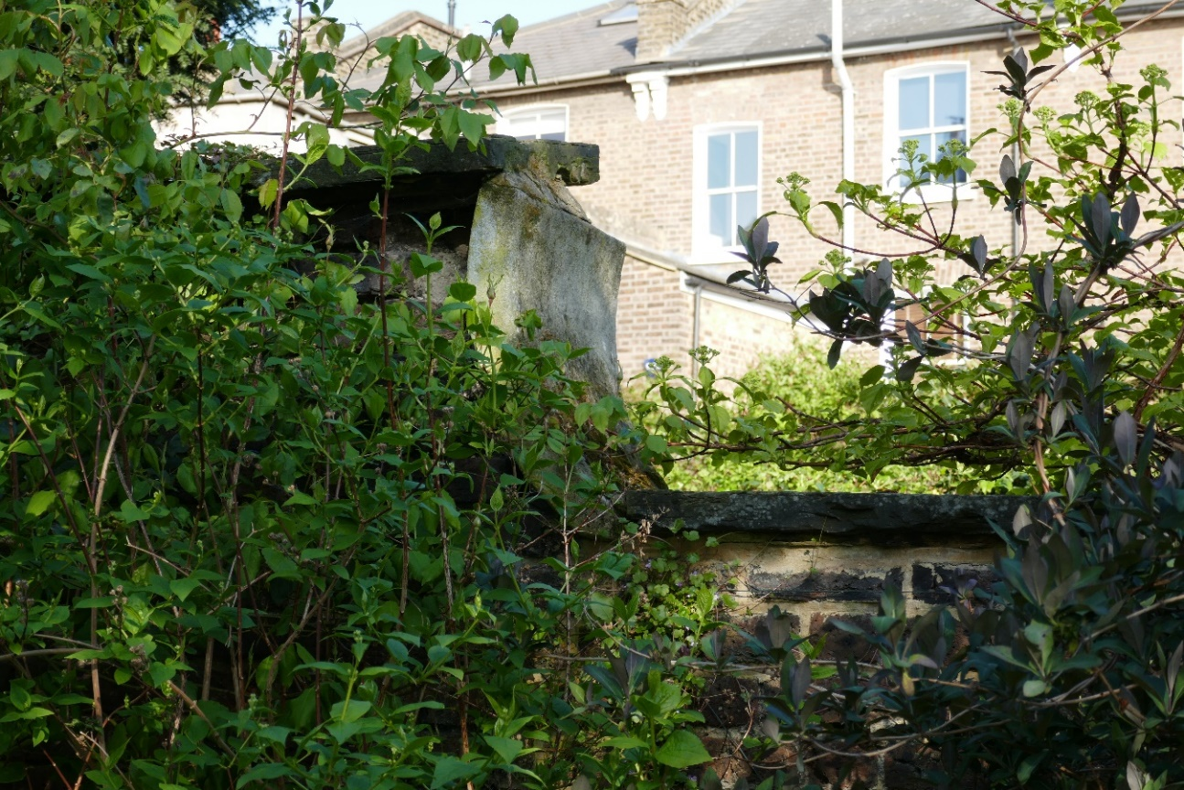

2.4 Detail of curved coping shown on drawings 26-GT-LBC-2-02 and 04, to be re-bedded.

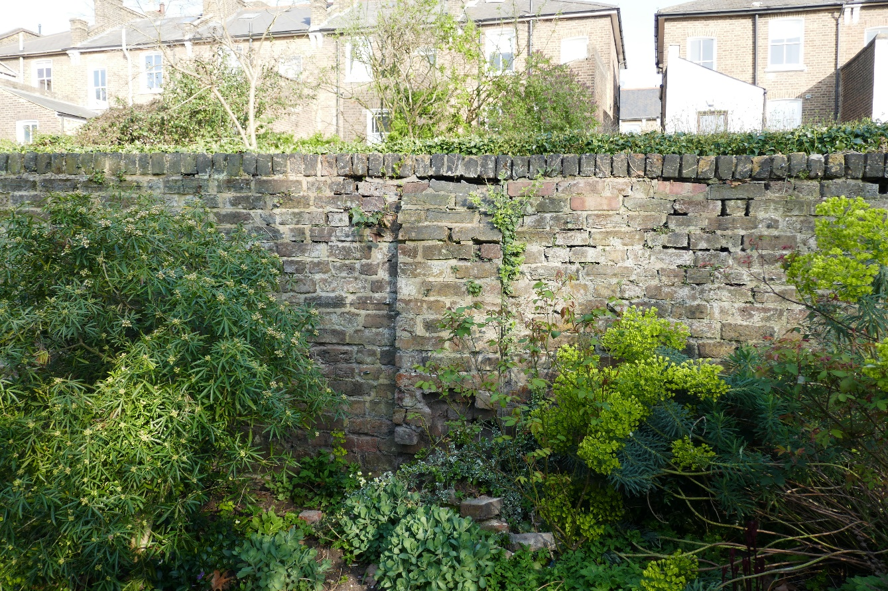

2.5 Detail of buttress and wall to be repaired at Pier 2, new buttresses will match this detail

