CIVIL

Engineers

Limited

**Consulting Structural & Architectural Engineers and Party Wall Surveyors**

*E.G.Soufiani (Director) BSc., MSc., Ph.D*

**Camden Council**

Planning - Development Control

Camden Council

Camden Town Hall

London

WC1H 8NDCIVIL Engineers LTD

22 Kingswood Road, Goodmayes

Ilford, Essex, IG3 8UE

Tel: 020 8598 1998

Email: [info@cengineers.co.u](mailto:info@cengineers.co.uk)k Website: [www.cengineers.co.u](http://www.cengineers.co.uk)k Date: 25/09//2019

**Evidence In Support Of Application for Certificate of lawfulness to retain the existing use of**

**ground floor rear extension**

**Site Address: 240 Camden high street London NW1 8QS**

**Client Name:** Mr Hossein Rezvani

Evidence of the ground floor rear extension are displayed on the next six pages from the dates of 1999- 2015

Ariel images from <https://www1.getmapping.com/>

**1999**

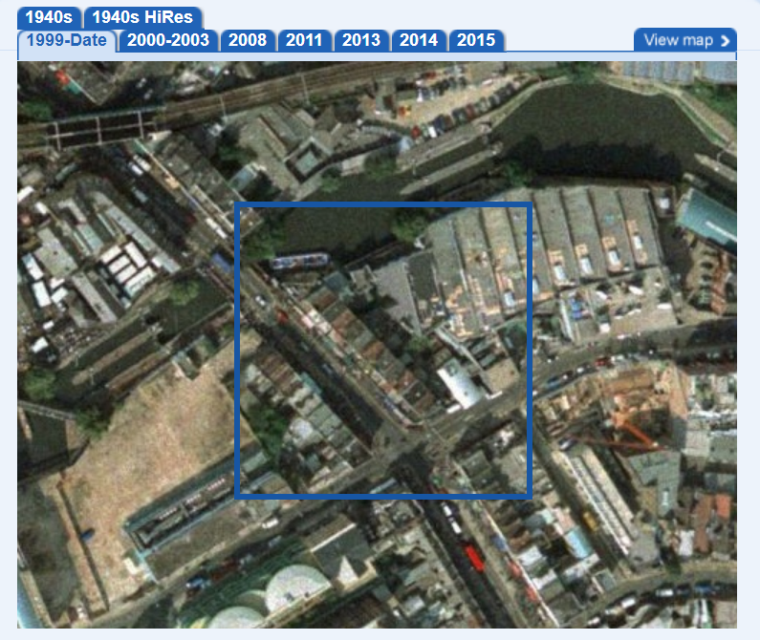

**2000-2003**

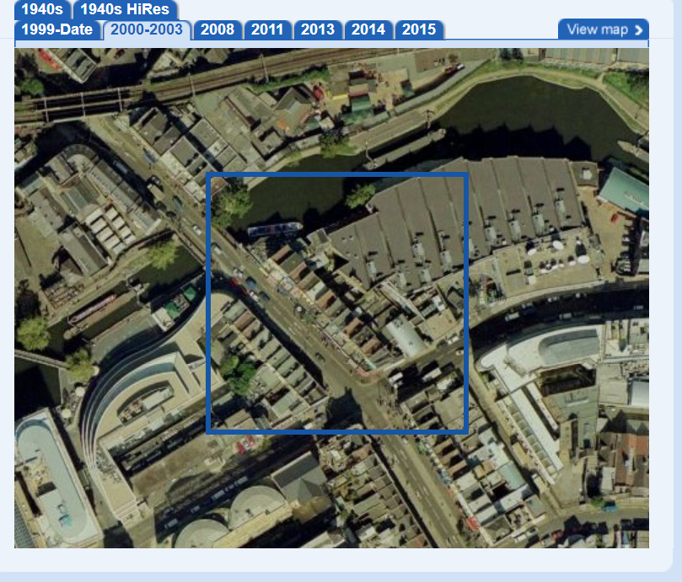

**2008**

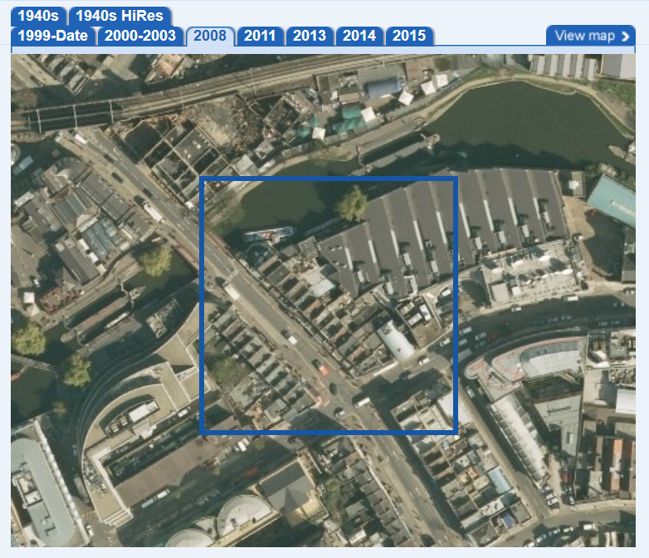

**2011**

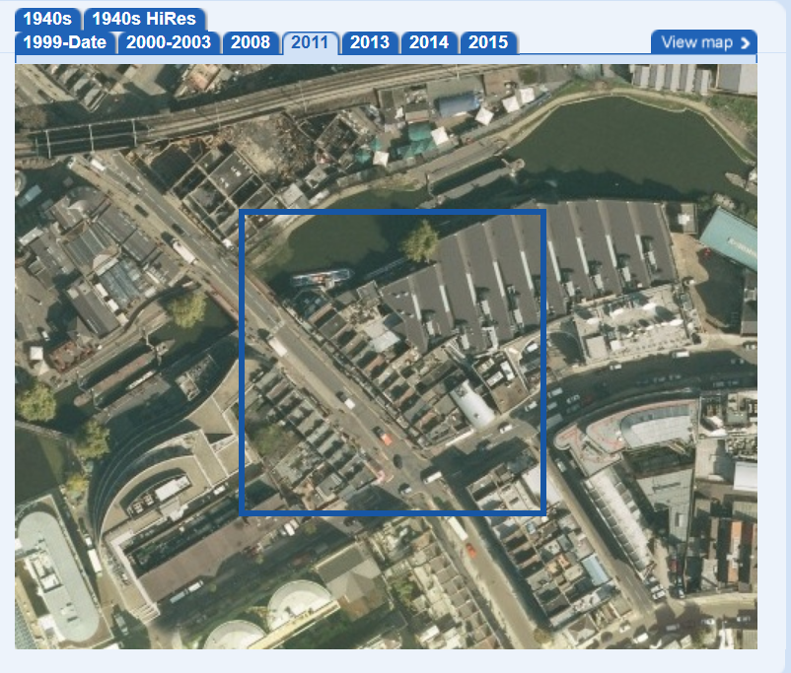

**2013**

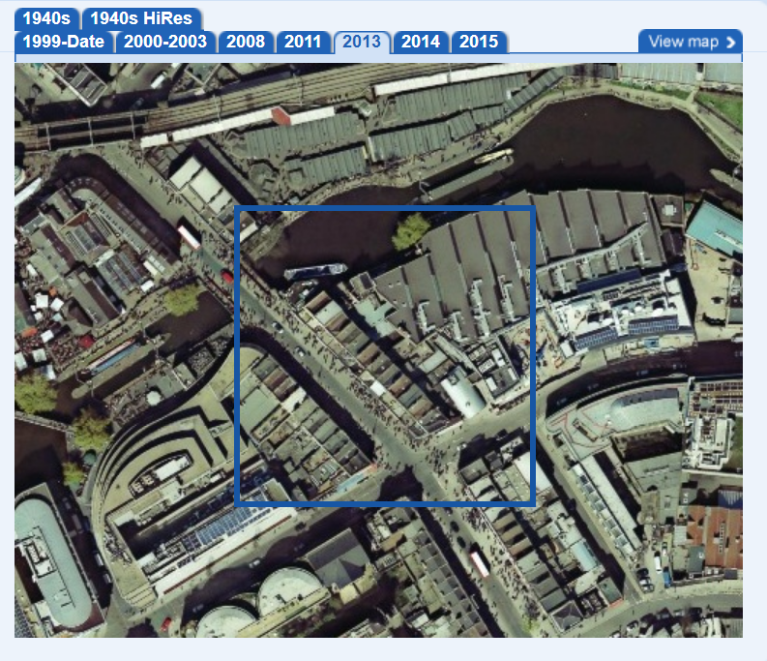

**2014**

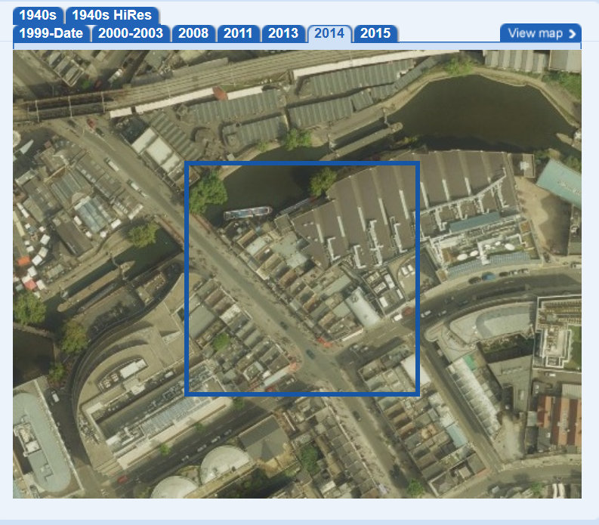

**2015**

