**13/808: 1 PAKENHAM STREET**

**LONDON WC1X 0LA**

**DESIGN AND ACCESS STATEMENT**

**Brill + Owen: Architects September 2019**

1. **INTRODUCTION**
   1. This application is for the addition of two new pavement lights and the conversion of an existing barrel drop to a third pavement light.
2. **EXISTING BUILDING AND CONTEXT**
   1. The existing three storey building is Listed Grade 2 and is located on the corner of Pakenham and Calthorpe Streets acting as pivot between the three storey terraced houses along each street. These consist of coursed white painted render at ground and lower ground floor with an area enclosed with iron railings with pedimented windows at first floor and arched windows at second floor set in facing brickwork with a rendered cornice and parapet above.
   2. No. 1 Pakenham Street is lower than the houses on each side with a painted render ground floor and the basement below pavement level with no railings or enclosed area to the highway. The first floor windows are pedimented with matching width windows at second floor set in facing brickwork with a deep overhanging cornice and parapet set lower than the surrounding houses.
   3. Planning Permission was granted in October 2017 for change of use from a pub to retail (class A1) at basement and ground floor levels.
   4. The ground floor contains commercial unit with a timber staircase leading to the basement to its rear and a single storey room projecting into the former garden space. The basement contains several rooms that currently have no natural light or ventilation and as such are not deemed habitable. The upper floors are accessed by a separate entrance to the north of the property and contain four residential units.
3. **PROPOSED SCHEME**
   1. It is proposed to create two new pavement lightwells to serve two principle Basement rooms, and to convert the existing barrel drop to a third lightwell. These three lightwells will improve natural light levels in the Basement and thereby lower the energy consumption for lighting.
   2. The proposed pavement lights will be of a traditional glass-block design set into precast concrete grids. The former barrel drop will be split into two halves by a metal strip to reference its previous use. This opening will be framed in 50mm CorTEN steel to mark it out as an original opening as opposed to the two new ones.
   3. Internally the new lightwells will include a sloped sill detail to reflect light back into the rooms.

3.2 The rear wall would be.raised to replace the current mansard and line through with the rear walls of the houses on each side with the rear

staircase enclosure altered. A new lead clad enclosure to the new staircase would provide access to the main flat roof.

3.3 Internally the new layouts have been designed to retain the majority of the main walls at first and second floors and to enable remaining original features such as skirting boards, cornices and ceiling mouldings particularly at first floor to remain and be restored with later insertions such as the kitchens removed. Fire lobbies have been inserted to protect the single staircase Means of Escape leading down to an enclosed access corridor to the existing separate entrance in Pakenham Street.

3.4 It is proposed to convert the rear toilet block to the kitchen for the public house with a kitchen flue rising up the party wall. The pub toilets would be relocated to the basement with new staircase access using what is possibly a previous location under the staircase up to first floor.

* 1. Provision for cycle and buggy / pram storage has been shown in cupboards off the access corridor leading to the entrance to the flats.
  2. All the work will be in sympathy with the original design of the Listed Building, using matching facing brick, render and details and painted timber

framed fenestration externally and preserving or matching interiors.

* 1. Planning permission (reference No 2013/P6910/P) and Listed Building Consent (Reference No 2013/6984/L) were granted in March 2014 for the above alterations and refurbishment.
  2. Following the detailed design development and further site investigation a slightly revised scheme is proposed as shown on revised drawings No’s 13/808/P02B, P05B, P12B, P14B and P15C. These show the following amendments:

.1 Drawings P 02B and P 12B: In order to accommodate the headroom for the new staircase to the Basement, it has become necessary to raise part of the Ground Floor level. For this reason, it is proposed to remove the winders at the bottom of the non-original staircase and a small section of the Ground Floor landing. The staircase will be preserved above the fourth tread, and other areas of the Ground Floor will be preserved beneath the new suspended floor.

.2 Drawing P 14B: In order to accommodate preferred sanitary ware, it is proposed to widen the shower room in flat unit 2 from 1200mm to 1480mm by relocating a new wall. The remaining parts of this floor remain unaltered.

.3 Drawings P 05B and P 15C: In order to rationalise the drainage design it is proposed to relocate the Kitchen in flat unit 3 to the reverse side of the wall from the Kitchen in unit 4. This will enable both units to share one soil pipe. The room in unit 3 formerly shown as the Kitchen / Dining Room would become a Study or separate Drawing Room. It is proposed to form a door opening from the Living Room in place of the wider opening previously shown.

.4 Additionally, it is proposed to widen the shower room in unit 4 from 1200mm to 1540mm by relocating a new wall in order to accommodate preferred sanitary ware. This revision would mean more of the original fabric could be retained, as shown on drawing 13/808/P05B.

1. **PLANNING**

4.1 Accommodation

There will be no alteration to the floor areas of the four flats which would remain as:

First floor - 2 bedroom three person flat floor area of 61 sq. m

1 person studio floor area of just over 36 sq. m

Second Floor - 1 bedroom 2 person flat floor area of 56 sq. m

1 person studio Floor area of 37 sq. m

These areas are in excess of Camden Council space standards in policy DP5 and comply with The London Plan’s increased space standards. Main bedrooms exceed 11 sq. m. and secondary bedrooms exceed 6.5 sq. m. internal floor area.

4.2 Interiors

Only minor changes in the layouts are proposed as described above mainly by relocating new walls.

**5.0 DESIGN AND ACCESS**

Wherever possible within this Listed Building all new interventions will accord with Part M of the Building Regulations and Lifetime Homes Criteria as follows:

1. There will be no on site car parking;
2. The approach from on street car parking to the entrance door which is directly at the edge of the site will be level
3. As 2 above
4. The access to the entrance will be illuminated, level, and the existing door has a clear opening width of 850 mm and the corridor will be 1,000 mm clear width to the staircase
5. The staircase will be 900 mm clear width with 170 mm risers and 250 mm treads with contrasting staircase nosings and handrails at 900 mm height extending 300 mm beyond the top and bottom of staircase.
6. Internal doorways have been shown at 800 mm width and corridors of 1,000 mm width;
7. The living / dining rooms have been designed to allow turning wheelchairs;
8. There are no entrance level flats
9. As above
10. As above
11. Bathroom partitions will have plywood linings to allow for grab rails support
12. Not applicable
13. The structure above the ceilings will be strengthened in each flat so as to be adaptable to install future hoists
14. The bathrooms have been designed to be adaptable so as to be accessible as set out in Lifetimes Homes specification.
15. The sills of the existing and new windows are at 620 mm at second floor and 750 mm at first floor above FFL so as to provide views to outside when occupants are seated and as these are sashes, the bottom sash can be reached to open.
16. Switches will be set at 1100 mm and socket outlets at 500 mm above Finished Floor Levels.

Bird’s eye view from East

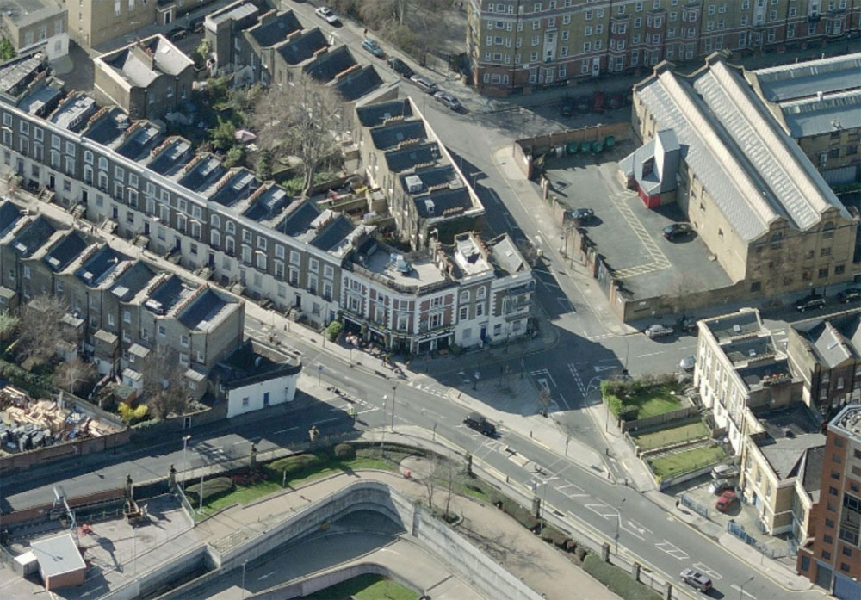

Bird’s eye view from West

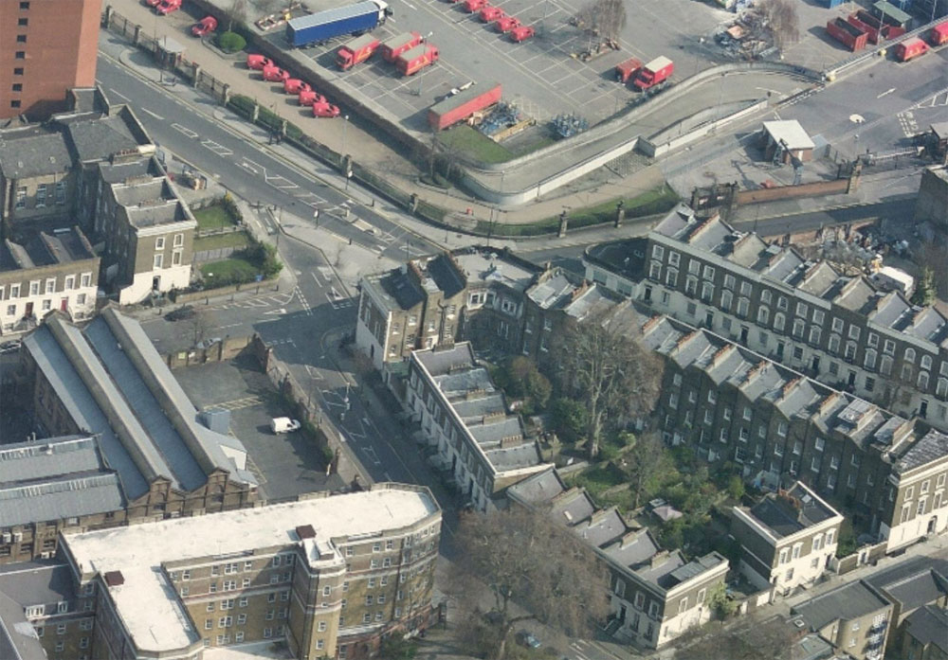

View from Wren Street showing existing mansard roof.

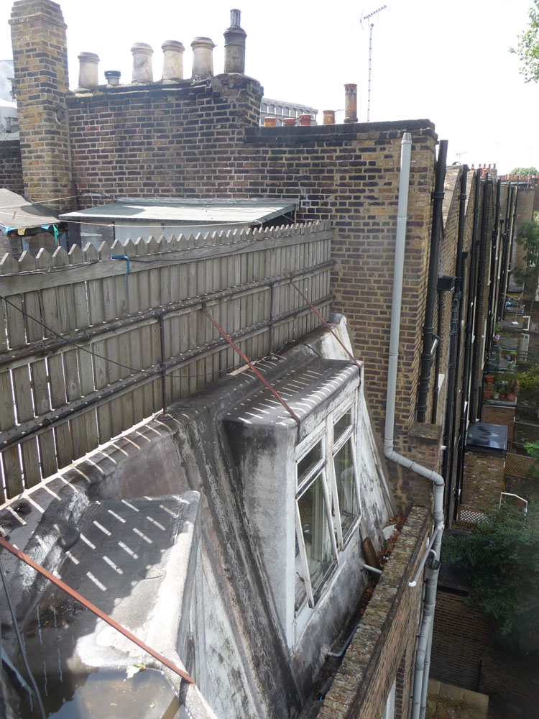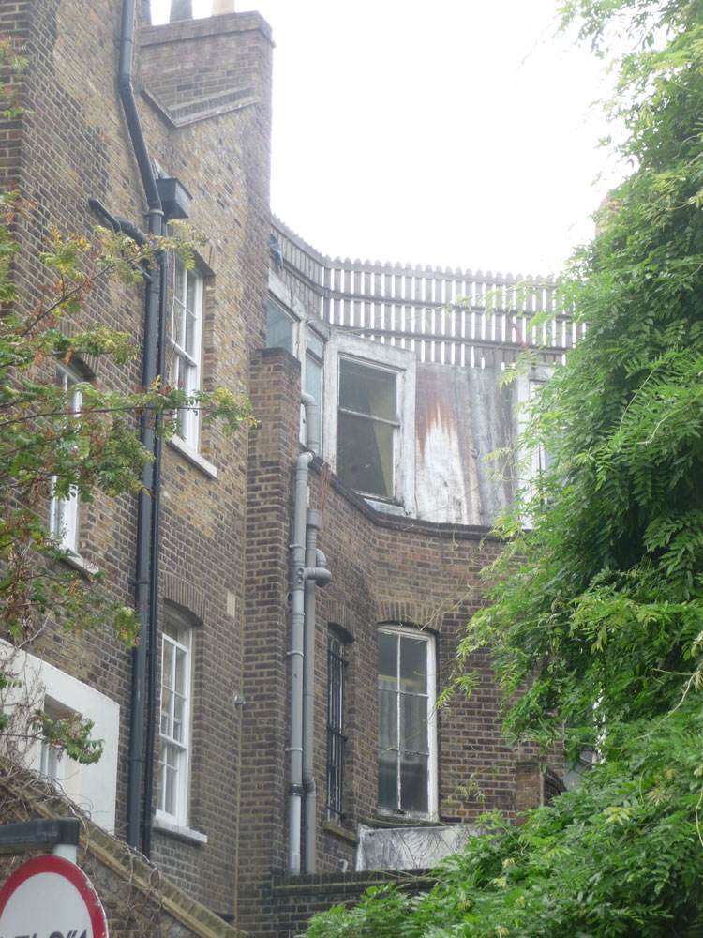

View from roof looking south showing rear elevations of houses on Calthorpe Street

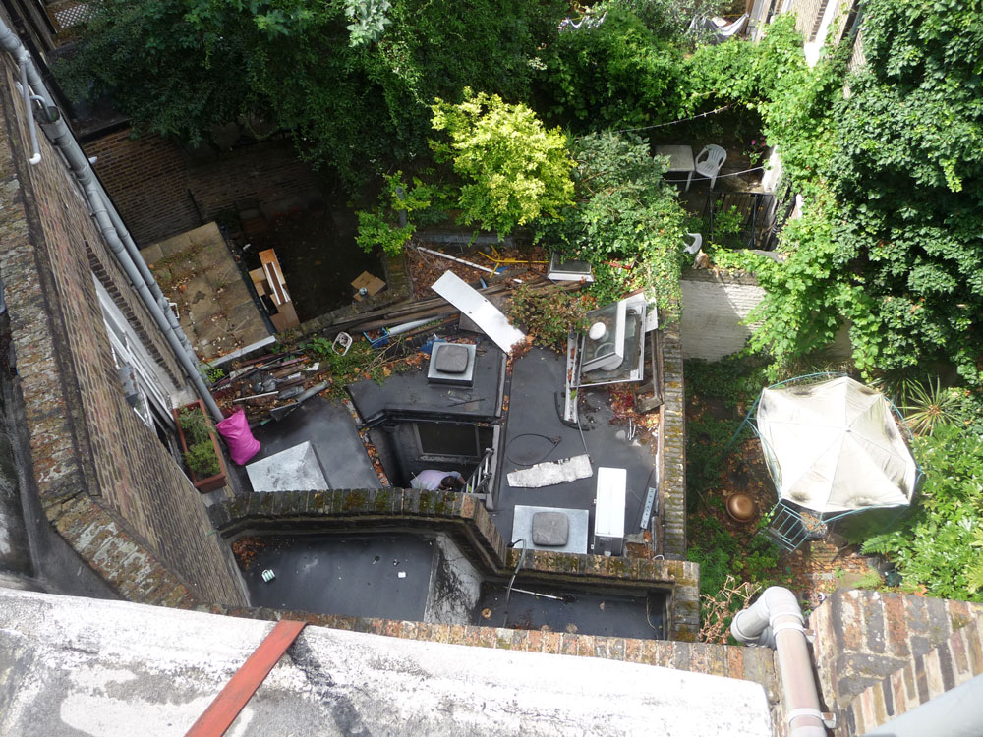

View from roof to Ground Floor rear extension to be demolished and rebuilt.

Elevation from Pakenham Street showing proposed entrance to new flats above.

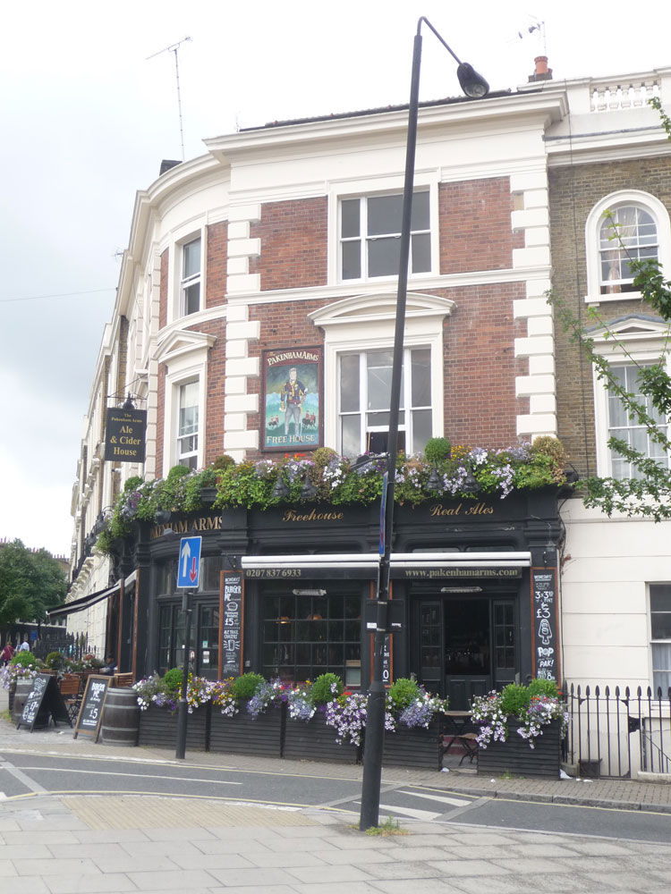

Internal view of existing staircase to upper floors, to be enclosed with new corridor wall.

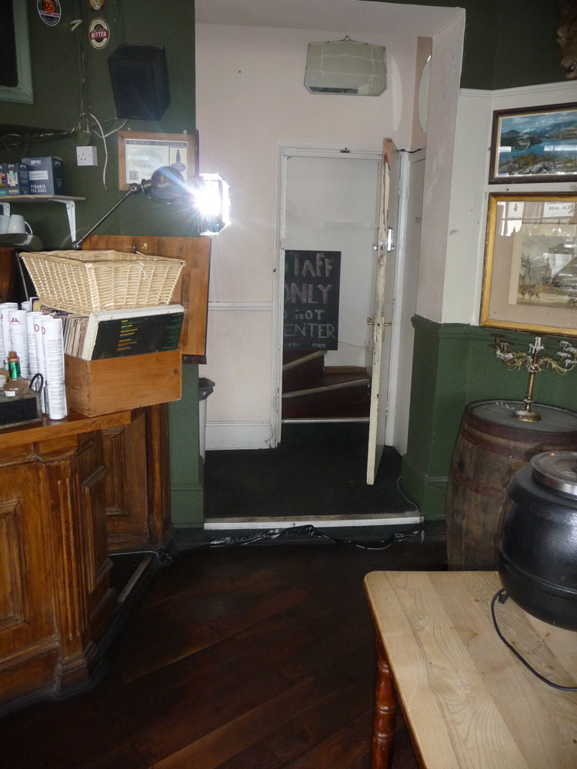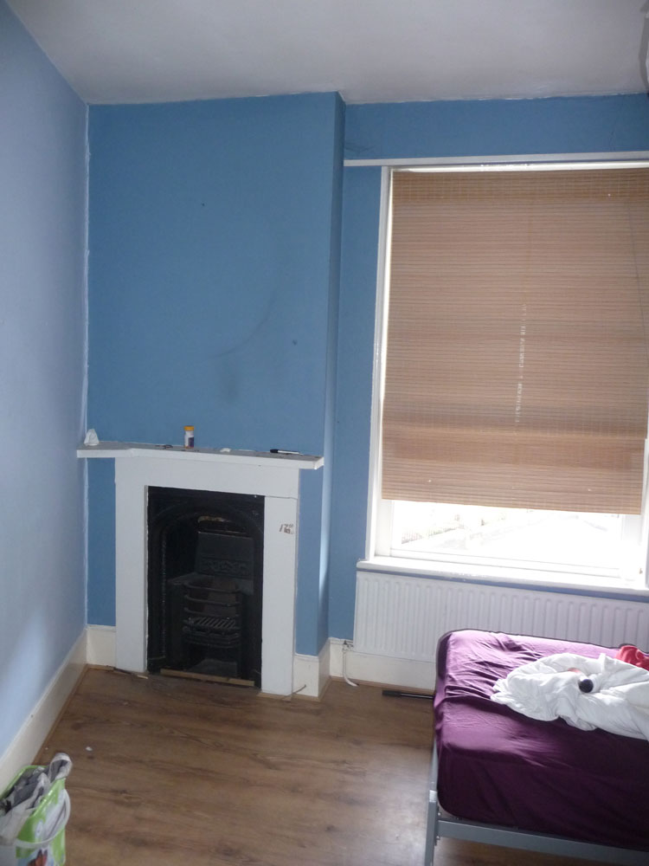

Second Floor fireplace to be retained.

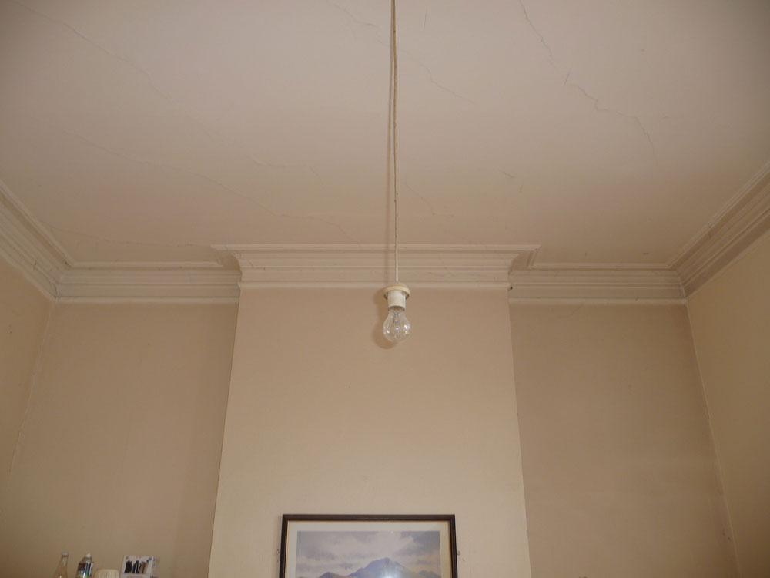

First Floor cornice to be retained and preserved.

Ground to First Floor staircase to be removed and replaced.

