Planning Department

2nd Floor, 5 Pancras Square  
c/o Town Hall, Judd Street

London  
WC1H 9JE

FAO: Ben Farrant

24th September 2019

Dear Sir / Madam,

**22 FROGNAL WAY, LONDON, NW3 6XE**

**APPLICATION FOR PLANNING PERMISSION FOR WORKS TO EXISTING BOUNDARY WALL**

We enclose an application for planning permission for works to the boundary wall at 22 Frognal Way.

The works relate to the wall at its boundary with 20 Perrins Walk. The works that are proposed are minimal and will see the removal and infill of existing gates and the provision of a new gate.

Planning permission was granted in August 2019 for works of repair/reinstatement to the wall and the outbuilding (2019/3210/P) and these works relate to this part of the boundary.

The following details are enclosed:

* Planning application drawings including Site Location Plan, prepared by KSR Architects
* Design and Access Statement, prepared by KSR Architects
* Structural Inspection Report, prepared by Price and Myers, Engineers

We trust that this is sufficient for the Council to register this application and to consider these proposals. Please contact Matthew Gibbs with any queries.

Yours faithfully,

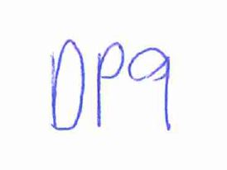

**DP9 Ltd**