SITE SPECIFIC SUPPLEMENTARY INFORMATION

- Site Details

Site Name: | SW at St Augustine’s Road NW | Site Address: | SW at St Augustine’s Road NW  London  NW1 9RN
NGR: | E: 529712, N: 184331
Site Ref Number: | 77418 | Site Type: Macro | SW Site – Replica Telegraph Pole

- Pre Application Check List

Site Selection

Was an LPA mast register used to check for suitable sites by the operator or the LPA? |  | No
If no explain why:

After a phone call to the LPA it was felt that the industry database was a more up to date source of information.

Was the industry site database checked for suitable sites by the operator: | Yes
If no explain why:

N/A

Pre-application consultation with LPA

Date of written offer of pre-application consultation: | 6th July 2018 & 6th July 2019
Was there pre-application contact: |  | No
Date of pre-application contact: | N/A
Name of contact: | The Director of Planning
Summary of outcome/Main issues raised:

At the time of preparing this submission, and despite our attempt to engage in pre-application dialogue with the LPA, no comments had been received in respect to the proposals.

Ten Commitments Consultation

Rating of Site under Traffic Light Model: | Green
Prior to the submission of this application the applicant initiate pre-consultation discussions with the local planning authority. This provides an opportunity for the LPA to discuss development proposals and identify site specific issues.

Summary of outcome/Main issues raised:

No response has been received at the time of submission.

School/College

Location of site in relation to school/college:

There are no schools in close proximity to the site.

Outline of consultation carried out with school/college:

N/A

Summary of outcome/Main issues raised:

N/A

Civil Aviation Authority/Secretary of State for Defence/Aerodrome Operator consultation (only required for an application for prior approval)

Will the structure be within 3km of an aerodrome or airfield? |  | No
Has the Civil Aviation Authority/Secretary of State for Defence/Aerodrome Operator been notified? |  | No
Details of response:

N/A

Developer’s Notice

Copy of Developer’s Notice enclosed? |  | Yes
Date served: | 6th September 2019

- Proposed Development

The proposed site:
PLEASE NOTE THIS IS A RESUBMISSION OF THE PREVIOUSLY APPROVED APPLICATION 2017/2972/P ON JULY 2017 AND 2018/3807/P IN SEPTEMBER 2018. THE PREVIOUS LOCATIONS CANNOT BE CONSTRUCTED DUE TO UNDERGROUND SERVICES ISSUES AND THUS THE EQUIPMENT HAS BEEN MOVED MARGINALLY AND A NEW GPDO APPLICTION HAS BEEN SUBMITTED TO CAPTURE THIS. THE DESIGN OF THE INSTALLATION HAS NOT ALTERED.

The Planning History is captured below:

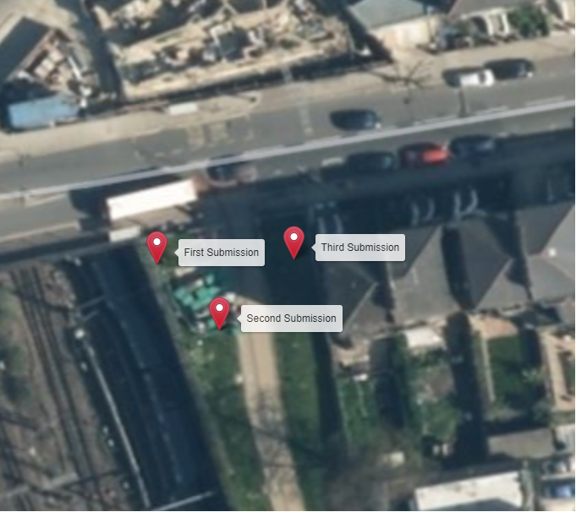

The Home Office-led emergency services mobile communications programme provides a basis to develop a new ‘blue-light’ communications service known as the Emergency Services Network (ESN). EE Limited have been selected by the Home Office to provide the resilient national mobile network and appointed a number of agents including WHP Telecoms (WHP) to support site identification, acquisition and planning approval services to extend critical site coverage across the UK. The constrained cell search area to achieve the required coverage is highlighted below
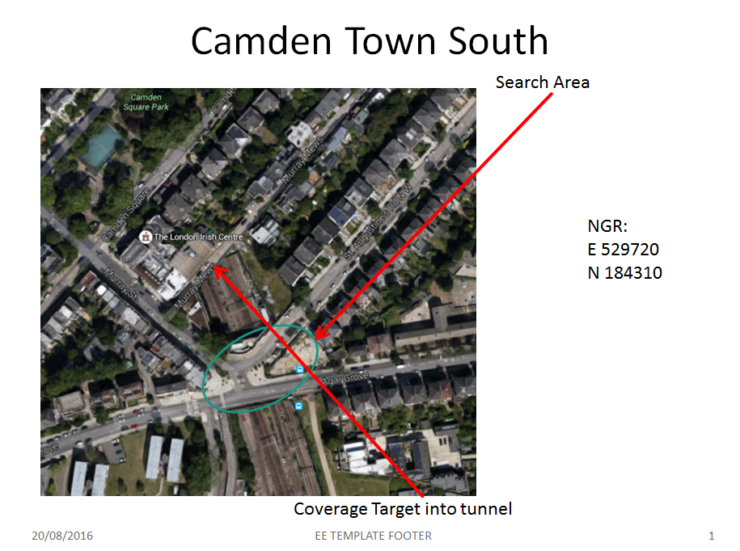
The search area focuses on the southern end of the Camden Town South Railway Tunnel which falls within the control of Camden Council. The search was undertaken with a view to improving coverage within the railway tunnel and the cell search area is extremely constrained due to requiring line of sight towards the tunnel mouth.

In terms of Town and Country Planning the vast majority of the identified search area is situated within the Camden Square Conservation Area and the land designation is deemed to be a material consideration. Any options identified within the small region of the search area situated outside of the Conservation area are also likely to be assessed against their impact on the setting of the Conservation Area for this reason the monopole has been kept to an absolutely minimum in terms of both its height and design. An extremely modest 10m replica telegraph pole has been proposed which reflects the scale and massing of the adjacent street lights. The London Borough of Camden does not have a specific telecoms policy and the local plan policy which relates specifically to the cell is Policy DP25 (LB Camden LDF Core Strategy DPD / LB Camden LDF Development Policies DPD 2010) – Conserving Camden’s Heritage.

The majority of the search are has been identified as sitting within a Conservation Area and thus the design needs to be sensitive to respect the setting of the Heritage Asset and the proposed installation has been sited so as to benefit from existing screening elements with the majority of the infrastructure out of normal public view as far as is feasible. The chosen site has been nominated just outside of the Conservation Area to reduce its impact on the Article 2 (3) designation.
Identified planning constraints:

Green Belt / AONB – NONE
Statutory Ecological Designations – NONE
Conservation Areas – Yes - Camden Square Conservation Area
Listed Buildings / Heritage Assets – Yes

Conservation Area indicated by beige shading in map extract below.

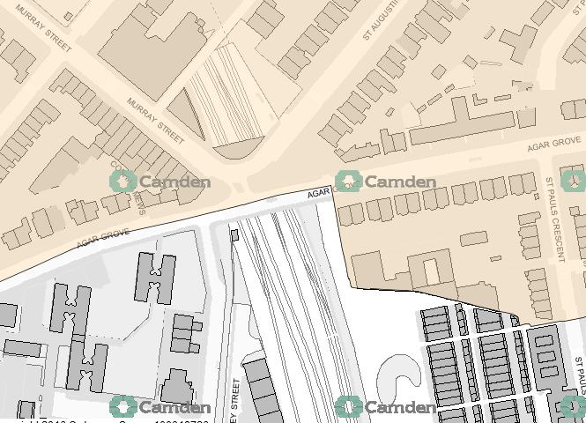

Listed Buildings / Heritage Assets indicated by red triangles in map extract below:

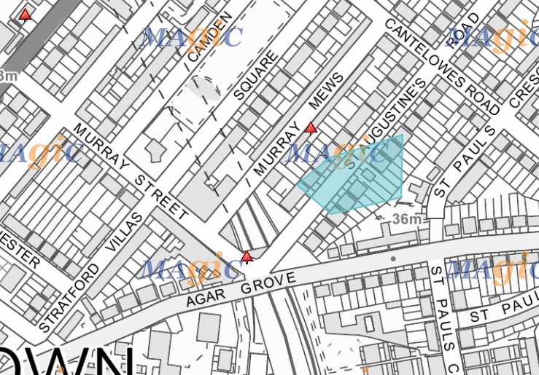

The proposed site is situated on a wide grass verge area adjacent to the railway wall off St Augustine’s Road. The proposal is for the installation of a new 10.0m High HEL replica Telegraph Pole on new Root Foundation that will provide new coverage for EE and ESN and has the potential for H3G LTE. The proposed new facility will require the installation of a limited number of equipment cabinet housing radio equipment at ground level and in close proximity to the base of the pole. The cabinet equipment are however, permitted development (without Prior Approval) and thus do not form part of this application.
Site Ref | 77418 | Site Address: | St. Augustine’s Road, Camden Town, London, NW1 9RN

Local Planning Authority: LB Camden

Development Plan: LB Camden LDF Core Strategy DPD / LB Camden LDF Development Policies DPD
Fig.1 – Local Plan Map (extract – reference only)

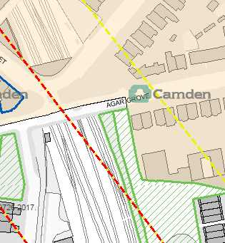

Site and its surrounds

Policy Relevant to the Development Site:

The site is designated as being in the settlement boundary, with urban uses to the north, east, south and west. The site is not located in an area that is deemed to be a material consideration.

LB Camden does not have a specific telecoms policy. Therefore the NPPF is of relevance. The National Planning Policy section of this supporting statement goes into detailed analysis of why this site is in compliance with the NPPF.

Policy Analysis:

The proposed works would not be to the detriment of the surrounding area with a sensitive design (it would preserve the character of the Conservation Area to the east), but is necessary to ensure improved delivery of service, and would respect and continue to maintain the appearance of the area, so according with the principles of the Development Plan. The proposal fully accords with the requirements of the NPPF and the objectives of the London Plan (Policy 4.11 Encouraging a Connected Economy (March 2015).

The site has been carefully selected in a position that benefits from some screening effects so as to provide the required new coverage to the area whilst minimising visual intrusion for residential properties. The monopole style design has been specified in order to allow the proposal to merge with the numerous street lighting columns distributed around the vicinity of the site.
The sharing of base stations between multiple operators is one of the key strategic policy principles contained within the NPPF. H3G and EE have a network sharing agreement and thus these installations are fully compliant with the NPPF.
Central Government attaches great importance to the design of the built environment and outlines this within Section 7 (para. 56) of the National Planning Policy Framework. It states:
“Good design is a key aspect of sustainable development, is indivisible from good planning, and should contribute positively to making places better for people”.
In keeping with the National Planning Policy Framework (NPPF). guidelines of using: “high quality communications infrastructure”, the proposed street works monopole design has been selected to minimise visual impact upon the street scene by integrating with the existing street furniture, having similar vertical lines and overall appearance to the street lighting columns that are common feature in the built environment. As stated above the National Planning Policy Framework advocates site sharing, and as such we believe that there are no sequentially preferable locations within the defined site search area.
RADIO PLANNING AND PROPAGATION
When planning cellular telecommunications networks it is important for engineers to predict, with a high degree of confidence, the behaviour of cellular transmissions. This then enables the operator to calculate how many cell sites are needed to provide the level of coverage required by the services they offer under the terms of their licence.
The strength of radio signals detected at a receiving device naturally reduces the further away it is from the transmitter. In general the reduction (or decay) in signal power is affected by a number of variables. The main factors are
- frequency,
- distance (from transmitter),
- terrain (such as hills),
- clutter (such as buildings, foliage, vehicles, and water)
- and atmospheric conditions (such as rain).

A reduction in the strength of the radio signal increases the likelihood of dropped calls and reduced data rates for internet browsing, for example.
Clutter
Any physical object obstructing the propagation of radio signals causes a reduction in signal strength reaching a customer’s device. A common term for these objects is ‘clutter’. The more obvious examples are buildings and geographical terrain such as hills and trees.
Buildings cause a varying amount of signal reduction depending on their height, construction, thickness of walls, amount of windows etc. Glass causes a lower reduction in signal than brick/concrete walls.
Customers will inadvertently be aware of this by finding that sometimes they need to go near windows, a higher floor of a building or even outside in order to achieve a stronger signal for their mobile devices.
Tree Clutter
The effects of trees on signal degradation should never be underestimated. Signal absorption and shadowing effects vary according to vegetation and density, and are caused by the main tree trunk, branches and leaves.
Cell sites located in or near trees will have signals significantly reduced. As a result a number of extra sites may need to be built locally in order to counter-effect this.
Signal variation throughout the seasons is also a practical concern. Leaves on trees in the spring and summer can cause shadowing and reduce radio voice quality and increase the number of dropped calls.
As a result the bottom of an antenna should be a) above the top level of the trees, b) allow greater height due to the antenna downtilt at build or for future requirements and c) allow some room for future growth of the trees.
In the case where the cell site utilises point-to-point microwave backhaul transmission the microwave dish should not be obscured at all.
Propagation Models
In essence these are mathematical formulae used to characterise radio wave propagation, in order to determine the received signal strength at a receiving device.
The most well-known propagation model used for mobile telecommunications is ‘Okamura-Hata’. More specific studies have been performed to investigate specific clutter and terrain such as dense-urban and urban environments. Resulting from these are propagation models for specific clutter types.
Coverage Planning Tools
Radio planning engineers plan cellular networks using highly sophisticated computer programs that incorporate the above propagation models. Armed with data on cell site location, cell site configuration, maps, terrain etc they are used to predict areas of coverage deficiency (so called ‘coverage holes’), new site requirements and configurations.
Network Changes
Over time the topography and clutter in an area is subject to change. For example, building developments, housing and tree growth can all change. As a consequence the signals received from local phone masts can degrade, as they are dependent on these factors. These reasons along with customer complaints, network consolidation (mast sharing) and new technologies (4G) require a re-evaluation of a network operator’s telecommunications infrastructure.
Mast sharing can result in some masts no longer being needed. As a result they are decommissioned and physically removed.
Technical surveys undertaken for reasons above may highlight that antenna height increases are required – this is more likely for sites with low antenna heights around 15m AGL, particularly street furniture sites. More details on these reasons below.
While thus far this document is generic to mobile telephony masts it should be noted that each mast has to be dealt with on a case-by-case basis.
Site Height increases
There are a number of reasons why an operator may request a height increase on existing structures. The main ones are described below.
Maintaining existing coverage
The antennas inside, for example, street furniture sites are generally of 2 physical build designs – ‘Single Stack’ and ‘Dual Stack’. The former describes when the set of antennas are all at the same height. The latter describes a site with 2 sets of antennas one above the other.
The ‘Dual Stack’ is by far the preferred option. This is due to a number of factors including greater flexibility & control for different technologies and providing optimum service performance to customers.
Network Consolidation between H3G LTE and EE and new 4G technologies facilitate a Single Stack structure being upgraded to a Dual Stack structure. In a straight swap scenario at equal height the new lower aperture antennas would be lower than they were originally - resulting in significantly reduced coverage. To ensure existing coverage is maintained the whole structure needs to be increased in height.
Clutter changes
A more extreme example is when the local clutter or tree lines have changed, or are such that the mobile signals are blocked, resulting in lower quality calls and downloads for mobile device users. To provide sufficient services to customers height increases on existing masts or additional new masts are required. The former is the preferred option in many cases.
ICNIRP Compliance
The addition of new technologies and mast sharing affects ICNIRP compliance – a higher minimum mast height is required in some cases.

Enclose map showing the cell centre and adjoining cells:

This can be emailed to the LPA on request

Type of Structure
Description:

Tower Details:

10.0m High HEL replica Telegraph Pole (TP325) on new D6 root foundation
Material: Steel
Colour: Black

Cabinet Details:

1No. BTS 3900A (side by side) on 200mm High Steel Plinths on root foundation
Dimensions: 2No. 600 x 480 x 700 High
Material: Steel
Colour: Green

1No. Link/AC Mk4 Cabinet on root foundation
Dimensions: 600 x 500 x 1520 High
Material: Steel
Colour: Green

Proposed Works

New Site Build

- Install 1No. BTS 3900A (side by side) 2G/4G on 200mm High Steel Plinths on new root foundation. Connect to Transmission and proposed Mk4 Link AC DB with 1No. 40A MCB.
- Install proposed MK4 Link AC Cabinet on new root foundation C/W IDU and 100A incoming Rec supply.
- Install proposed 10.0m High HEL Replica Telegraph Pole (TP325) on new D6 root foundation.

Overall Height: 10.0m AGL
Height of existing building |  | N/A
Equipment Housing:
Length: |  | See drawings
Width: |  | See drawings
Height: |  | See drawings
Materials
Tower/mast etc – type of material and external colour: | 10.0m High HEL replica telegraph pole, (TP325) on new D6 root foundation, Material: Steel, Colour: Black
Equipment housing – type of material and external colour: | 1No. BTS 3900A (side by side) on 200mm High Steel Plinths on root foundation, Dimensions: 2No. 600 x 480 x 700 High, Material: Steel, Colour: Green  1No. Link/AC Mk4 Cabinet on root foundation, Dimensions: 600 x 500 x 1520 High, Material: Steel, Colour: Green

Reasons for choice of design:
Central Government attaches great importance to the design of the built environment and outlines this within Section 7 (para. 56) of the National Planning Policy Framework. It states “Good design is a key aspect of sustainable development, is indivisible from good planning, and should contribute positively to making places better for people”.

The proposed installation is an EE LTD 10.0m High HEL replica telegraph pole (TP325) which will house both Orange and T-Mobile (now called EE) and H3G LTE and ESN. The sharing of base stations between multiple operators is one of the key strategic policy principles contained within the NPPF.

In keeping with the National Planning Policy Framework (NPPF). guidelines of using “high quality communications infrastructure”, the proposed design has been selected to minimise visual impact upon the street scene by integrating with the existing street furniture, having similar vertical lines and overall appearance to the numerous street lighting columns.

- Technical Information

ICNIRP Declaration attached  ICNIRP public compliance is determined by mathematical calculation and implemented by careful location of antennas, access restrictions and/or barriers and signage as necessary. Members of the public cannot unknowingly enter areas close to the antennas where exposure may exceed the relevant guidelines.  When determining compliance the emissions from all mobile phone network operators on the site are taken into account. | Yes

Frequency: | This information can be emailed to the LPA on request
Modulation characteristics | As above
Power output (expressed in EIRP in dBW per carrier)  In order to minimise interference within its own network and with other radio networks, (EE LTD) operates its network in such a way the radio frequency power outputs are kept to the lowest levels commensurate with effective service provision  As part of (EE LTD)’s network, the radio base station that is the subject of this application will be configured to operate in this way. | As above
Height of antenna (m above ground level) | 10.0m AGL

- Technical Justification

Reason(s) why site required
The National Planning Policy Framework clearly states that authorities should not question the need for the service, nor seek to prevent competition between operators. Notwithstanding this fact, the Applicant considers it to be important to explain the technical justification for the site and how the facility fits into the overall network.

Notwithstanding this fact, the Applicant considers it to be important to explain the technical justification for the site and how the facility fits into the overall network.

The site is required to provide new 3G and 4G coverage for EE LTD in order to improve coverage in the NW1 area of London. The cell search areas for 3G and 4G are extremely constrained with a typical cell radius of approximately 250m meaning that it would not be feasible to site the column outside of this locale.

Further detail regarding the general operation of the network can be found in the accompanying document entitled ‘General Background Information on Radio Network Development for Planning Applications’. This information is provided to assist the local planning authority in understanding any technical constraints on the location of the proposed development.

- Site Selection Process – alternative sites considered and not chosen

Discounted Options
In accordance with the sequential approach outlined in the National Planning Policy Framework (NPPF) following search criteria have been utilised. Firstly consideration is always given to sharing any existing telecommunication structures in the area, secondly consideration is then given to utilising any suitable existing structures or buildings and thirdly sites for freestanding ground based installations are investigated.

This sequential approach is outlined below:

- Mast and Site Sharing
- Existing Buildings Structures
- Ground Bases Installations

In compliance with its licence and the sequential approach outlined in the NPPF all attempts to utilise any existing telecommunication structures where they represent the optimum environmental solution have been employed. The Ofcom Site Finder mast register is always examined prior to the submission of an application.

DISCOUNTED OPTIONS:

PLEASE NOTE THIS IS A RESUBMISSION OF THE PREVIOUSLY APPROVED APPLICATION 2017/2972/P ON JULY 2017 AND 2018/3807/P IN SEPTEMBER 2018. THE PREVIOUS LOCATIONS CANNOT BE CONSTRUCTED DUE TO UNDERGROUND SERVICES ISSUES AND THUS THE EQUIPMENT HAS BEEN MOVED MARGINALLY AND A NEW GPDO APPLICTION HAS BEEN SUBMITTED TO CAPTURE THIS. THE DESIGN OF THE INSTALLATION HAS NOT ALTERED.

The above site has also now been discounted

Site Type | Site Name and Address | NGR | Reason for not choosing
Streetworks | Land adj. to Bus Shelter at Agar Grove | E 529693, N 184334 | Potential for a street works installation adjacent to a bus shelter on the southern side of Agar Grove. The site is on the edge of the identified search area however, a street works facility at this location has the potential to achieve the required line of sight of the tunnel mouth. The site was discounted due to the narrow pavement width and proximity to a new residential development. It was felt that the streetworks locations that have been put forward were more viable options from a planning perspective.
Greenfield | Land adj. to Belvard Point | E 529649, N 184368 | Land to the rear of a three storey residential apartment block on the eastern side of Murray Street and adjacent to the railway lines. A potential GF site was identified to the rear of the building however this option was discounted due to limited access and due to being situated outside of the extremely constrained search area.
Streetworks | Jn. of Murray Street / Agar Grove – Street Works | E 529655, N 184345 | Option identified for a street works installation on a wide area of pavement in front of the Nisa Local store at the junction between Murray Street and Agar Grove. The site is within the identified search area however, the site was discounted due to the large mature tree at the end of Murray Street restricting the line of sight towards the tunnel mouth. A further restriction was the lack of available space despite the width of the pavement area to house a street works installation and associated ancillary development without impinging on pedestrian movement.
Streetworks | Footpath and cycleway off Agar Grove | E 529657, N 184316 | Potential for a streetworks installation on land adjacent to the railway lines on the south side of Agar Grove. The site was discounted due to a lack of available build space without restricting pedestrian and cyclist movement and due to being outside of the identified search area.
Streetworks | Land in front of cycle path off Agar Grove – Streetworks | E 529652, N 184324 | Potential for a streetworks installation on land in front of the footpath and cycle way adjacent to the railway lines on the south side of Agar Grove. The site is currently housing an equipment cabinet and due to being situated adjacent to existing fencing would not be restricting pedestrian flow. The site was discounted due to evidence of a significant amount of underground utility services and constraints on the availability of build space for the development of a streetworks telecommunications installation and ancillaries at this location.
Greenfield | – Land adj. to footpath off Agar Grove | E 529703, N 184330 | Potential for a greenfield installation on a grassed verge adjacent to the footpath and to the rear of the bus shelter on the southern side of Agar Grove. The site situated adjacent to the railway bridge was discounted due to being outside the borders of the identified search area. A further reason for discounting was due to evidence of planned construction work within the verge in close proximity to the proposed site.
Rooftop | Murray Arms Site | E 529641, N 184344 | Option identified for hosting a rooftop installation on the site of the former Murray Arms now housing a Nisa Local store. This option was discounted due to the ‘clipping’ effects associated with a large mature tree situated at the junction between Murray Street and St Augustine’s Rd NW and blocking the line of sight towards the target area.

If no alternative site options have been investigated, please explain why:

N/A

- Additional Relevant Information

Background to the Proposal
This specific proposal forms part of an integral requirement for EE LTD to expand their respective 3G telecommunications network across London specifically in this instance to enhance 3G and 4G coverage levels and network capacity within the NW1 area.

This partnership has resulted in the development and production of an array of “dual user” structures and cabinets, which have the ability to accommodate both operator’s antenna systems and radio equipment.

Mobile phone base stations operate on a low power and accordingly base stations therefore need to be located in the areas they are required to serve. Increasingly, people are also using their mobiles in their homes and this means we need to position base stations in, or close to, residential areas.

A further limiting factor is that the position has to be one that fits in with the existing network. Sites have to form a patchwork of coverage cells with each cell overlapping to a limited degree with the surrounding base stations to provide continuous network cover as users move from one cell to the other. However if this overlap is too great unacceptable interference is created between the two cells.

DEVELOPMENT PLAN POLICY.

Development plan considerations have a special significance in law. Section 54A of the Town and Country Planning Act 1990 (The Act), and re-iterated in Section 38 of the Planning and Compensation Act 2004, it is stated that:

“Where in making any determination under the Planning Acts regard is to be had to the Development Plan, determination shall be made in accordance with the Development Plan unless material considerations indicate otherwise.”

NATIONAL PLANNING POLICY

PPG8 and PPS1 have been replaced by the National Planning Policy Framework (NPPF) (March 2012). This document condenses the advice outlined previously although the broad principles of promoting the expansion of electronic communication networks remain the same:

The Government remain committed to promoting telecommunications and place emphasis on the importance of telecommunications to the wider economy. The National Planning Policy Framework (NPPF) sets out the Government’s planning policies for England and how these are expected to be applied at the Local level. It provides a framework within which local people and their accountable Councils can produce their own distinctive local and neighbourhood plans, which reflect the needs and priorities of their communities.

The purpose of the planning system is to contribute to the achievement of sustainable development. There are three dimensions of sustainable development, each of which give rise to the need for the planning systems to perform a number of roles including;

- Economic Role – contributing to building strong, responsive and competitive economy;
- Social Role – Supporting strong vibrant and healthy communities; and
- Environmental Role – Contributing to protecting and enhancing our natural, built and historic environment.
The NPPF contains at its core a presumption in favour of sustainable development which runs through both plan-making and decision-making processes.

Paragraph 19 states that “The Government is committed to ensuring that the planning system does everything it can to support sustainable economic growth. Planning should operate to encourage and not act as an impediment to sustainable growth. Therefore significant weight should be placed on the need to support economic growth through the planning system”.

It continues in Paragraph 20 to confirm Central Government advice that “To help achieve economic growth, local planning authorities should plan proactively to meet the development needs of business and support an economy fit for the 21st century”. The following paragraph states “Planning policies should recognise and seek to address potential barriers to investment, including a poor environment or any lack of infrastructure”

Section 4 of the NPPF (Paragraph 29) encourages the “smarter use of technologies” to reduce the need to travel and promote sustainable transport methods in accordance with the central sustainable development thread which travels through the Framework.

The most pertinent section of the NPPF to the proposed development is that contained within Section 5: Supporting High Quality Communications Infrastructure.

There is recognition from Central Government in Paragraph 42 that “Advanced, high quality communications infrastructure is essential for sustainable economic growth” which will in turn play a vital role in developing provisions within the local community of both facilities and services.

Paragraph 43 identifies the need to “keep the number of radio and telecommunications masts and the sites for such installations to a minimum consistent with the efficient operation of the network”. In doing so, Central Government encourages the use of existing masts, buildings and other structures unless the need for a new site can be justified. Where such new sites are required, it is suggested that, where appropriate, equipment should be sympathetically designed and camouflaged.

Paragraph 45 defines the evidence that should be supplied to justify the proposed development. This should include:

- “The outcome of consultations with organisations with an interest in the proposed development, in particular with the relevant body where a mast is to be installed near a school or college or within a statutory safeguarding zone surrounding an aerodrome or technical site; and
- for an addition to an existing mast or base station, a statement that self-certifies that the cumulative exposure, when operational, will not exceed International Commission on non-ionising radiation protection guidelines; or
- for a new mast or base station, evidence that the applicant has explored the possibility of erecting antennas on an existing building, mast or other structure and a statement that self-certifies that, when operational, International Commission guidelines will be met.”
Confirmation that Local planning authorities must determine applications on planning grounds is also contained in Paragraph 46. In determining applications, it is the contention of Central Government that LPAs should not seek to prevent competition between different operators, question the need for the telecommunications system, or determine health safeguards if the proposal meets International Commission (ICNIRP) guidelines for public exposure.

Central Government attaches great importance to the design of the built environment and outlines this within Section 7 (para. 56). It states “Good design is a key aspect of sustainable development, is indivisible from good planning, and should contribute positively to making places better for people”.

In respect to good design, decision making should aim to ensure that any proposal deemed appropriate would “function well and add to the overall quality of the area, not just for the short term but over the lifetime of the development” and “respond to local character and history, and reflect the identity of local surroundings and materials, while not preventing or discouraging appropriate innovation”.

In determining planning applications “great weight should be given to outstanding or innovative designs which help raise the standard of design more generally in the area”. Paragraph 63.

It is the intention of the NPPF that “Local planning authorities should not refuse planning permission for buildings or infrastructure which promote high levels of sustainability because of concerns about incompatibility with an existing townscape, if those concerns have been mitigated by good design (unless the concern relates to a designated heritage asset and the impact would cause material harm to the asset or its setting which is not outweighed by the proposal’s economic, social and environmental benefits)”. Paragraph 65.

Paragraph 66 clarifies that “Applicants will be expected to work closely with those directly affected by their proposals to evolve designs that take account of the views of the community. Proposals that can demonstrate this in developing the design of the new development should be looked on more favourably”.

Conclusion

We consider that the development is complaint with the council’s policy and that in accordance with Section 38 (6) of the Planning and Compensation Act 2004 permission should be granted for the installation.

We consider the development complies with both central government and local planning policy guidance where the underlying aim is to provide an efficient and competitive telecommunication system for the benefit of the community while minimising visual impact.

Taking into account the factors of technical constraints, available sites and planning constraints we consider that this site and design clearly represents the optimum environmental solution.

On the basis of a recognised need to expand and promote telecommunications networks across the region, it is considered that the proposal fully accords with the requirements of the National Planning Policy Framework and the Council’s Local Plan Policies.

Damian Hosker BA(Hons) MA MRTPI
d.hosker@whptelecoms.com

07771527070

Contact Details

Name: (Agent) | Damian Hosker BA(Hons) MA MRTPI | Telephone: | 01132583565  07771527070
Operator: | EE and H3G LTE | Fax no: | N/A
Address: | WHP  Ponderosa Scotland Lane  Horsforth  Leeds  LS18 5SF | Email Address: | d.hosker@whptelecoms.com
Signed: |  | Date: | 7th September 2019
Position: | Planning Manager | Company:  (on behalf of above operator) | WHP

The modulation method employed in GSM is GMSK (Gaussian Minimum Shift Keying) which is a form of Phase modulation The modulation method employed in UMTS is QPSK (Quad Phase Shift Keying) which is another form of Phase Modulation

