**Northern arm of Biodiversity Corridor J along rear gardens of north Thurlow Road**

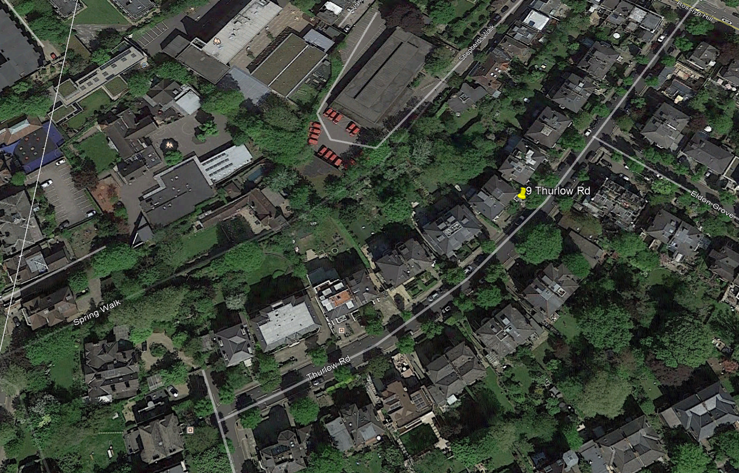

**Gaps between houses on the north side of Thurlow Road, demonstrating visibility of the Biodiversity Corridor here from the street.**

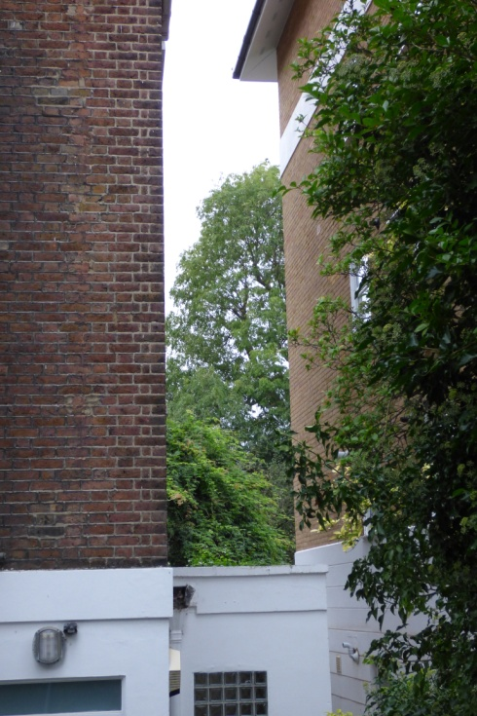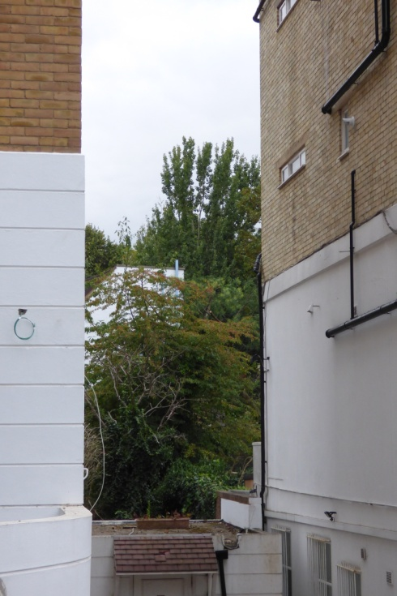 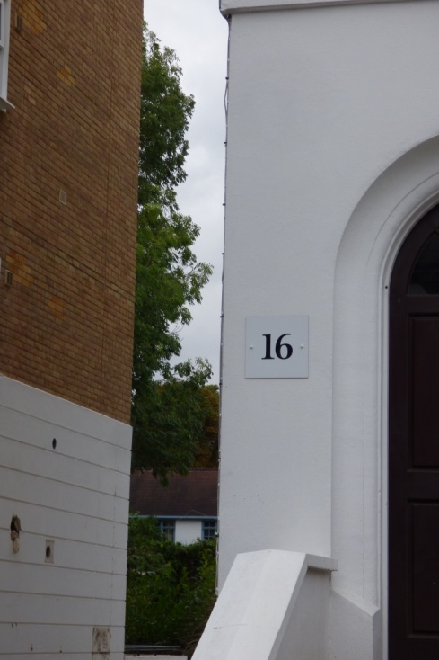

Thurlow Rd trees between 17 & 18; 16 & 17 16 & 17

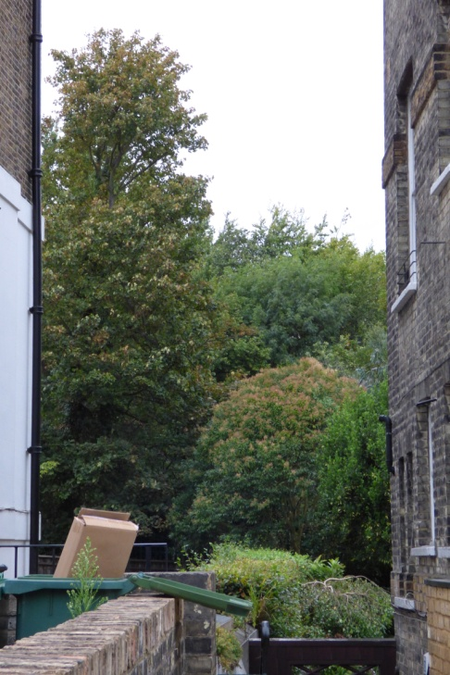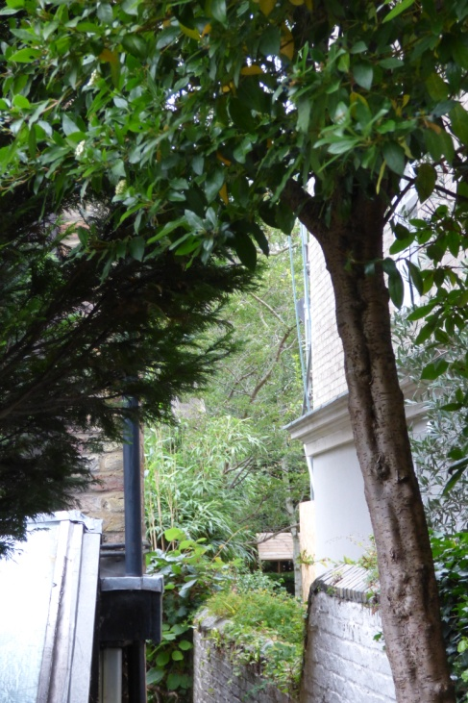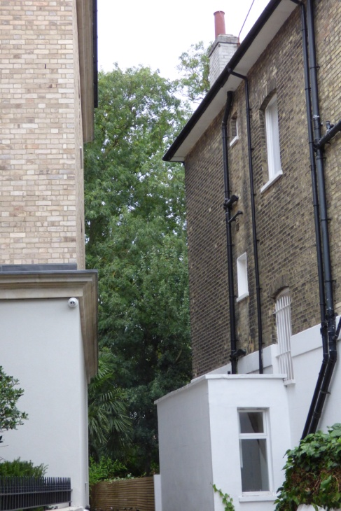

14 & 15 12 & 13 10 & 11

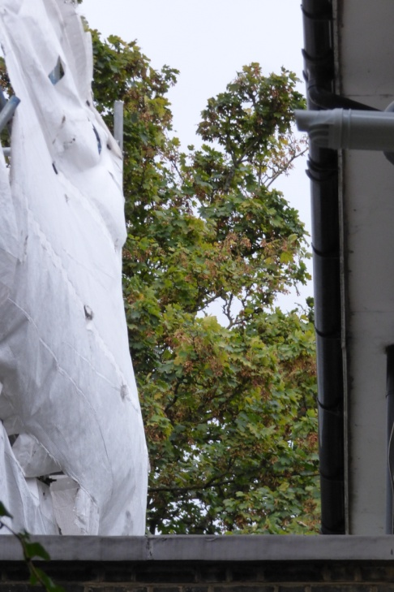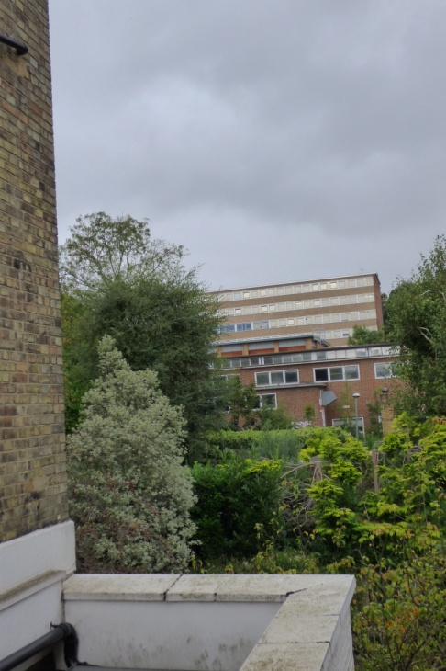 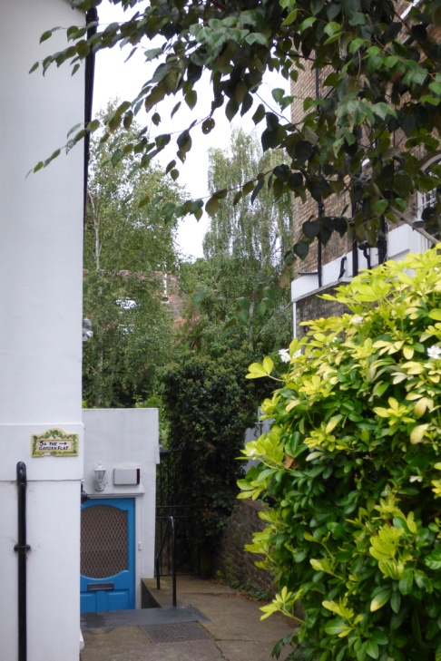

8 & 9 6 & 7 4 & 5