
CONCORDE BGW
Palmer Street
Hyde Park
Doncaster
DN4 5DD
On behalf of PubLove
SITE ADDRESS:
The Northumberland Arms
141 King's Cross Rd,
Kings Cross,
London
WC1X 9BJ
25th August 2019

DESIGN AND ACCESS STATEMENT TO ACCOMPANY AN APPLICATION FOR CHANGE OF USE IN RELATION TO THE HOSTEL TO 1ST & 2ND FLOORS, NEW KITCHEN LOCATION & FULL REFURBISHMENT

EXISTING BUILDING AND ITS CONTEXT:

The Northumberland is an existing public house located on a corner site of two adjoining streets; Kings Cross Rd and Wicklow St with Kings Cross Station located just a 6 minute walk away.

The Northumberland is a traditional building of a 19th century style, set within a conservation area. Consisting of three storeys with tall architraved window bays, double sashes with cornices, segmental pediments to the first floor and one window on a bowed corner. The second floor arched window bays are architraved with simple stepped dentil cornice detailing above.

The public house lower frontage is fully tiled with columns carrying entablature; entrance doors to both elevations are part glazed panelled doors and the elecation has similar glazed windows both sides and a curved glazed window to the corner. There is a stepped frieze with dentil cornice between the first and second floor with prominent quoins to the corner and end of each elevation. The upper façade is fully painted with contrasting painted detailing.

The Ground floor area is currently used as trading areas for the pub, compromising of one open space with a raised seating area. Male and female toilets are located at ground floor to the rear of the building which is a small flat roof construction that backs onto a small yard area.

The First and Second floors are currently being used as short term letting rooms with shared facilities.

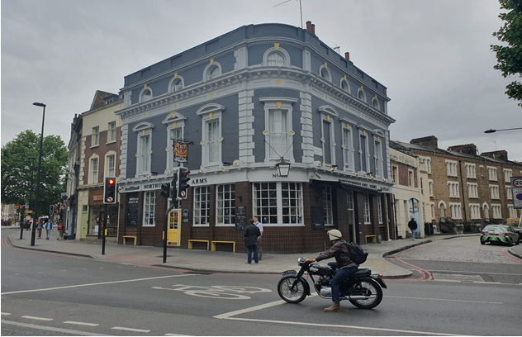

DESIGN PROPOSAL:

The proposal is to refurbish the existing ground floor pub area, introducing a new small kitchen area with open serving hatch; adapting the existing main bar to accommodate a secondary staircase for access to the basement where a new wash-up and stores will be located to serve the new kitchen.

The basement is still to be retained as ancillary/back of house (BOH) for the pub with a new kitchen store and wash-up.

The male and female toilets will remain as the existing arrangement and be refurbished in line with the new scheme. Introducing a DDA compliant WC at this site was investigated and is not spatially viable.

The upper floors (first and second) are to be converted into a backpackers hostel managed by pub staff, in line with our clients offer. The existing layout of the upper floors will remain the same with the exception of the existing facilities; the existing kitchen at First floor will be reconfigured to allow for shared WC and shower facilities and at Second floor the existing WC & shower facilities will be reconfigured to allow for improved shared WC and shower facilities.

There will be 9 rooms spread over two floors; providing 6 to 12 bed space dormitories through the use of triple bunk beds.

ACCESS:

Pedestrian access to the building is located to Wicklow St and Kings Cross Rd.
Both entrances lead into the main trade area which are accessible directly from the pavement where there is a level difference of 100mm. In addition there is also a single door located on Wicklow St as a private secondary access to the upper floors.

The upper floors (hostel bedrooms) will be accessible through the pub or the existing external door on Wicklow St. - External keypad access will be installed for security.

The internal stairs to the upper floors will be retained as existing, the existing finishes will be refurbished, handrails improved/added where required, lighting improved and contrasting nosing will be added in line with building regulations.

The existing internal staircase to the basement will be improved to allow better access to BOH areas. A new staircase is to be introduced next to the main ground floor bar to allow access from the newly proposed kitchen area to wash-up and stores in the basement.

Access doors to the upper floors will be upgraded and fitted with a key card system for security reasons.

There is no existing passenger lift within the building and it is not economically or spatially viable to install this provision.

Each existing entrance door will provide minimum of 750mm clearances in accordance the current Building Regulations Part M.

CONCLUSION:

It is our client’s intention to re-brand this site into a traditional pub and hostel offer.

The proposed works do not include external changes; the internal alterations proposed seek to improve and enhance the quality of the property and preserve it’s use in the local area.

Our client intends to comply with all current regulations and good practice.

SOURCES:

We have referred to:

- Current building regulations
- Planning Portal Guidance

