65 CHETWYND ROAD NW5 1BX - 2019/1930/P. **Revision D - dated 05/08/20019**

Erection of dormer window roof extension to rear roof slope; replacement of front and rear fenestrations

to match existing; installation of rear facing patio doors following removal of existing patio doors.

**OBJECT**

We continue to object most strongly to the introduction of any rear dormer.

Due to the building’s location, the complexity of this part of the roofscape in Chetwynd Road, as per photo below, the importance of the DPCA roofscape setting with many locations where roofs are looked down upon and seen from the public domain (from Bellgate Mews at the rear and York Rise through the gap at the rear of no 67), dormers should not be permitted.

If the Council is minded to allow dormers there should be only one. If light is required to the loft, a rooflight could be inserted to retain the roof profile.

Crucially, Council’s own guidelines in any event show a 500mmm drop from ridge to any dormer roof where dormers would be acceptable.

The **window schedule** has not been altered to show the characteristic glazed corner segments to the upper floor sliding sash windows to be retained.

There is no annotated reference to the **provision of refuse and recycling storage space** on the plans.

**Note**: See also our previous objections dated 19/05/2019 and our comment that the plan does not show how the site relates to the rear of No 65’s lower terrace level roof (see a previous consent: 2017/3898/P for Nos 65-67) This area shown on block plan drwg CRT/PL/402, but not on sections AA and BB which it should, see below.

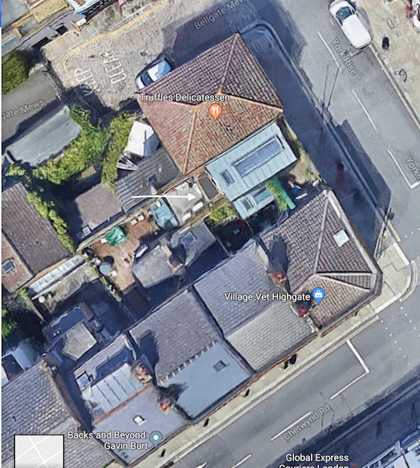

Arrow indicates part of no 65 shown on location plan, but not on sections and its relationship.