The National Trust: Application for Listed Building Consent for the replacement and automation of the rear service yard timber gates at

**Fenton House, Hampstead Grove, Hampstead, London NW3 6SP**

Site Plan

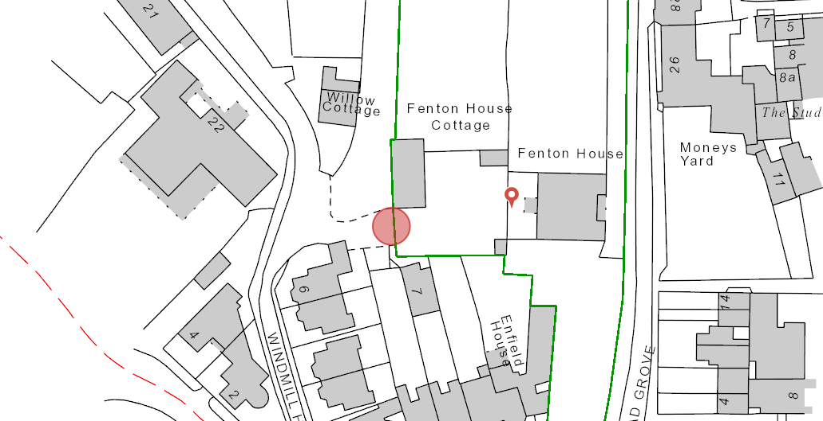

Location rear service yard gates at Fenton House.