The National Trust: Application for Listed Building Consent for the replacement and automation of the rear service yard timber gates at

Fenton House, Hampstead Grove, Hampstead. London. NW3 6SP

HERITAGE STATEMENT

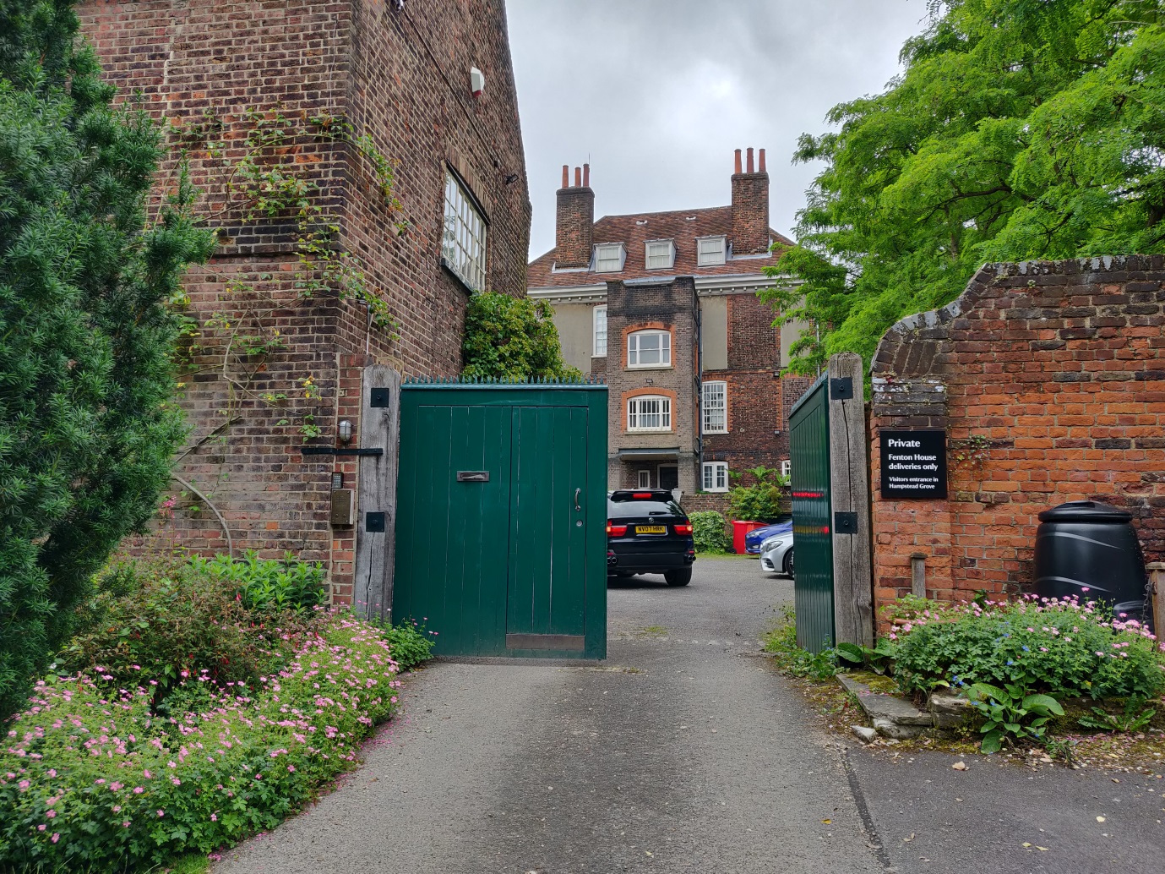

Figure : Fenton House – West elevation and service yard/ carriage entrance showing green gates for replacement

Historic England - Listing:

The subject gates are not themselves listed despite other gates walls and railings at Fenton being Grade II listed in their own right (List Entry Number: 1378654) and as such the closest listed structure.

The mansion is Grade 1 Listed (List Entry Number: 1378648) and the adjacent coach house is Grade II listed (List Entry Number: 1378651) and as such the subject gates and posts require an application for Listed Building Consent given being within the curtilage of the listed structures named above.

Fenton House and Garden – Background:

A house in the country, rather than a country house, Fenton was built as a rural retreat from the City of London. Today its principal significance lies in its architectural merit, its collections, and in visitors’ appreciation of the garden setting against the backdrop of Hampstead village. Begun just twenty years after the Great Fire of London, c.1686, it is one of the earliest brick houses to be built and a rare survival of a gentry home. Both the human and architectural story of Fenton ‘is not one of aristocratic continuity but rather of the prosperous middle classes’ (CMP). For three hundred years it was occupied by a succession of merchant families with City connections who valued the country air and view of the River Thames and Port of London. Its modest grandeur and shifting pattern of ownership lends the house a particularly modern appeal, encouraging the feeling that Fenton belongs to all who enter it.

When Fenton was built Hampstead was still a rural village, attracting visitors up the hill to enjoy the clear air of the heathland, views of London and iron-rich water from local wells. Since then it has drawn writers such as Keats, Coleridge and Galsworthy, and artists as diverse as John Constable, Kate Greenaway and Ben Nicholson. Hampstead is now a densely populated urban environment but Fenton House remains, as it was always intended to be, a sanctuary from the city.

Architecture

The survival of Fenton in an area of developmental pressure makes its architectural importance exceptional (it is Grade I listed). Built c.1686 as a speculative build by a master-bricklayer, rather than a professional architect, the house was tenanted for much of its history and remains little altered in consequence. The overall layout follows a standard four-room square plan but there are idiosyncratic features of architectural interest such as the tall central window in the north front, the placement of the chimney stacks, and the asymmetrical roof with two small wings to the east with balustraded terraces. The house is an unusual mixture of the functional, the fashionable and the experimental, indicative of its creation by master builders and craftsmen without the oversight and direction of a specialist designer.

The principal South side of the house displays many of its characteristic features, including a brownish brick with rubbed red brick dressings to the windows and quoins, and a boldly carved wooden cornice under widely projecting eaves. This latter feature is repeated in other, later, houses in Hampstead for which Fenton may have been an inspiration. Also notable to the south is the wrought iron entrance gate which is in the style of the ironworker Jean Tijou (fl. 1689-1712), the designer of gates for Hampton Court and St Paul’s Cathedral. The gate bears the initials ‘JAG’, presumably for Joshua and Anne Gee who lived in the house from 1706-1750. Fenton is built on a hill and magnificent sweeping views from the east can be gained from the rooftop balcony, whose unique panorama of London’s ever-changing skyline - from the completion of the dome of St Paul’s Cathedral in 1708 to the erection of the Shard in 2010 - continues to encourage a meditation on the relationship between town and country. The views are of considerable significance for an understanding of Fenton House, which has remained neither wholly rural nor become fully urban.

The Coach House (former Stables and Brewhouse) is referred to in the 1686 grant and is of the same brick as the house. Successive campaigns of alteration make its original form difficult to understand in detail and the building (Grade II listed) is currently tenanted with part of the ground floor garage in use as a storeroom.

Garden

Of outstanding significance to Fenton in communal terms is the garden of 1½ acres. It is the feature for which the house is best known and is of particular significance for some of the local community as well to visitors from farther afield. Despite the original village environment the land around the house was laid out on the model of a town garden. Described in sale particulars from 1756 as ‘pleasant…well planted with Fruit-Trees, and a Kitchen-Garden, all inclos’d with a substantial Brick Wall’, it was created on three levels and mostly used to grow fruit and vegetables for the house. The footprint remains relatively unchanged today, the orchard and kitchen garden balancing the more formal walks of the terrace above. The lead statue of a shepherd is by the British sculptor John Cheere and was cast in 1735, the sole survivor of a group of four that once graced the garden. The southern garden gates, the railings, garden walls and lead sculpture are all Grade II listed, as is a cistern in the grounds.

When Fenton came to the National Trust in the 1950s the garden was over-grown and over-mature. Without sufficient records to attempt a restoration or re-creation, the Trust has instead used the existing structure and changes of level to plant a traditional ‘old English garden’ evocative of the Edwardian partnership of Lutyens and Jekyll. Since the 1980s new features, such as the sunken rose garden, and imaginative planting has created a garden of timeless appeal that is rewarding to visit at any time of year. The original underlying structure is considered of exceptional significance for its date, size, level of investment and survival.