Issue | First raised | Affected employers | Relevant screen shots | Response from PFIKS | Update | Priority
Applicants who have applied for jobs are getting strange emails instead of the proper email acknowledgement |  | Springdene | 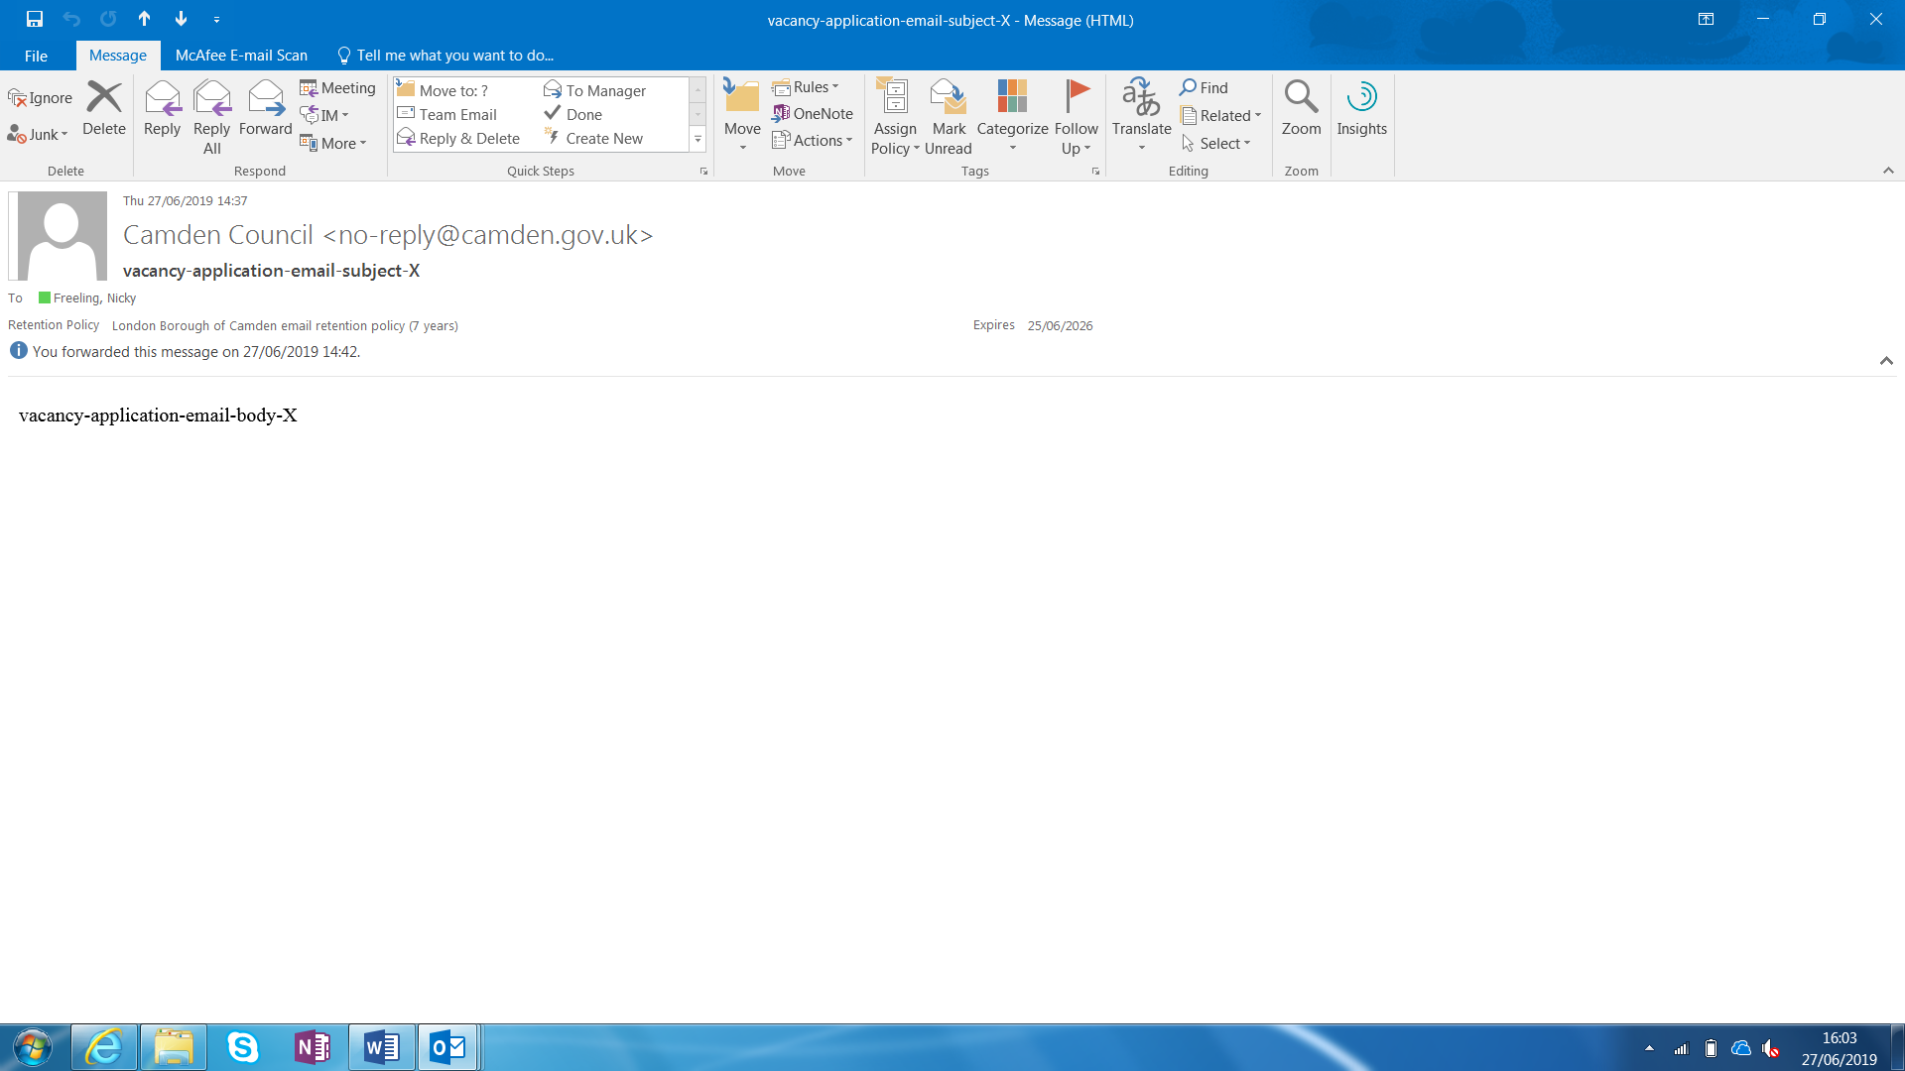 |  |  | medium
Employers are not receiving email alerts regarding job applications |  | Bluebird  Hartwig  Springdene  Priscilla wakefield |  | Must be due to their company firewall |  | HIGH
Employers are not receiving job applications at all |  | Same as above |  | Must be due to their company firewall |  | HIGH
Employers cannot see the jobs they have posted on the site |  | HArtwig |  | Its because they were preregistered. We have to delete and resubmit all jobs |  | Medium
Apply button doesn’t work, it just takes you back to the jobs page | 28/6 | Medacs Health care |  |  | Email sent to Nicky to check External URL | HIGH
Emails come from Camden council and from an address likely to go into junk mail |  |  |  | PFIKS support ticket raised 28th June TKT19062810129 |  | HIGH
Google does not find the url when you search for it |  |  |  |  |  | HIGH

