65 CHETWYND ROAD NW5 1BX - 2019/1930/P. **Revision A - dated 20/06/20019**

Erection of dormer window roof extension to rear roof slope; replacement of front and rear fenestrations

to match existing; installation of rear facing patio doors following removal of existing patio doors.

**OBJECT**

Bar the **changes** to the proposed **front elevation** drwg CRT/PL/200 Rev A showing the entrance door to match the timber four panelled door at No 63 Chetwynd, and the correct house numbering of the terrace Nos 63-65, which we accept, we continue to object most strongly to the introduction of a rear dormer.

The **marginally reduced width of the dormer** now shown on drwgs:

proposed rear elevation CRT/PL201 Rev A, proposed loft CRT/PL/103 Rev A,

proposed roof plan CRT/PL104, proposed section AA CRT/PL/300 Rev A,

proposed Section BB CRT/PL/301 Rev A,

is not acceptable.

Due to the building’s location, the importance of the DPCA roofscape setting with many locations where roofs are looked down upon, together with the view of the rear of this building from the public highway, Bellgate Mews, a dormer should not be permitted. The roof plan clearly shows the unacceptable three-dimensional visual impact, one of bulk, this proposal would introduce. Its introduction is also likely to be viewed from York Rise through the gap at the rear of no 67. Crucially, Council’s own guidelines in any event show a 500mmm drop from ridge to any dormer roof where dormers would be acceptable.

The **window schedule** has not been altered to show the characteristic glazed corner segments to the upper floor sliding sash windows to be retained.

There is no annotated reference to the **provision of refuse and recycling storage space** on the plans.

**Note**: none of the Revision A drawings have a description of the changes listed under the Key, which they should have.

**Note**: See also our previous objections dated 19/05/2019 and our comment that the plan does not show how the site relates to the rear of No 65’s lower terrace level roof (see a previous consent: 2017/3898/P for Nos 65-67) This area shown on block plan drwg CRT/PL/402, but not on sections AA and BB which it should, see below.

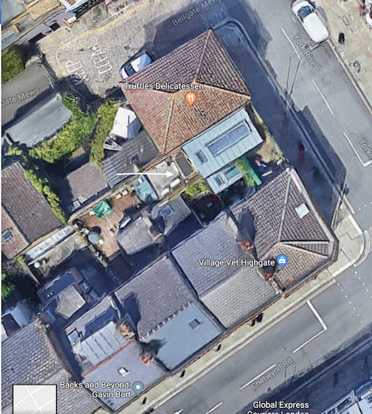

Arrow indicates part of no 65 shown on location plan, but not on sections and its relationship.

26/06/2019