MM MELNYK

FLAT 3, 4 HAMPSTEAD HILL GARDENS, LONDON NW3 2PL

**Re: Planning Application 2019/2964/P – 4b Hampstead Hill Gardens**

Dear Mr Sild,

I write to place on record my objections to the above planning application.

1. **Design and scale**

The redevelopment proposes a futuristic building three storeys high in and amongst Grade 2 listed Victorian buildings. The sheer scale of the building and the design would compete with the nearby historic architecture rather than resonate with it.

The current 1960s building, whilst perhaps not the most handsome, presents modestly amongst neighbouring properties. If redeveloped to the proposed specification, the property would dominate this part of the streetscape. It would lead to imbalance and would not preserve the setting of the listed buildings within close proximity, both on the same side of the street and in the arc opposite the site of 4b.

The description in the applicant’s Heritage Statement, of the existing property being “at best neutral”, as a “sympathetic infilling” and “fitting a new house into a vacant place without causing anybody to feel outraged” remains apt for any redevelopment of this site. Given the nature of the surrounding buildings and its location within the Conservation Area, we are concerned with conservation and enhancement.

This application also represents substantial overdevelopment of both the surrounding area and the existing site, referred to in the supporting Heritage Statements as “on a narrow plot”.

1. **Land stability**

As owner and resident of the above address, I have experienced disruption and added cost due to subsidence experienced in 2011. This application therefore causes me great concern.

I would note:

* The basic geology and arboriculture of the area suggest the starting point for a fresh planning application should be one of utmost caution.
* The existing two- storey property, without a basement, has already been the subject of two subsidence related insurance claims (2005 and 2015).
* It is now proposed to add a basement and an additional storey. The basement will significantly increase the differential depth of the foundations relative to neighbouring properties and places these homes at undue risk.

The starting point for this application is, therefore, far from prudent.

The detail contained in the submission documentation fails to reassure any/all interested parties. By way of example:

* The Basement Impact Assessment refers “… the heave/settlement assessment **assumes perfect workmanship** in the underpin construction and does not allow for shrinkage of the dry pack between existing footings and the new concrete”
* “Ground movement during construction will be **dependent on the quality of workmanship** adopted”.
* “The assessment (basement) **assumes** that the neighbouring propertiesarefully flexible and deform to follow the profile of the ground”.
* ‘The predicted settlement value includes a workmanship allowance of 5mm for the under pinning. **Good quality … workmanship is essential”.**
* “Long term wall deflection is **expected** to be very low”. Long term is not defined and “expected’ is less convincing than “will be”.
* “The proposed development is **not expected** to affect groundwater”. “Will not” would better assure.
* The construction of the basement “will generate ground movement including heave, ground settlement and deflection.”
* “The net loading on foundation soils will generate ground movement which could affect neighbouring foundations.”
* “History of seasonal shrink-swell subsidence in the local area …” is noted.
* “upper soil levels are susceptible to volume change”.”
* The BIA dated 16th May 2019 notes the requirement for 3 land stability assessments. The nature of these assessments suggests it prudent to have carried out these assessments to help determine the feasibility of such a scheme.
* Future risk includes the copper beech at No 6. “Do not allow to exceed current dimensions”. Critically, this is not in the control of the applicant. It is dependent on the actions of the occupants of No 6, to whom the substantial costs of pruning will fall and the agreement to such works of the Trees Team at Camden Council.

Such assumptions, dependenciesand outstanding assessmentshighlight the precarious nature of this application.

Future concerns:

* The Basement Impact Assessment references soil testing and borehole sinking in February 2015 to support the subsidence related insurance claim. This was undertaken in a dry spell. That the submission uses data compiled over four years ago is unsatisfactory.
* The supporting documents for this application speak to resolving the considerable existing challenges. However, nothing in the submission addresses what impact climate change might have on future ground and water conditions and any potential harm to neighbouring properties and the integrity of this special Conservation Area if this proposal goes ahead.
* The carbon footprint of this development will be high. The perfect opportunity to neutralize it has been missed. The submission references sustainable and sustainability but proposes that the new build uses gas. Indeed, the first session of Camden’s Citizen Assembly discussed energy saving measures including the banning and replacement of gas boilers with electric heat pumps in new builds.

1. **Basement development**

* The applicant’s reference to Camden ‘s Local Plan - “basement development is a popular way of getting additional space in homes” should be set alongside the “**however**” contained in the very same section of the CLP and the key message they “must not cause harm”.
* The applicant’s submission notes: “The basement provision does not fully accord with paras h and l of Policy A5 regarding basement development”. The Camden Local Plan Evidence Report (survey of basement developments) notes “**the most significant change in policy revision is to introduce the guideline limits on the maximum size of basement development including that basement development should not exceed 50% of each garden.** On this basis alone, the application merits rejection.

1. **Roof-scape & loss of light**

4b is a focal point of multiple properties due to the shape of the road and its aspect.

The applicant’s supporting Heritage Statement notes “the original houses on the inner curve were more widely set, with a large gap between numbers 4 and 6”.

I would urge that the remaining gaps between properties and the current skyscape be protected by not permitting this development.

I would question the conclusions of the submitted daylight/sunlight report on the basis of omission and assumptions made:

* The views and light into the living area of my first-floor apartment would be impacted. Now into my 20th year of residency at the above address, the large windows in the living area overlook the garden, trees and the view includes the roofs of Grade 2 listed houses on the opposite side of the street. A three-storey house on the site of 4b will not just be intrusive but very detrimental to my personal space and the peaceful enjoyment of my home and will most definitely impact the overall roof, the views and skyscape.
* There is no reference to the daylight/sunlight impact on the communal garden at the rear of 4 Hampstead Hill Gardens.

1. **Gardens and loss of amenity**

* 4 Hampstead Hill Gardens is the family home of four ‘family’ units. At this time, 10 people reside here including young children. This development will substantially impact our enjoyment of our communal garden and recreational amenity.
* The argument that the living space of the new property will not overlook neighbouring gardens is not correct. The height and mass of the new building would significantly impose itself on our garden.
* We have invested time, money and great consideration in the planting of the garden at No4. The garden faces natural challenges – the span of neighbouring trees including the copper beech at No 6, the clay soil and drainage. An additional storey overlooking the garden of 4 Hampstead Hill Gardens, will impact sunlight and thereby the plants and vegetation.

Part of the original garden of No 4 was lost to the development of 4b. No 4 would suffer further loss to garden amenity if this application is approved. It is perfectly reasonable that further encroachment into what remains of the original garden be resisted.

Photographs from first floor level are attached below to support the above statements.

1. **Breaches of Planning guidance**

The following are noted:

* The blatant disregard of A2 planning guidelines for basements alone should disqualify this application.
* Camden Planning Guidance on basement development also requires that basement development “minimise the loss of garden space”. A lowered garden is not in the same category as a standard garden.
* Notwithstanding that the daylight/sunlight report is highly questionable, the submission notes that “the proposals do not fully accord with part (f) of policy A1”

Non-compliance to planning guidelines, especially in a Conservation Area, should be resisted.

1. **Disruption**

Finally, whilst technically not a planning matter, the scale of the proposed redevelopment and the ensuing disruption merits your consideration.

Much as we prefer to consider ourselves as neighbours, the redevelopment will reclassify 4 Hampstead Hill Gardens as one of “the nearest potential receptors”; most likely to be affected by site activities including noise, vibration, fumes, dust etc.

For those who are largely housebound and others who work from home, this project will be very unpleasant with noise and vibration as constant irritants. It is not unnatural that the prospect of a lengthy and significant intrusion into our lives is of concern.

In relation to disruption, I raise the following two points:

1. Duration of works

* The Construction Management Plan (CMP) notes four phases of the programme of 65 weeks. Assuming tasks/activities overlap this “will be **around** 55 weeks”.
* Allowing for standard construction workers annual holidays, weather events, delivery failure, ongoing testing/monitoring and potential stoppages if remedies are required along with the constraints of the site, “around 55 weeks” is implausible.
* “Around 55 weeks” in the real world, and given the scale of the project, will likely translate to 2 years+. Inevitably no-one will be held accountable for delayed outcomes. This is not a credible schedule and the nearest potential receptors, most especially, will suffer.
* The Construction Management Plan notes “a new gas supply will be required on completion of the project **if** r**equired’**? Also, “It is **hoped** that the existing 3 phase temporary builder’s supply will be used for the new permanent supply on completion of the project”. Has a potential new gas supply been factored into the “around 55 weeks” statement?
* The submission notes the need for “**perfect workmanship”** to avoid heave and settlement. Time pressure and “perfect workmanship” are incompatible bedfellows. The premise that delivery of this sensitive building project will take “around 55 weeks” merits serious questions.

1. Vehicular movements

* That a full time Traffic Marshall is required to supervise activity speaks to the volume and complexity of managing the project’s logistics.
* The statement re the maximum number of vehicles per day is slightly unclear to a lay person. E.g. “10 vehicles per day, 8 HGV”.
* Acceptable vehicle movements are between 9.30 to 4.30 pm weekdays (7-hour window). If, say, 10 vehicles, this might equate to a vehicle arriving every 42 minutes.
* Notwithstanding that “some days will be much less”, this represents a considerable level of activity. It would be of further concern if the overlapping of construction tasks gives rise to even higher density vehicle movements on certain days.
* Re the aim to avoid part loads. Given the constraints of the site and the overlap of construction tasks, the project will inevitably give rise to part loads being delivered. This would lead to an increase in vehicle movements.
* Re Pond Street access. Not mentioned in the submission is the location of Hampstead Hill School (2 – 7 years) at the intersection of Pond Street and Hampstead Hill Gardens. Guidance for contractors working in Camden states if schools are in the vicinity of the site or proposed access/egress routes, vehicles will be restricted to the hours of 9.30am and 3.30pm during term time. If this restriction is applied, the window for vehicle movements is reduced to 6 hours making the vehicle activity potentially even more concentrated.
* Given the need to negotiate the turn into Hampstead Hill Gardens, navigate through cars parked on both sides of the road, negotiate with oncoming through traffic and park on a troublesome bend, an intense delivery schedule gives rise to potentially more hazardous conditions for cars, pedestrians and on-site contractors.
* The traffic in the Pond Street/South End Road area is heavy and includes ambulances to and from the Royal Free along with considerable bus movement. Just in time management as proposed, will prove exceptionally challenging. Delays, late arrivals, failures to arrive will also compromise the suggested “around 55 weeks” schedule.
* On top of the demolition, excavation and construction work, the noise and vibration of vehicle arrivals, loading (excavation), unloading and departures at high frequency will add significantly to the overall disruption of normal life for all residents.

The impact of vehicle movement for this project is, I believe, understated. Not only disruptive to neighbours but also an impediment to both pedestrians and car users.

In summary, whilst disruption is not in itself a consideration in determining the application, it is especially objectionable in the context of what is proposed. A redevelopment on land that is demonstrably compromised; a building of density and mass that will be overbearing and out of scale and whose design is out of character with the surrounding buildings; that will impact the roof and skyscapes and neighbouring gardens and residential amenity. This proposal also breaches a number of planning guidelines.

I ask that this application be refused for all the above reasons.

Please note my wish to attend the Committee meeting should such meeting take place.

Yours Sincerely,

MM Melnyk

15th July 2019

Enc.: photographic evidence

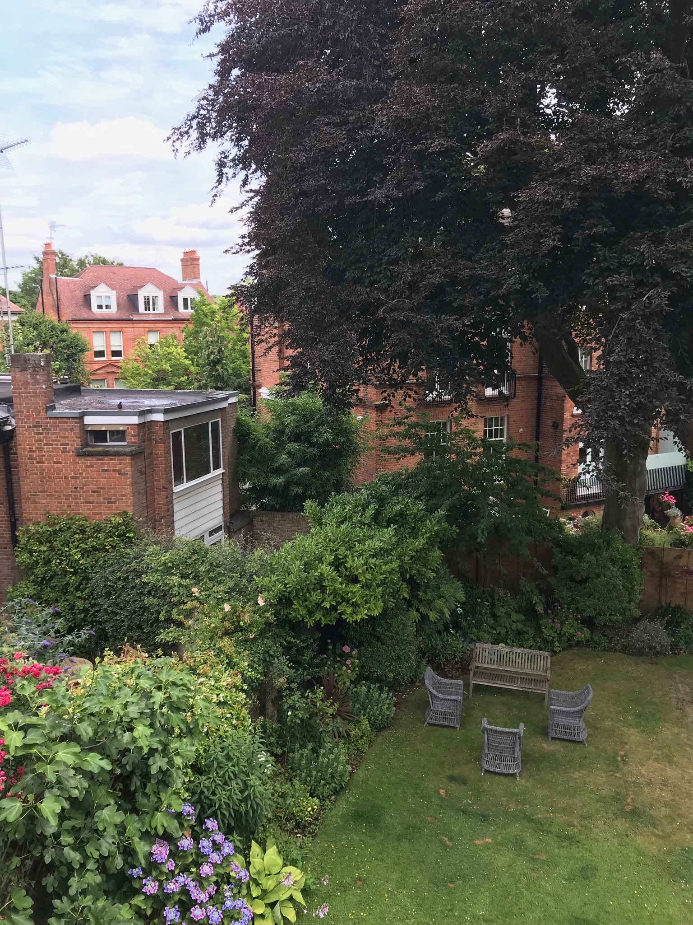

The view from living room window (marked as W2/61). Highlights the current aspect of 4b; the roof-scape, part of 4’s communal garden and the significance of the copper beech tree

T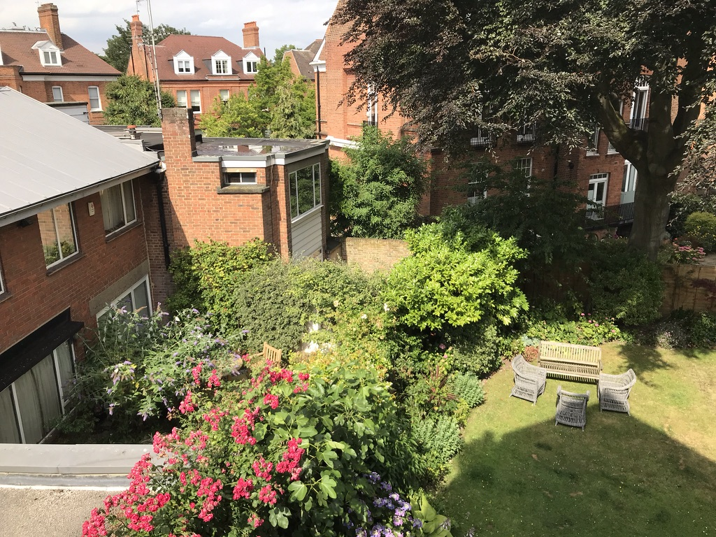

The view from the same window incorporating part of 4a alongside 4b. It illustrates the vegetation of 4 and 4a in close proximity to 4b. It further illustrates the roof-scape that would be lost due to the massing of the new development