DECISION

Town and Country Planning Act 1990 (as amended)

Approval of Details Granted

Address:
Charles Clore House
17 Russell Square
London
WC1B 5JP

Proposal:
Discharge Condition 5 (Roof plant details)(ref: 2017/6637/P granted 14/03/2018) for: External alterations to the entrance of the building ... and including the installation of rooftop plant machinery.
Drawing Nos:
Example of EEC acoustic louvre screen manufacturers photograph;
739-PL090 B;
739-PL091 B;
EEC acoustic louvre specification:
EC15205-032 Plant Noise Impact Assessment;
EC15205-DWG-04 rev 1;
1378-L6R-MECH-01 rev 3;
739 DIS (Series PL) 190218.

The Council has considered your application and decided to grant permission subject to the following condition(s):

Condition(s) and Reason(s):

Informative(s):

Reason for Approval:

An Environmental Health officer has assessed the proposed details and raises no objections. The information submitted provides sufficient detail regarding the mechanical systems. Given the above, officers are satisfied and the condition is discharged.

No objections were received prior to making this decision. The site's planning history and relevant appeal decisions were taken into account when coming to this decision.

As such, the proposed development is in general accordance with Camden Local Plan 2017 policies G1, C1 and A1 and with policies D1 and D2 of the Camden Local Plan 2017

You are advised that all conditions relating to reference 2017/6637/P granted 14/03/2018, which require details to be submitted to and approved in writing by the local planning authority, have been discharged.

In dealing with the application, the Council has sought to work with the applicant in a positive and proactive way in accordance with paragraph 38 of the National Planning Policy Framework 2019.

You can find advice about your rights of appeal at:
http://www.planningportal.gov.uk/planning/appeals/guidance/guidancecontent

Yours faithfully

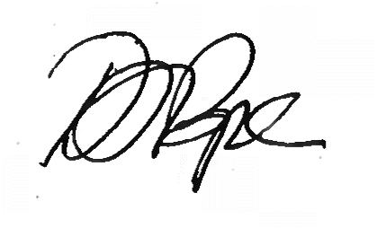
Daniel Pope
Chief Planning Officer

