Application for Listed Building Consent for the installation of emergency lighting systems and lighting internally to Fenton House, Hampstead Grove, Hampstead. London. NW3 6SP

Existing light fitting to back stair, 1st floor landing to which new light fitting to half landing between first and ground floors will be matched

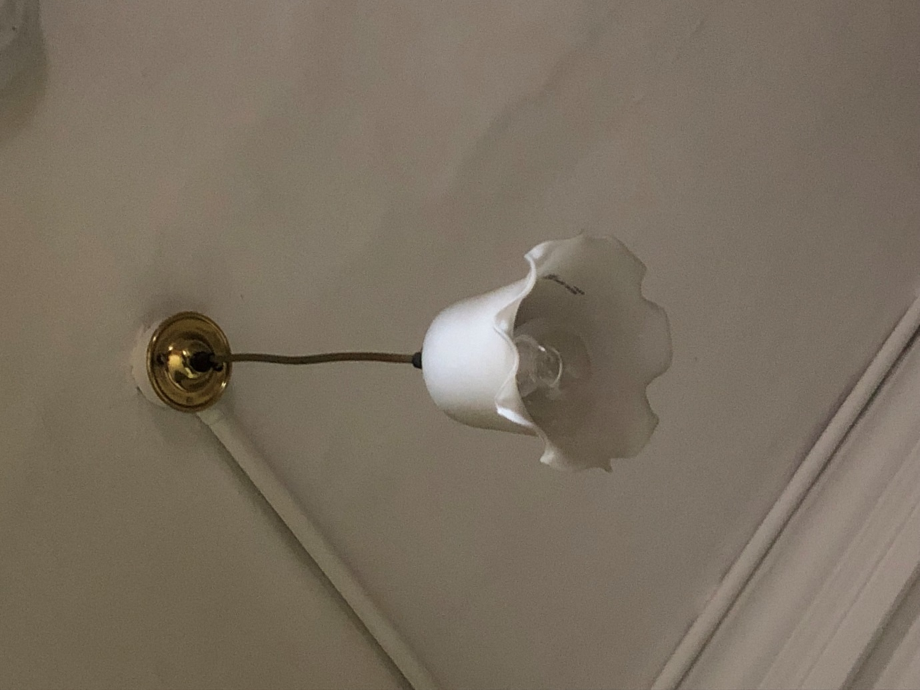

Figure 1: Existing rose pendant light fitting to 1st floor back stair landing with braided flex, brass effect lamp holder and frosted glazed tulip shade