HERITAGE STATEMENT

Application for Listed Building Consent for the installation of emergency lighting systems internally to Fenton House, Hampstead Grove, Hampstead. London. NW3 6SP

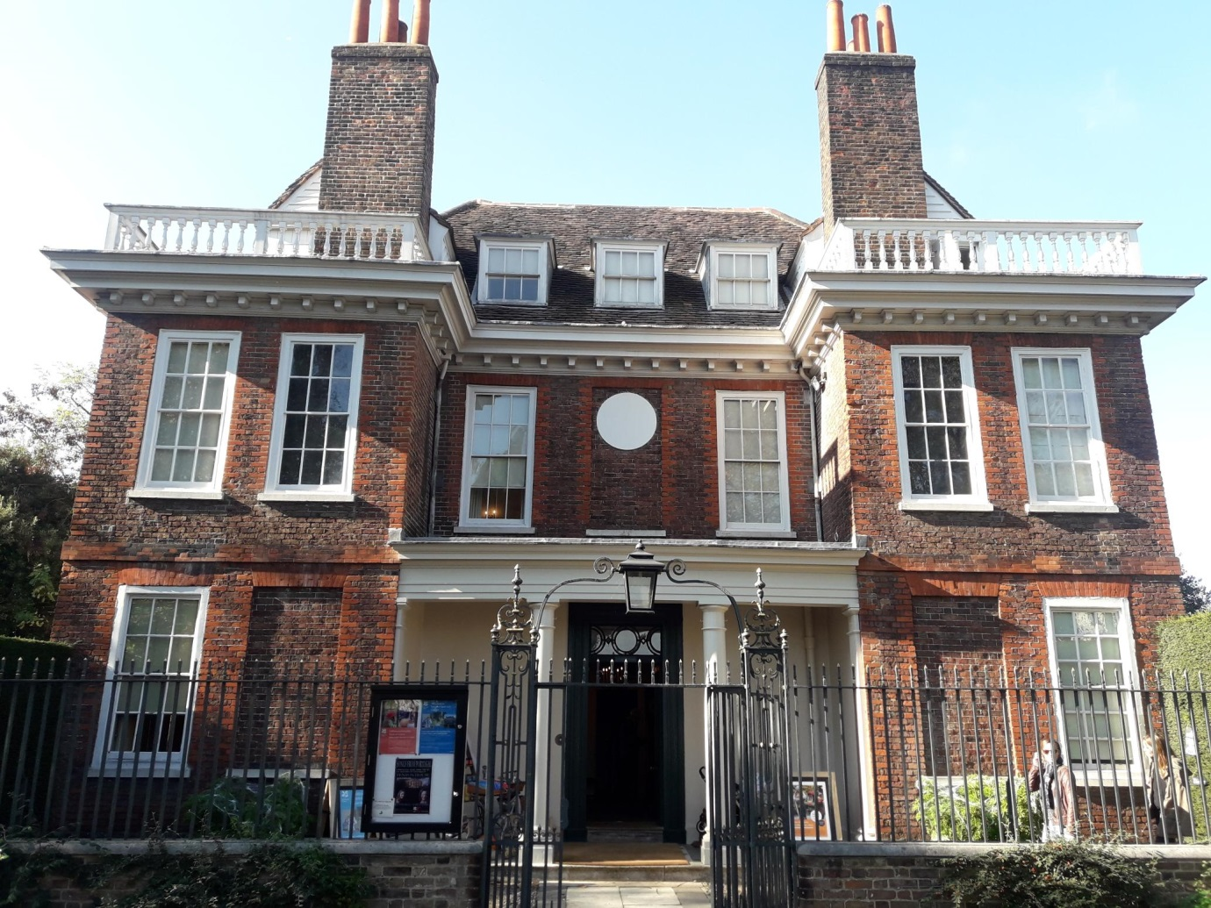

Figure 1: Fenton House - East elevation and public entrance

A house in the country, rather than a country house, Fenton was built as a rural retreat from the City of London. Today its principal significance lies in its architectural merit, its collections, and in visitors’ appreciation of the garden setting against the backdrop of Hampstead village. Begun just twenty years after the Great Fire of London, c.1686, it is one of the earliest brick houses to be built and a rare survival of a gentry home. Both the human and architectural story of Fenton ‘is not one of aristocratic continuity but rather of the prosperous middle classes’ (CMP). For three hundred years it was occupied by a succession of merchant families with City connections who valued the country air and view of the River Thames and Port of London. Its modest grandeur and shifting pattern of ownership lends the house a particularly modern appeal, encouraging the feeling that Fenton belongs to all who enter it.

When Fenton was built Hampstead was still a rural village, attracting visitors up the hill to enjoy the clear air of the heathland, views of London and iron-rich water from local wells. Since then it has drawn writers such as Keats, Coleridge and Galsworthy, and artists as diverse as John Constable, Kate Greenaway and Ben Nicholson. Hampstead is now a densely populated urban environment but Fenton House remains, as it was always intended to be, a sanctuary from the city.

Architecture

The survival of Fenton in an area of developmental pressure makes its architectural importance exceptional (it is Grade I listed). Built c.1686 as a speculative build by a master-bricklayer, rather than a professional architect, the house was tenanted for much of its history and remains little altered in consequence. The overall layout follows a standard four-room square plan but there are idiosyncratic features of architectural interest such as the tall central window in the north front, the placement of the chimney stacks, and the asymmetrical roof with two small wings to the east with balustraded terraces. The house is an unusual mixture of the functional, the fashionable and the experimental, indicative of its creation by master builders and craftsmen without the oversight and direction of a specialist designer.

The principal South side of the house displays many of its characteristic features, including a brownish brick with rubbed red brick dressings to the windows and quoins, and a boldly carved wooden cornice under widely projecting eaves. This latter feature is repeated in other, later, houses in Hampstead for which Fenton may have been an inspiration. Also notable to the south is the wrought iron entrance gate which is in the style of the ironworker Jean Tijou (fl. 1689-1712), the designer of gates for Hampton Court and St Paul’s Cathedral. The gate bears the initials ‘JAG’, presumably for Joshua and Anne Gee who lived in the house from 1706-1750. Fenton is built on a hill and magnificent sweeping views from the east can be gained from the rooftop balcony, whose unique panorama of London’s ever-changing skyline - from the completion of the dome of St Paul’s Cathedral in 1708 to the erection of the Shard in 2010 - continues to encourage a meditation on the relationship between town and country. The views are of considerable significance for an understanding of Fenton House, which has remained neither wholly rural nor become fully urban.

The Coach House (former Stables and Brewhouse) is referred to in the 1686 grant and is of the same brick as the house. Successive campaigns of alteration make its original form difficult to understand in detail and the building (Grade II listed) is currently tenanted with part of the ground floor garage in use as a storeroom.

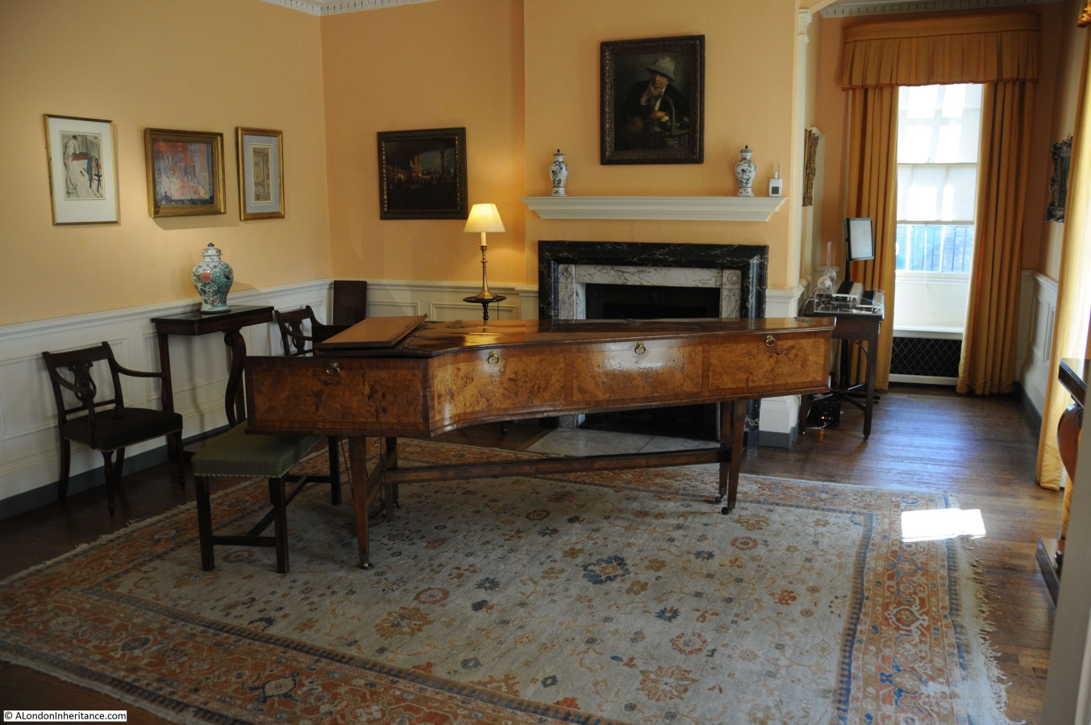

Figure : Morning Room - Ground Floor

Interiors

While no complete original scheme survives in the interior, much of the original panelling, fireplaces and windows have been retained, the sashes of which are unusually early examples of their type. Fashionable improvements made in the 19th century by the Fenton family were relatively small-scale and are interesting in their own right both as documents in the history of taste and because so little of the work of that period survives intact. The decorative character of the house today, particularly the colour schemes, fabrics and upholstery dates from 1973 and is largely the result of the ‘country house’ taste of interior designer John Fowler, who was enlisted to help bring the disparate collections on display into a more harmonious arrangement. Fowler was the foremost society decorator of post-WWII Britain and is a key figure in the serious study of decorative history. Research should be done at Fenton to determine whether his work there has independent decorative significance.

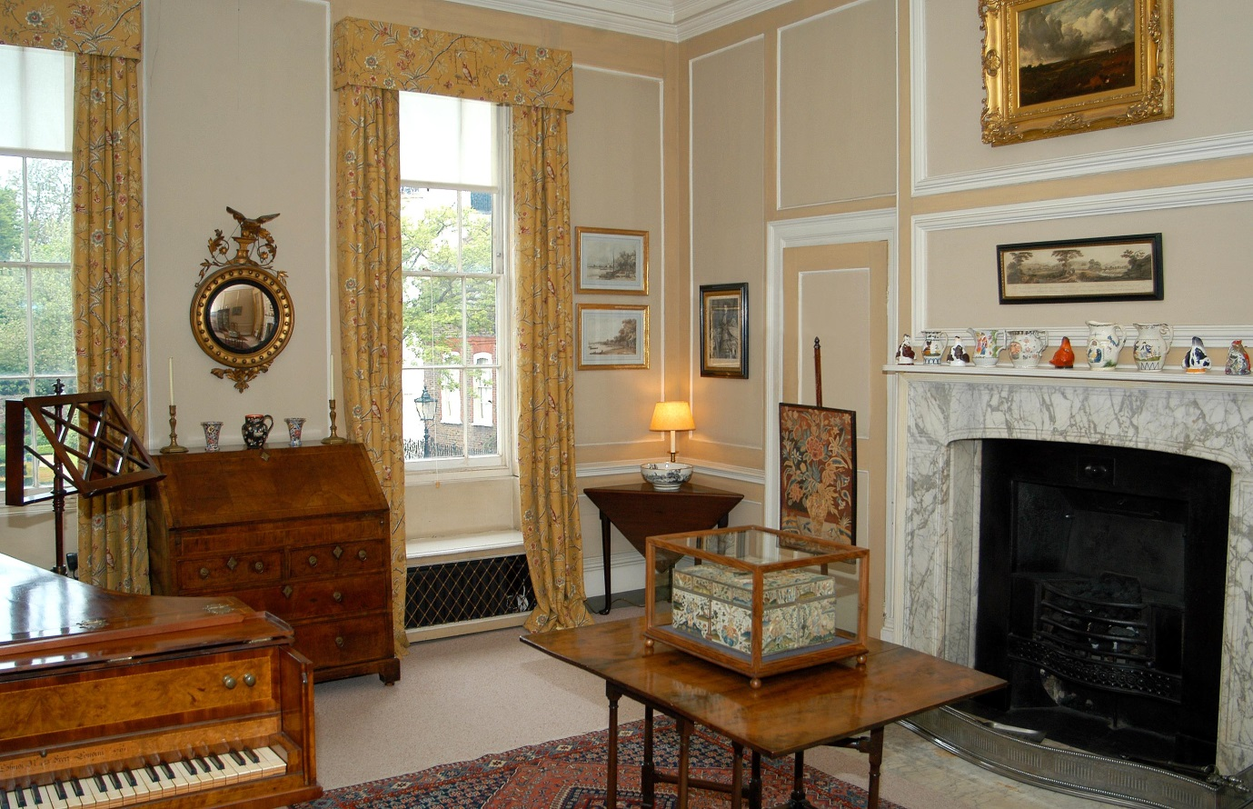

Figure : Rockingham Room - First Floor

Garden

Of outstanding significance to Fenton in communal terms is the garden of 1½ acres. It is the feature for which the house is best known and is of particular significance for some of the local community as well to visitors from farther afield. Despite the original village environment the land around the house was laid out on the model of a town garden. Described in sale particulars from 1756 as ‘pleasant…well planted with Fruit-Trees, and a Kitchen-Garden, all inclos’d with a substantial Brick Wall’, it was created on three levels and mostly used to grow fruit and vegetables for the house. The footprint remains relatively unchanged today, the orchard and kitchen garden balancing the more formal walks of the terrace above. The lead statue of a shepherd is by the British sculptor John Cheere and was cast in 1735, the sole survivor of a group of four that once graced the garden. The southern garden gates, the railings, garden walls and lead sculpture are all Grade II listed, as is a cistern in the grounds.

When Fenton came to the National Trust in the 1950s the garden was over-grown and over-mature. Without sufficient records to attempt a restoration or re-creation, the Trust has instead used the existing structure and changes of level to plant a traditional ‘old English garden’ evocative of the Edwardian partnership of Lutyens and Jekyll. Since the 1980s new features, such as the sunken rose garden, and imaginative planting has created a garden of timeless appeal that is rewarding to visit at any time of year. The original underlying structure is considered of exceptional significance for its date, size, level of investment and survival.

Collections

Fenton House was bequeathed to the National Trust in 1952 by its last private owner, Lady Katherine Binning (née Salting), as a showcase for her collections some of which are of exceptional importance. They comprise important early Chinese ceramics, snuffboxes, and fine examples of both English and German eighteenth-century china including Meissen ware and English porcelain from the factories of Bristol, Bow, Chelsea and Derby. They also include an excellent group of seventeenth-century embroideries and stumpwork which has an international reputation. Lady Binning also left an eclectic mixture of furniture and pictures. Her father, William Salting, had been a collector of Chinese ceramics, and her uncle was the prolific Victorian collector George Salting (1835-1909), who left the majority of his important acquisitions to the National Gallery, the British Museum and the V&A Museum. Research into Lady Binning as a collector, and into the possible Salting provenance of certain items, would help inform future presentation.

While not indigenous to the house, Fenton’s current dominant feature is the Benton Fletcher collection of early keyboard instruments which the Trust brought to the house in 1952 and which have been on display ever since. Uniquely, in accordance with Major Benton Fletcher’s wishes, they are kept in playable condition. The collection contains some extremely rare instruments including the earliest surviving Shudi and Broadwood harpsichord of 1770 (with both partners names inscribed), and possibly unique Italian examples. Over the years additional instruments have been added to the collection including the Dolmetch Clavichord, two further Broadwood pianos and non-keyboard musical instruments such as lutes, two harps and a hurdy gurdy. A comparative assessment of the significance of the ceramics, textiles and Benton Fletcher collections is needed in order to inform future decisions.

A collection of pictures bequeathed by the actor and Hampstead resident Peter Barkworth (1929-2006) contains works of art by members of the Camden Town group, including Walter Sickert and Spencer Gore, and reflect his interest in the locality as well as in the theatre.

Items from the descendants of former owners of Fenton have recently been bequeathed to the house and include two portrait miniatures of James and Margaret Fenton.

Loaned collections include an exceptional group of family portraits by Ben Nicholson, a former Hampstead resident, and a number of portraits from the National Trust’s collection at Courts Holt (Wiltshire) of William IV, George IV, and the sons of William IV and Dora Jordan. The latter relate to the Hart Davies family, who occupied Fenton in the nineteenth century, and who are descended from William IV and Dora Jordan through a daughter.