DESIGN AND ACCESS STATEMENT

Job Reference: | 17 Boscastle Road, NW5 1EE | Date: | 23th May 2019
Issue: | Design and Access Statement | Our Ref: | 17BOS-B-PL-190523

Introduction
This Design & Access Statement accompanies and supports the application for planning consent in relation to 17 Boscastle Road, NW5 1EE. The proposal includes for the installation of a small external plant unit enclosed by a timber screen which is discreetly sited towards the rear of the flank wall of the applicant’s dwelling house.

Documentation
This Design and Access Statement is to be read in conjunction with the following drawings by Finkernagel Ross:
- 17BOS-000_P1
- 17BOS-010_P1
- 17BOS-200_P1

And following supporting document by Paragon Acoustic Consultants:
- 17BOS-Environmental Noise Assessment

Context
17 Boscastle Road, NW5 1EE is an unlisted semi-detached family home located in the Dartmouth Park Conservation Area. The property is currently undergoing works covered by the following permitted planning application and is substantially complete:
- 2018/4480/P

The proposal under this application is to install an external piece of plant equipment, which will serve the main residence at 17 Boscastle Road, towards the rear of the flank wall of the applicant’s dwelling house.

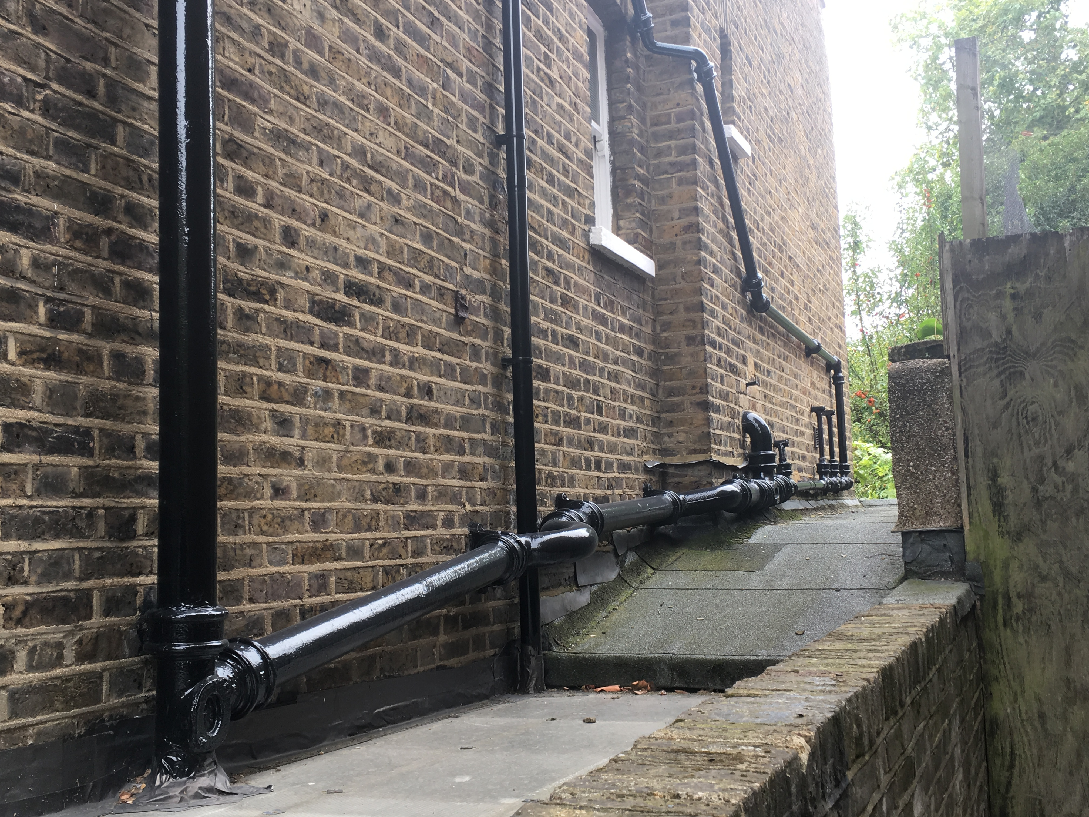
Figure 1.0 – Existing flank elevation at 17 Boscastle Road.

The proposal locates the unit discreetly towards the rear of the flank wall of the applicant’s dwelling house, in a location not visible from the public highway (Boscastle Road). The unit is also located out of view from the neighbour’s rear windows.

The unit is contained in an acoustic enclosure to minimise noise levels. This is in accordance with Camden Council’s requirements regarding environmental noise, as demonstrated in the accompanying Environmental Noise Assessment by Paragon Acoustic Consultants.

A horizontal timber screening system will clad the new equipment to provide a sympathetic aesthetic that blends well with the surrounding context.

Analysis
As described above the proposal is not visible from the public highway and the accompanying acoustic report demonstrates that the proposal will comply with Camden Council’s requirements regarding environmental noise. These aspects mean that there will be no impact on the conservation area.

We therefore trust that the information enclosed is sufficient and we look forward to hearing from you in due course.

