|  |  |
| --- | --- |
| BT Plc  Radio Design, Infrastructure & Operations  Site Share Specialist  81 Newgate Street  London  EC1A 7AJ | MONO CONSULTANTS LIMITED  STEAM PACKET HOUSE  76 CROSS STREET  MANCHESTER  M2 4JG  t: 44 (0) 0161 839 8839 f: 44 (0) 161 839 8840  www.monoconsultants.com |

07.05.19

Dear Sir/Madam,

**APPLICATION FOR FULL PLANNING PERMISSION & LISTED BUILDING CONSENT**

**BT TOWER, 45 MAPLE STREET, LONDON, W1T 4JZ**

I write to inform you that Mono Consultants Ltd are applying for full planning permission and listed building consent to the London Borough of Camden to install the development at the above site as described in the attached Notice.

Please find attached the appropriate Notice served under Article 11 of the Town and Country Planning (General Development Management Procedure) (England) Order 2015.

The Notice is required by law to be served on you as the owner of the land/building that an application for planning permission has been submitted. Should you wish to make representations to the Local Planning Authority on the application then the relevant details are contained on the Notice.

Should you have any further queries regarding the proposal please do not hesitate to contact the undersigned.

Yours faithfully,

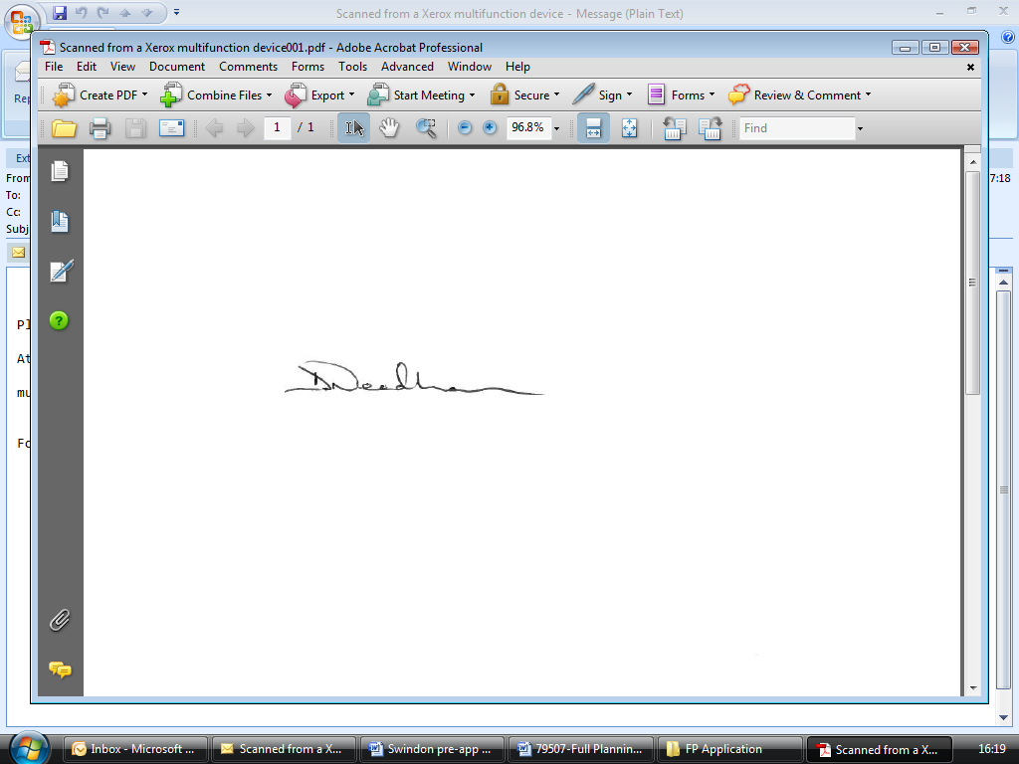

**Dom Needham *BA MPlan (Hons)***

Acquisition Manager

Mono Consultants Limited

Direct:  0161 214 1742

E-mail: dom.needham@monoconsultants.com

**Town and Country Planning (Development Management Procedure) (England) Order 2015 NOTICE UNDER ARTICLE 11 OF APPLICATION FOR PLANNING PERMISSION**

**(Notice 1: This notice is to be printed and served on individuals if Certificate B or C is completed)**

________________________________________________________________________________________

**Proposed development at:**

**Name or flat number**

**Property number or name** BT Tower

**Street** 45 Maple Street

**Town** London

**Postcode** W1T 4JZ

**Take notice that application is being made by:**

**Organisation name** Luminet c/o Mono Consultants as a duly authorised agent

**Applicant name** **Title** n/a **Forename** n/a

**Surname** n/a

**For planning permission to:**

**Description of proposed development**

*The rooftop installation of 3no. antennas mounted on existing support poles and ancillary development thereto.*

**Local Planning Authority to whom**

**the application is being submitted:** London Borough of Camden

**Local Planning Authority address:** London Borough of Camden, Planning - Development Control, Camden Town Hall, Judd Street, London, WC1H 8ND

**Any owner of the land or tenant who wishes to make representations about this application, should write to the council within 21 days of the date of this notice.**

**Signatory:**

**Signatory** **Title** Mr **Forename** Dom

**Surname** Needham

**Signature**



**Date (dd-mm-yyyy)** 07-05-2019

**Statement of owners' rights: The grant of planning permission does not affect owners' rights to retain or dispose of their property, unless there is some provision to the contrary in an agreement or lease.**

**Statement of agricultural tenants' rights: The grant of planning permission for non-agricultural development may affect agricultural tenants' security of tenure.**

**'Owner' means a person having a freehold interest or a leasehold interest the unexpired term of which is not less than seven years. 'Tenant' means a tenant of an agricultural holding any part of which is comprised in the land.**

**Once completed this form needs to be served on the owner(s) or tenant(s)**