SUPPORTING PLANNING STATEMENT

Site Name & Reference | BT Tower
Postal Address | BT Tower, 45 Maple Street, London, W1T 4JZ
National Grid Reference (NGR) | E529227, N181917
Description of Development | The rooftop installation of 3no. antennas mounted on existing support poles and ancillary development thereto.

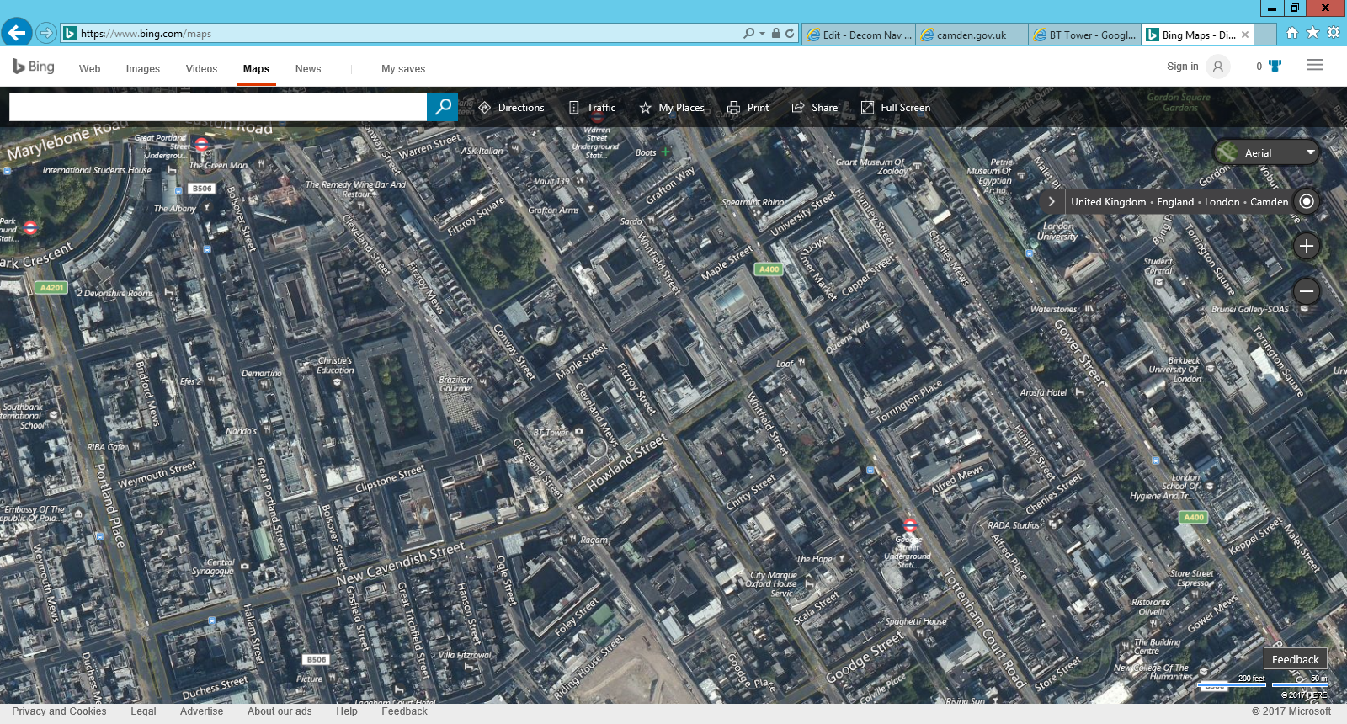
Application site
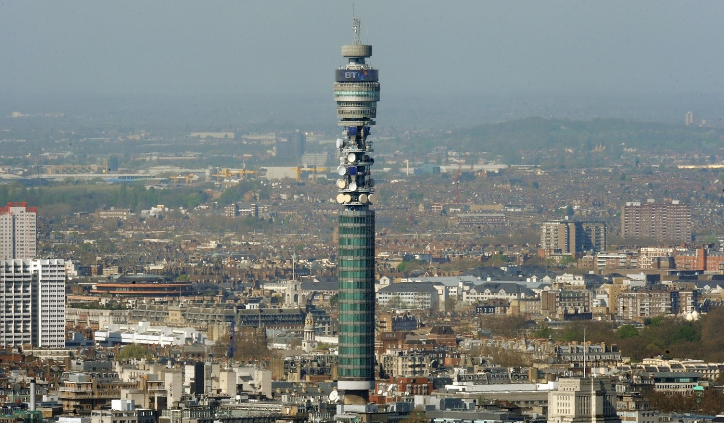

Application Site

Application Overview

Luminet is the trading name of Urban Wimax Ltd based in the centre of London. Luminet’s has some 500 business customers in the centre of London with businesses located in the Camden Council area and many more businesses in other parts of central London. Luminet supplies high quality connection to the Internet for these customers and is unusual in being able to connect new customers within 28 days.

Luminet are currently providing high speed internet connections using Fixed Wireless Access systems to 190 customers from their current hub site on roof of Hilton Hotel, Park Lane. However, Luminet have been served with a notice to remove their apparatus from this property by March 2018. Therefore in order to maintain their current service to their 190 customers and facilitate future network expansion there is a need to find a replacement site. It is highlighted at this juncture that this cannot be achieved through the use of a single building and Luminet are consequently seeking to deploy their equipment across the application and two other properties.

This application stems from the need for Luminet to meet greater network demands to provide high speed internet connection as their customer base increases. It is of note that this applications follows on from the approval of application ref:- 2017/5582/P & 2017/5583/L, to install 6no. antennas and 1no. equipment cabinet at the application site.

Technical Justification

Dish antennas operate on a line of sight basis and transmit and receive highly focussed low powered radio waves that travel in a straight line direction. Dish antennas usually have the function of linking a base station, sometimes through a series of dish links, to a base station site elsewhere in a telecommunications network. In this respect dishes can vary in terms of their diameter size, subject to the distance between base station sites and the data it seeks to send.

In this respect dishes need to be positioned at height above the immediate built and natural clutter so as to have a direct line of sight to the neighbouring dish site it aims to link with. Therefore if a direct line of sight between base station sites is compromised by an obstruction placed in their path this means the link goes down. Therefore technical justification dictates that dishes need to be installed on large radio masts or on tall buildings.

Electronic communications has become a critical aspect of business. Looking forward, the economic benefits to the market of transferring data via wireless dish links as oppose to fibre optic cables and email is vast. In order to remain competitive with other world leading financial markets and cities, it is essential that point to point microwave dish links are in operation, hence the proposal is justified.

Site Selection

Due to the sensitive nature of their business and specific network requirements, the applicant is limited in the number of available options that fulfil their criteria for site selection. In this respect the BT Tower is the only sufficiently tall building in the intended area that can meet both their technical requirements and maintain operational security.

Local & Central Government Planning Policy Context

Local Planning Policy

It is acknowledged that the Council’s approach to the plan-led system has evolved. Central Government now seek to streamline the process for the preparation and adoption of Development Plans, in which Local Planning Authorities are now required to adopt a new Development Plan in accordance with section 20 of the Planning and Compulsory Purchase Act 2004 (as amended) and the National Planning Policy Framework. The documents that provide local planning policies are referred to within the 'Local Plan', in which they describe the spatial strategy for the authority. The Core Strategy is the key document that forms the Local Plan and this is supported by various types of detailed information about the local and sub-regional matters.

In this regard, there is no saved policy specific to telecommunications development. However the following Camden Council’s Local Plan states in relation to Digital connectivity;

“The Council recognises the importance of digital infrastructure in enterprise development and expects electronic communication networks, including telecommunications and high speed broadband, to be provided in business
premises.

Camden’s Digital Strategy sets out a series of actions to support the uptake of high quality, next generation connectivity. This includes better connections for businesses and residents already on-line, tackling the ‘digital divide’ where people lack the confidence to use IT and the greater use of digital technology in delivering services.”

The following planning policy is also considered relevant given the sites location within Article 2(3) land and the buildings listed status;

Policy D2 Heritage

“The Council will preserve and, where appropriate, enhance Camden’s rich and diverse heritage assets and their settings, including conservation areas, listed buildings, archaeological remains, scheduled ancient monuments and historic parks and gardens and locally listed heritage assets.

Designated heritage assets
Designed heritage assets include conservation areas and listed buildings. The Council will not permit the loss of or substantial harm to a designated heritage asset, including conservation areas and Listed Buildings, unless it
can be demonstrated that the substantial harm or loss is necessary to achieve substantial public benefits that outweigh that harm or loss, or all of the following apply:

a. the nature of the heritage asset prevents all reasonable uses of the site;
b. no viable use of the heritage asset itself can be found in the medium term through appropriate marketing that will enable its conservation;
c. conservation by grant-funding or some form of charitable or public ownership is demonstrably not possible; and
d. the harm or loss is outweighed by the benefit of bringing the site back into use.

The Council will not permit development that results in harm that is less than substantial to the significance of a designated heritage asset unless the public benefits of the proposal convincingly outweigh that harm.

Conservation areas
Conservation areas are designated heritage assets and this section should be read in conjunction with the section above headed ‘designated heritage assets’. In order to maintain the character of Camden’s conservation areas,
the Council will take account of conservation area statements, appraisals and management strategies when assessing applications within conservation areas.

The Council will:
e. require that development within conservation areas preserves or, where possible, enhances the character or appearance of the area;
f. resist the total or substantial demolition of an unlisted building that makes a positive contribution to the character or appearance of a conservation area;
g. resist development outside of a conservation area that causes harm to the character or appearance of that conservation area; and
h. preserve trees and garden spaces which contribute to the character and appearance of a conservation area or which provide a setting for Camden’s architectural heritage.

Listed Buildings
Listed buildings are designated heritage assets and this section should be read in conjunction with the section above headed ‘designated heritage assets’. To preserve or enhance the borough’s listed buildings, the Council
will:

i. resist the total or substantial demolition of a listed building;
j. resist proposals for a change of use or alterations and extensions to a listed building where this would cause harm to the special architectural and historic interest of the building; and
k. resist development that would cause harm to significance of a listed building through an effect on its setting.

Archaeology
The Council will protect remains of archaeological importance by ensuring acceptable measures are taken proportionate to the significance of the heritage asset to preserve them and their setting, including physical
preservation, where appropriate.

Other heritage assets and non-designated heritage assets
The Council will seek to protect other heritage assets including nondesignated heritage assets (including those on and off the local list), Registered Parks and Gardens and London Squares. The effect of a proposal on the significance of a non-designated heritage asset will be weighed against the public benefits of the proposal, balancing the scale of any harm or loss and the significance of the.”

National Planning Policy Framework (2019)

It is recognised that in seeking to adopt a new Local Plan and Core Strategy national guidance on the matter suggests that repetition, should be avoided thus the most up-to-date policy stance regarding telecommunication development should be taken from National Planning Policy Framework.

The following sections from National Planning Policy Framework is considered of material importance when determining this full planning application: -

6. Building a strong, competitive economy

“80. Planning policies and decisions should help create the conditions in which businesses can invest, expand and adapt. Significant weight should be placed on the need to support economic growth and productivity, taking into account both local business needs and wider opportunities for development. The approach taken should allow each area to build on its strengths, counter any weaknesses and address the challenges of the future. This is particularly important where Britain can be a global leader in driving innovation, and in areas with high levels of productivity, which should be able to capitalise on their performance and potential.

81. Planning policies should:
a) set out a clear economic vision and strategy which positively and proactively encourages sustainable economic growth, having regard to Local Industrial Strategies and other local policies for economic development and regeneration;
b) set criteria, or identify strategic sites, for local and inward investment to match the strategy and to meet anticipated needs over the plan period;
c) seek to address potential barriers to investment, such as inadequate infrastructure, services or housing, or a poor environment; and
d) be flexible enough to accommodate needs not anticipated in the plan, allow for new and flexible working practices (such as live-work accommodation), and to enable a rapid response to changes in economic circumstances.

82. Planning policies and decisions should recognise and address the specific locational requirements of different sectors. This includes making provision for clusters or networks of knowledge and data-driven, creative or high technology industries; and for storage and distribution operations at a variety of scales and in suitably accessible locations.”

10. Supporting high quality communications
“112. Advanced, high quality and reliable communications infrastructure is essential for economic growth and social well-being. Planning policies and decisions should support the expansion of electronic communications networks, including next generation mobile technology (such as 5G) and full fibre broadband connections. Policies should set out how high quality digital infrastructure, providing access to services from a range of providers, is expected to be delivered and upgraded over time; and should prioritise full fibre connections to existing and new developments (as these connections will, in almost all cases, provide the optimum solution).

113. The number of radio and electronic communications masts, and the sites for such installations, should be kept to a minimum consistent with the needs of consumers, the efficient operation of the network and providing reasonable capacity for future expansion. Use of existing masts, buildings and other structures for new electronic communications capability (including wireless) should be encouraged. Where new sites are required (such as for new 5G networks, or for connected transport and smart city applications), equipment should be sympathetically designed and camouflaged where appropriate.

114. Local planning authorities should not impose a ban on new electronic communications development in certain areas, impose blanket Article 4 directions over a wide area or a wide range of electronic communications development, or insist on minimum distances between new electronic communications development and existing development. They should ensure that:
a) they have evidence to demonstrate that electronic communications infrastructure is not expected to cause significant and irremediable interference with other electrical equipment, air traffic services or instrumentation operated in the national interest; and
b) they have considered the possibility of the construction of new buildings or other structures interfering with broadcast and electronic communications services.

115. Applications for electronic communications development (including applications for prior approval under the General Permitted Development Order) should be supported by the necessary evidence to justify the proposed development. This should include:

a) the outcome of consultations with organisations with an interest in the proposed development, in particular with the relevant body where a mast is to be installed near a school or college, or within a statutory safeguarding zone surrounding an aerodrome, technical site or military explosives storage area; and

b) for an addition to an existing mast or base station, a statement that self-certifies that the cumulative exposure, when operational, will not exceed International Commission guidelines on non-ionising radiation protection; or

c) for a new mast or base station, evidence that the applicant has explored the possibility of erecting antennas on an existing building, mast or other structure
and a statement that self-certifies that, when operational, International Commission guidelines will be met.

116. Local planning authorities must determine applications on planning grounds only. They should not seek to prevent competition between different operators, question the need for an electronic communications system, or set health safeguards different from the International Commission guidelines for public exposure.”

London Plan (2016)

The London Plan sets out the Mayor’s planning strategy for Greater London and contains strategic thematic policies, general crosscutting policies and more specific guidance for sub-areas within the Metropolitan Area. In Paragraphs 1.38-1.41 ‘Ensuring the infrastructure to support growth’, the London Plan recognises the strategic importance of providing the necessary infrastructure, including modern communications networks, that the city requires to secure its long-term growth. Such matters are further echoed by the Mayor’s Offices long term strategy as documented in the London Infrastructure Plan 2050.

It is considered that the Vodafone and Telefónica networks are an integral element in securing the Mayor’s vision for the delivery of modern communications networks across London. More specifically, the proposed development is entirely consistent with and will help to implement the strategic objectives contained in Policy 4.11 ‘Encouraging a Connected Economy’ of the London Plan. Policy 4.11, and its written justification, is clearly supportive of the proposal and the role that it will perform in allowing Vodafone and Telefónica to provide coverage to the surrounding area.

The aim of the Infrastructure Plan is to enable for fast, ubiquitous access to the internet from mobile and fixed devices. Chapter 16 of the Plan indicates how the London Mayor’s Office shall support an economically viable mix of technologies including fibre broadband, mobile broadband and future methods of wireless internet delivery to address the capacity crunch in the short term as well as aiming to make London the first capital city in the world to deploy 5G in the 2020s. This document is supported by the report Raising London’s High Speed Connectivity to World Class Level. As detailed within these Digital Connectivity is now considered the fourth utility. Internet access not only affects the productivity of businesses and proves essential to the future growth of many firms, it is also vital for many residents to take part in modern society as more services move online.

The Mayor’s Office shall work with central government and London’s local authorities to ensure that strategic communication networks are enabled rather than inhibited by the planning and other regulatory systems whilst ensuring the utility works themselves are properly managed.

The Vodafone and Telefónica networks are integral elements in securing the Mayor’s vision for the delivery of modern communications networks across London. More specifically, the proposed development is entirely consistent with and shall help to implement the strategic objectives contained in the London Plan and London Infrastructure Plan.

Central Government's stance on Telecommunications Infrastructure Development

The Government is committed to securing world-class communication networks across in both urban and rural areas of the UK and recognises the importance of telecommunication infrastructure development in supporting people's connectivity needs. They recognise this should be facilitated through the planning system in which various papers and initiatives have followed NPPF which try to keep up to speed with the growing demand for greater connectivity and the much needed supporting infrastructure. In recent times papers such as the Productivity Plan, National Infrastructure Delivery Plan, British Infrastructure Group report on mobile coverage and changes Part 16 have intended to quash historic stereotypes associated with telecommunication development and aid the much needed delivery of base stations in areas where there is a justified technical requirement.

Fixing the foundations: Creating a more prosperous nation (2015)

A relevant Government paper titled ‘Fixing the foundations: Creating a more prosperous nation’, otherwise known as Productivity Plan was published in July 2015. In this paper Chapter 7 – ‘World class digital infrastructure in every part of the UK’ is relevant to telecommunication development and is stated as follows.

“7.1 Reliable and high quality fixed and mobile broadband connections support growth in productivity, efficiency and labour force participation across the whole economy. They enable new and more efficient business processes, access to new markets and support flexible working and working from home. Investment in high speed broadband will support long-term economic growth, with GVA increasing by £6.3 billion, causing a net increase of 20,000 jobs in the UK by 2024. Geographic coverage and take-up of superfast broadband in the UK is already the highest of the 5 largest EU economies. The government’s superfast broadband programme is passing an additional 40,000 premises every week – superfast speeds of at least 24Mbps will be available to 95% of UK households by 2017.

7.2 By reducing regulatory red tape and barriers to investment, the government will support the market to deliver the internationally competitive fixed and mobile digital communications infrastructure the UK’s businesses need to thrive and grow, and which will enable the UK to remain at the forefront of the digital economy. The government is working with business so that the market can play the lead role in delivering against the ambitions set out in the Digital Communications Infrastructure Strategy, published in March, of near-universal 4G and ultrafast broadband coverage.

7.3 The government will take decisive action to make it easier for the market to roll out the fixed and mobile infrastructure that the UK needs:
- the government proposes to extend permitted development rights to taller mobile masts in both protected and non-protected areas in England. A call for evidence on these proposals has been published today
- the government intends to introduce legislation in the first session of this Parliament to reform the Electronic Communications Code, which regulates the relationship between electronic communications network operators and site providers
- the government will be consulting later this year on implementation of the EU Directive on measures to reduce the cost of deploying high-speed communications networks
- the government is also considering making the 2013 planning relaxations supporting fixed high speed broadband infrastructure rollout permanent

7.4 These measures will make it cheaper and easier for providers to build the infrastructure UK businesses need.

7.5 Electromagnetic spectrum is a valuable and scarce resource. By securing more efficient use of public sector spectrum (while safeguarding departments’ ability to deliver critical operational public services), the government will be able to share or release more of its spectrum, realising wider economic benefits both in terms of generating capital receipts and by supporting digital communications innovation and the development of new technologies. To deliver this, the government has implemented a new model for the centralised management of public sector spectrum.”

Planning Appraisal

The size and position of the proposed dishes antennas on the roof of the building offer the technically preferred solution. Taking into account the existing arrangement on the BT Tower belonging to the established mobile operators and other users as well as the character and appearance of the Grade II Listed Building and Fitzroy Square Conservation Area, the extent of development has been kept to a minimum. In this respect it is considered that the proposal will have a negligible visual impact on the roofscape of the host building and wider skyline.

The proposed dishes will not project above the roofline and would be seen alongside existing dishes of various sizes, however given their position at height above street level, it is considered that their visual impact and presence are likely to go unnoticed when seen at distance and in perspective. Given the amount of dishes and the intended use of the BT Tower for development of this very nature, it is considered that the proposal will not harm the character and appearance of the Grade II Listed Building or the Fitzroy Square Conservation Area and is therefore considered acceptable. The proposed dish antennas would not be overly bulky and are considered to be unobtrusive features in the context of the tower’s size and existing dishes already mounted around the building. Furthermore the applicant is seeking to use existing steelwork support frames found upon the building, limiting the potential for the cluttering of the roofline. They would also be similar in colour to existing dishes already present on the tower.

To expand upon the siting and appearance of the scheme within the context of Article 2(3) land, it is considered that the applicant has taken every reasonable step to ensure that the proposal has been design to respect the historic environment. In which it is of note that the extent of telecommunication development in this case has been kept to a minimum and has been progressed proportionate to the asset’s importance. In this regards it should be appreciated that the operators have as much as possible sought to minimise the appearance of apparatus and is designed with no more development than is sufficiently needed to fulfil the technical requirements of this site.

In light of the above it is considered that every effort has been made to limit the visual impact of the dish scheme on the host building and its wider context. It is considered that reasonable steps have been taken to achieve this by limiting the extent of development to a minimum. Accordingly, it is considered that the proposal when taking into account the siting and design of the existing rooftop dishes would have a negligible visual impact on the host building nor the Conservation Area, thus preserving its character and appearance.

It is emphasises that building a strong and competitive economy, as well as supporting high quality communications infrastructure is encouraged in NPPF and thus significant weight should be attached when considering these benefits against the minimal visual impact of the proposed developments as outlined within this statement.

