Job Profile Information: **Lead Consultation Officer**

**This supplementary information for Lead Consultation Officer is for guidance and must be used in conjunction with the Job Capsule for Job Level 4 Zone 1. Camden Way Category 4.**

**It is for use during recruitment, setting objectives as part of the performance management process and other people management purposes. It does not form part of an employee’s contract of employment.**

**Project Dimensions**

Accountable to the Senior Programme Manager for the communication and resident engagement strategies of a £100m high profile project, observing strict protocols relating to resident interaction, liaison between the contractors team, housing and legal departments, elected members and the general public.

**Role Purpose:**

* To manage stakeholder engagement interactions and communications with respect to the delivery of a £100m project comprising – A1 fire rated cladding system, curtain wall, glazing and roof covering.
* To operationally manage the administrator assigned to the project, monitoring the various processes relating to access into flats to undertake the works; working both with internal and contractor agencies.
* To ensure that the Council’s consultation and engagement requirements are met in the delivery of the scheme, liaising with internal departments where necessary.
* To provide accurate and timely project information management reporting.
* To manage, deliver, and embed service standards and approaches to operational delivery that will achieve the Council’s aims and targets in respect of resident consultation, data protection, and vulnerable persons.
* Work sensitively with residents, securing access for works to take place through agreed protocols and working with stakeholders including the contractor team, housing teams and social services.
* Ensure that resident profiling, access requests, and communication is tightly controlled with information collection protocols strictly adhered to.
* Optimise the ICT systems utilised in project delivery to ensure all information relating to resident communication is captured and recorded in an effective fashion.

**Example outcomes or objectives that this role will deliver:**

* Ensure stakeholders receive accurate information in regards to planned and actual project delivery.
* Manage and monitoring of day to day access protocol activities and assist the Senior Programme Manager as directed with regards to access for works.
* Develop and enhance all associated management processes, procedures, and systems within the team.
* Setting and reporting on performance data/outputs for resident access related services across multiple internal and external departments.
* Effectively manage the performance of direct reports and ensure that performance management processes within the service team are robust and effective.
* Take responsibility for facilitating effective co-operation between relevant stakeholders/partners, share information willingly, appropriately and work with others to improve integration and efficiency.
* Operate in accordance with all related best practices.

**People Management Responsibilities:** *(Number of reports, nature of management responsibility)*

* Management of a Project Administration Officer :

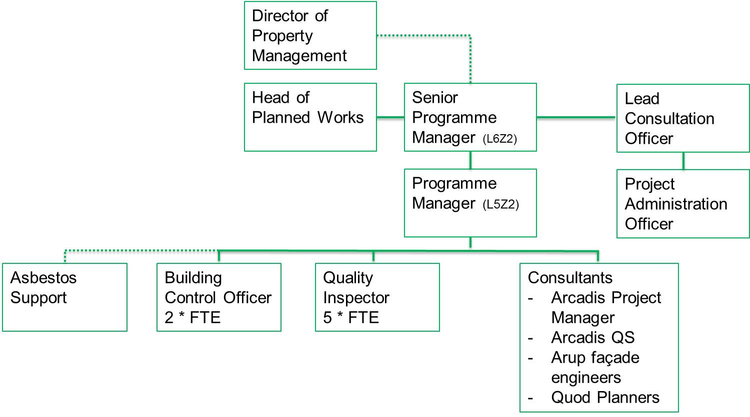

**Relationships;**

**Internal**

* Staff within Camden Council
* Specialist support teams/contractors
* Consultants

**External**

* Councillors of Camden Council
* Government Departments and agencies
* Private and voluntary sector providers of relevant services
* Other public sector providers and organisations
* Members of the public
* MPs

**Work Environment;**

Based on site and at offices in Jamestown Road, Holmes Road and 5 Pancras Square. Attendance at evening meetings as required.

**Technical Knowledge and Experience:**

* Preferably educated to degree level/post graduate qualification (or equivalent)
* Understanding of issues impacting on hard to reach groups and effective interventions to counter disadvantage.
* Experience of a range of methods of consultation, engagement and involvement.
* Strong communication skills, with the ability to represent the council in public & interact with a wide range of audiences, managing conflict in highly charged public meetings.
* Knowledge and understanding of community consultation processes.
* Knowledge and understanding of access protocols relating to social housing and leaseholders within the borough.
* Knowledge of current housing and social policy issues and legislation.
* Experience of working in a political environment.
* Evidence of continuing professional development.

**Camden Way Five Ways of Working**

*In order to continue delivering for the people of Camden in the face of ever increasing financial pressure, we need to transform the way we do things. We call this the Camden Way. The Camden Way is a key part of our transformation strategy often referred to as the transformation triangle which links the Camden Plan, the Camden Way and the Financial Strategy together.*

The Camden Way illustrates the approach that should underpin everything we do through five ways of working:

•Deliver for the people of Camden

•Work as one team

•Take pride in getting it right

•Find better ways

•Take personal responsibility

For further information on the Camden Way please visit:

<https://camdengov.referrals.selectminds.com/togetherwearecamden/info/page1>