**To: London Borough of Camden**

**Date: 26 April 2019**

At this stage Camden will be reassured that every known historic element is re-established. It is important that structural and historic significance is not impaired. The applicant is committed to ensuring that every historic element to be re-established is an authentic form and the choice of materials and appearance is appropriate.

Regards the new structural beam for the roof, this will not affect the existing beams and joist structure. New joists on the second floor will be in line with previous joist position and keep remaining pieces of existing ones. The staircase between 1st and 2nd floor remains untouched and existing spindles are kept in place.

A list has been produced by the architect on the various furnishings and interior elements that are being proposed:

**Design Inspiration:**

The Regency period is a transitional one for architecture and is a sophisticated expression of classical trends present for the preceding century and an era highly conscious of its own modernity. Pursuit of the exotic and eclectic was fashionable, and influences include the French Empire style, the English Gothic, Egypt, China and most of all classical Greek architecture and its associated motifs. In the interiors, there is a striking emphasis on architectural elements, with strongly accented mouldings and extensive use of crisp, linear detailing, such as reeded or incised patterns.

**MATERIALS:**

1. **Welsh slate** for the roof is a faithful incarceration of a building material that has been used for roofs for many centuries. the quality of Welsh slate has made it a premier building material, with top architects still demanding it for prestige projects, utilising its thin banding that allows it to be into slender sheets.
2. **Lime mortar** will be used for pointing the **external brickwork**, as the lime is the weaker element, and the mortar cracks in preference to the masonry. It provides efficient preservation to damp conditions as lime mortar is more porous than cement mortars, and it wicks any dampness in the wall to the surface where it evaporates. It is important to use the right mix of proportions with the ratio for brickwork ranging from 1:3 to 1:5 depending on the strength.
3. **On the internal brick wall**, lime render/plaster is a traditional material used for internal plaster, limewash and solid floors. Mortars made with lime putty cure slowly but result in strong, yet flexible, permeable and stable building fabric. It is most suitable here as a Lime-based building will allow it to expand, contract and flex with changes in temperature and moisture. It has aeration properties too which allows the brock to breather and diffuses any potential water ingress or damp. The use of lime allows damp to be absorbed to a limited degree and then evaporate harmlessly away.

**SKIRTING**:

Use of similar skirting to the one at the bottom of the 1st level staircase. As the skirting in this position is the only surviving element of the historic building, it is important to reinstate it as the template for the unified composition of a skirting board from one period in tome.

**CORNICE:**

1. **Entrance hall:**

The proposal to use an attractive and versatile Regency design (Kilverton Hall) in plaster is sympathetic to the type of historic character that will once have been seen here. There is no example of any surviving cornice, yet it is known that in the late Georgian. Regency period, aspects of internal decoration such as cornice were used to give a room a more elegant feel.

Once a feature of most Georgian and Victorian houses, but often removed by developers over the years, the cornice moulding can help restore the building to its former elegance.

1. 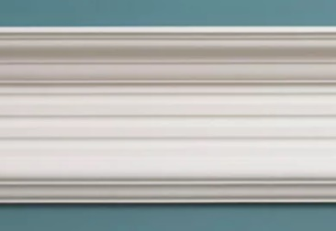Bearing in mind this pure approach to restoration, it is fitting that on the **1st floor,** the applicant has selected a more unusual profile, inspired by the mid-19th century redecoration of Thomas Carlyle’s handsome townhouse in Chelsea (In National Trust ownership).**2nd floor and corridors,** The Regency style is given a more subtle definition where a small cornice moulding influenced by John Nash in 1804.

***ENTRANCE Hall:*** *Kilverton Entrance Hall* ***1st floor****: Carlyle's House-Sitting Room*

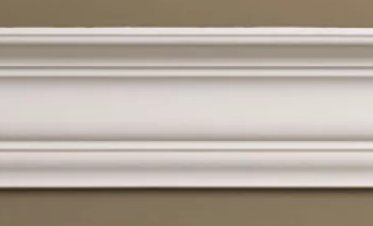

**INTERNAL DOORS:**

1. A plain Regency four panel door for **1ST, 2ND and 3RD floor** can reference an 1810 moulding from Mayfair, London. The ovolo and bead moulding have finesse which is set above a flat panel.

# *Regency Period Door Moulding*

**ARCHITRAVE**:

Architrave in the main rooms can be designed so it reflects the three-part architrave from the Admiralty Building in Whitehall. This is a fitting element that ties in with the age of the internal panel doors and imbues a sense of grandness.

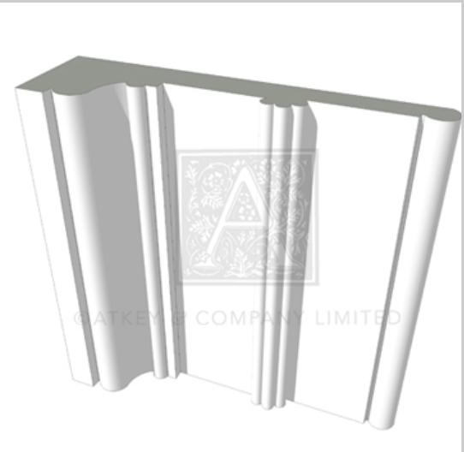 *Three-part architrave*

**FLOORBOARDS:**

The former timber floors have been buried beneath layers of treatments and finishes. It has been decided that as many of the floorboards are probably original with a number of Victorian and late 20th century ones being interspersed with the old, we intend to use a good quality period floor board for first floor , we will retain original floorboards on second floor and new square edge pine floor boards to top floor,

**KITCHEN:**

Designed for old London townhouses, the kitchen complements painted front doors, high ceilings, old fireplaces, period floors and delicate original sash window with shutters. The ambient light and calm interior give a feeling of authenticity.

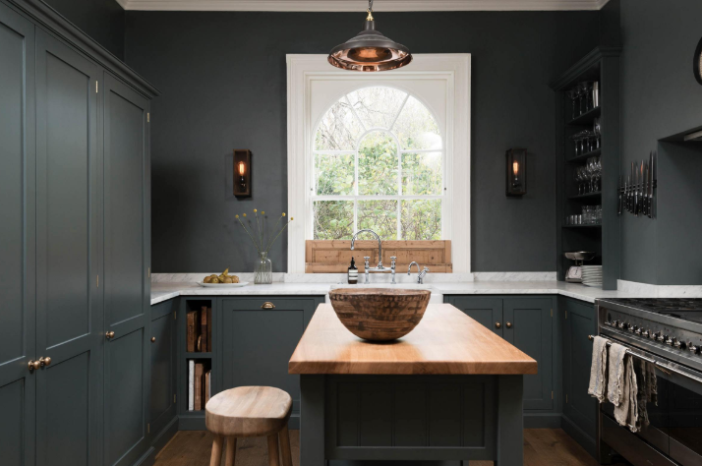

**SHOWER ROOM:**

There will only one shower room on the second floor - similar to existing size.

The bathroom on the loft floor will be slightly larger as we have moved the dividing wall to a more central position, similar to spine wall position on 1st and 2nd floor, the bathroom is to be similar in style (Regency/ Georgian)

**FIREPLACES:**

Period Georgian fireplaces are suitable for first and second floors:

On the 1st floor a period fireplace with bowed reeded pilasters and conforming frieze with diagonal ribbons and finely carved paterae (to the corner blocks), will be sympathetic to other decorative elements in the lounge. Whilst on the 2nd floor a plainer and less ostentatious fireplace will be used, 2nd floor fire place to be agreed in writing with conservation officer before fitting.

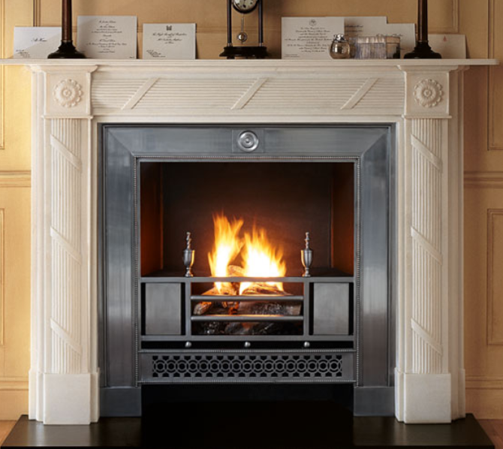

*1st floor*