c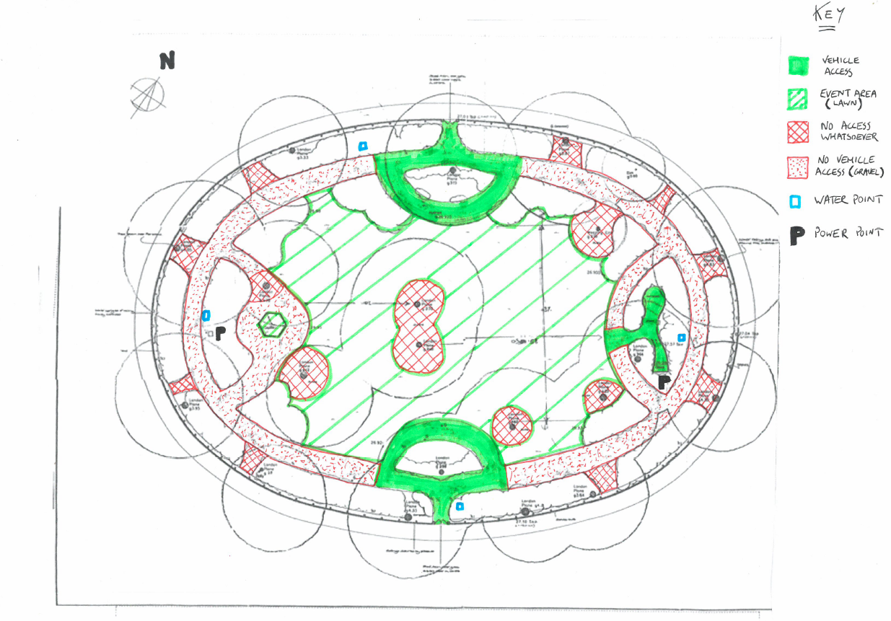

Ticketing and bookshop stall

Catering marquees

Carpeted walkways

Main marquee + AV extension

AA Graduation 2019

Graduating students’ entry point

Guests’ entry point